Table of Contents

1. Installing Google Chrome 2

2. Pre-requisites for installing Chromedriver 4

Setting Chromedriver PATH 4

Installing WinRAR 8

Check for Google Chrome version 10

3. Installing Chromedriver 14

Check for Chromedriver in the system 19

4. Configuring the configuration file(config.json) 21

Explanation of config.json parameters 24

Adding a new device for automated collation 26

Formatting rules to follow 26

Step-by-step guide to add new device 27

Mistakes that might be easily made 31

5. Running the automated collation program 32

Check whether the automation program is running 33

Restarting the program 34

PC limitations that will result in errors 34

Result of the automated collation 35

6. Error fixing 38

Types of errors 40

1. JSON Formatting Error 40

a. Directory error 40

b. Missing comma(,)/quotation mark(“)/colon(:)/curly bracket({}) 41

2. Invalid Configuration Error 43

a. Invalid IP address 43

b. Invalid password 43

c. Invalid slot name 44

# Installing Google Chrome

You may skip this step if your device already has Google Chrome installed.

**Ensure that you are connected to the Internet before proceeding with the next steps!**

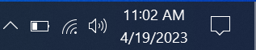

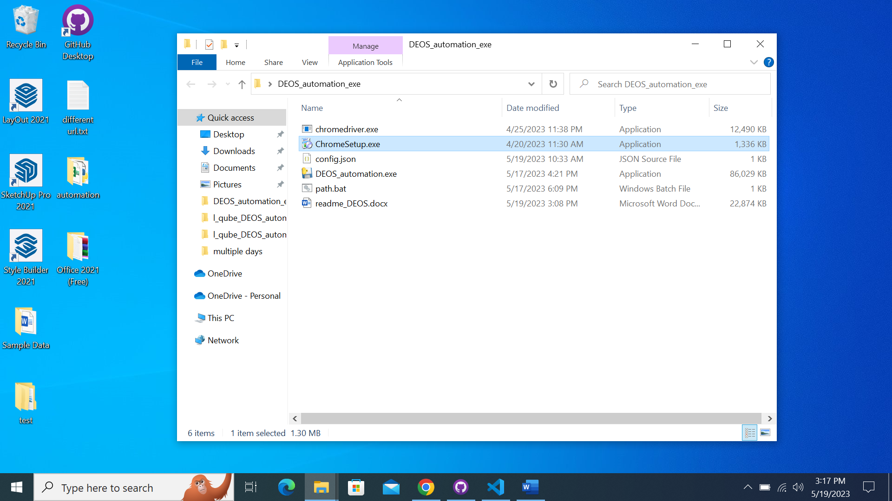

Double click on the file ‘ChromeSetup.exe’

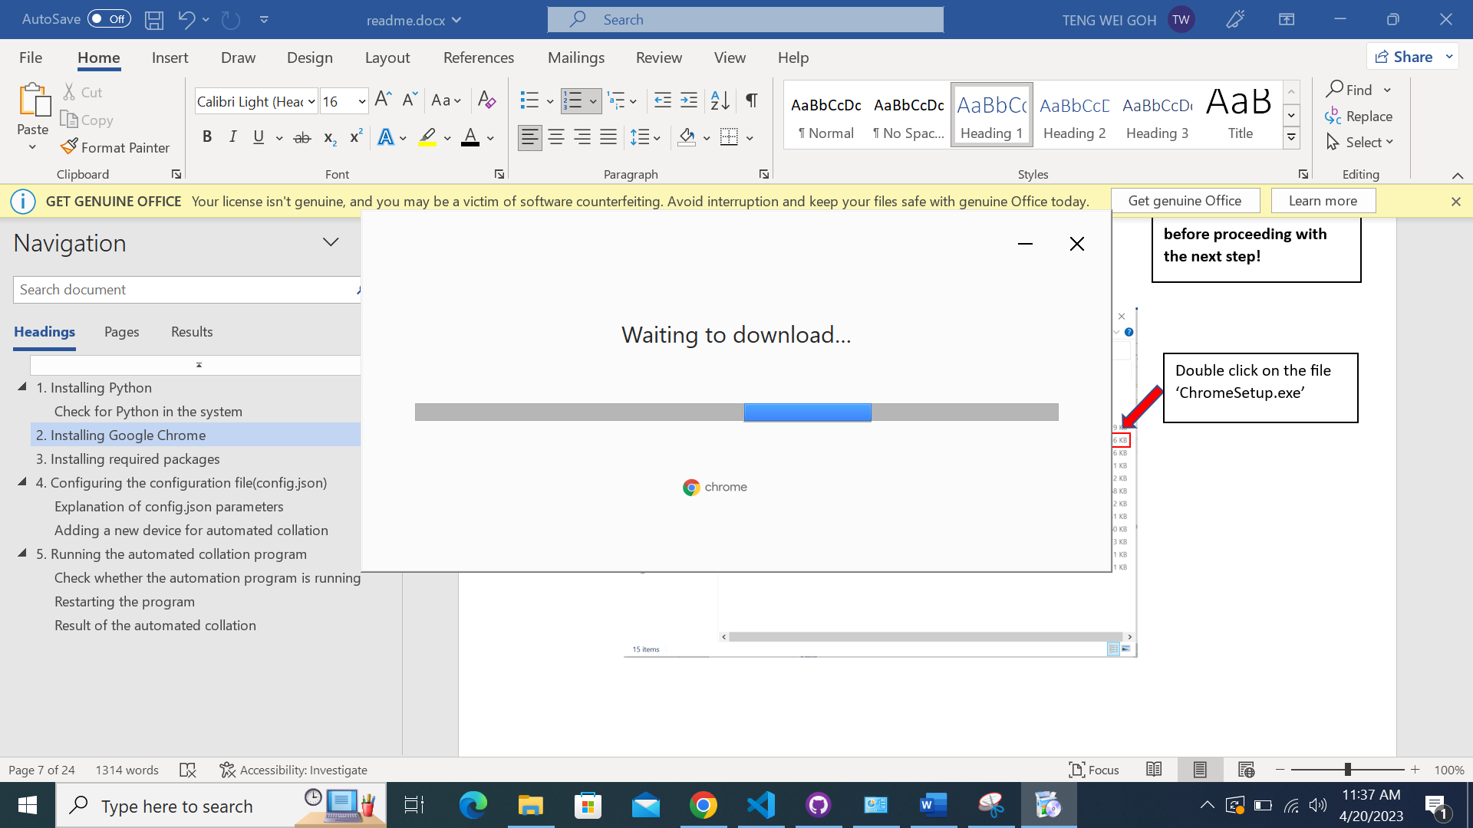

It should lead you to this page.

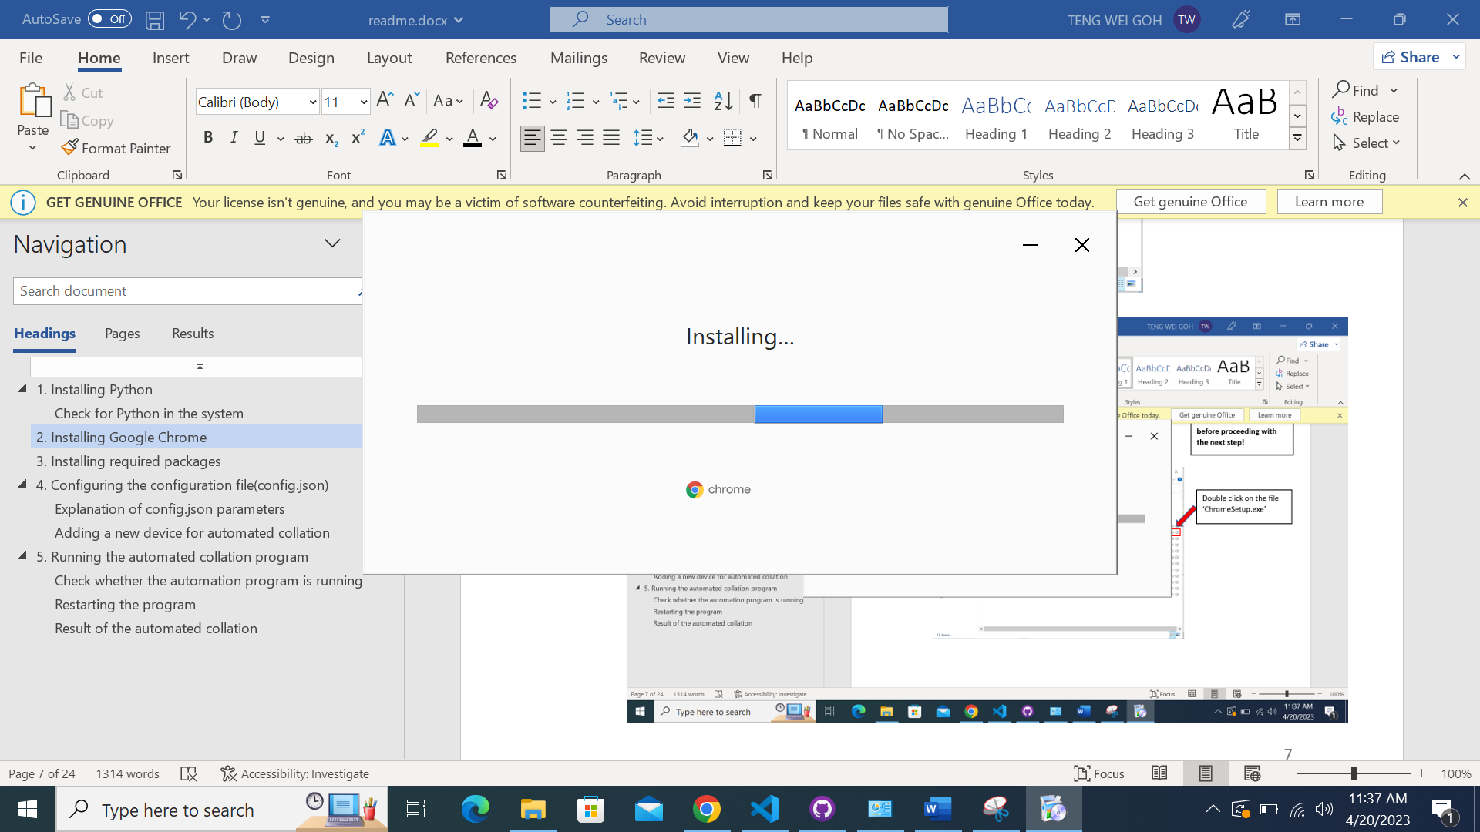

Google Chrome will automatically download if you are connected to the Internet.

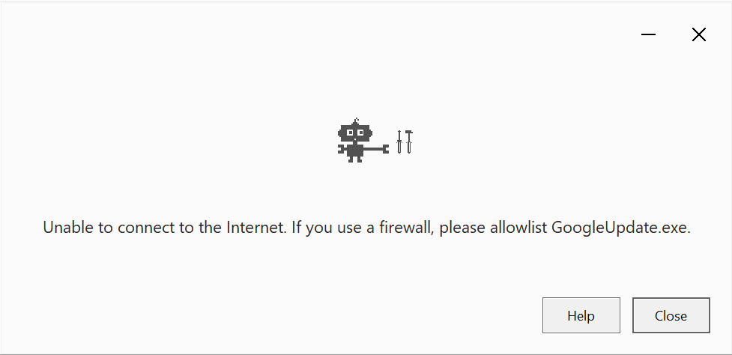

You will see this prompt if you are not connected to the Internet.

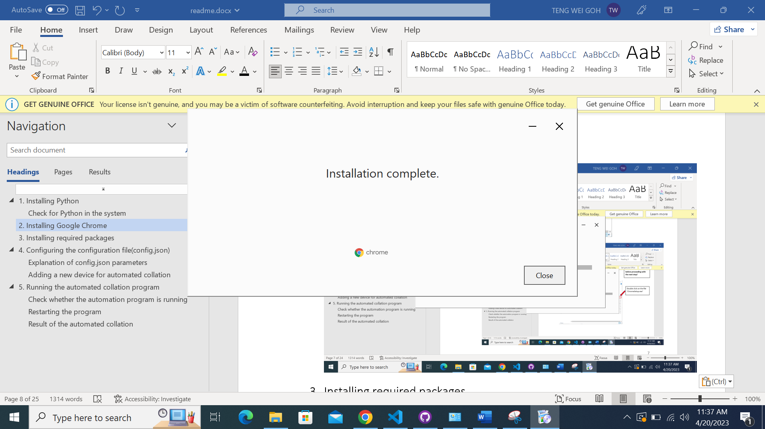

After installation has completed, you will see this prompt and you may close the installer now.

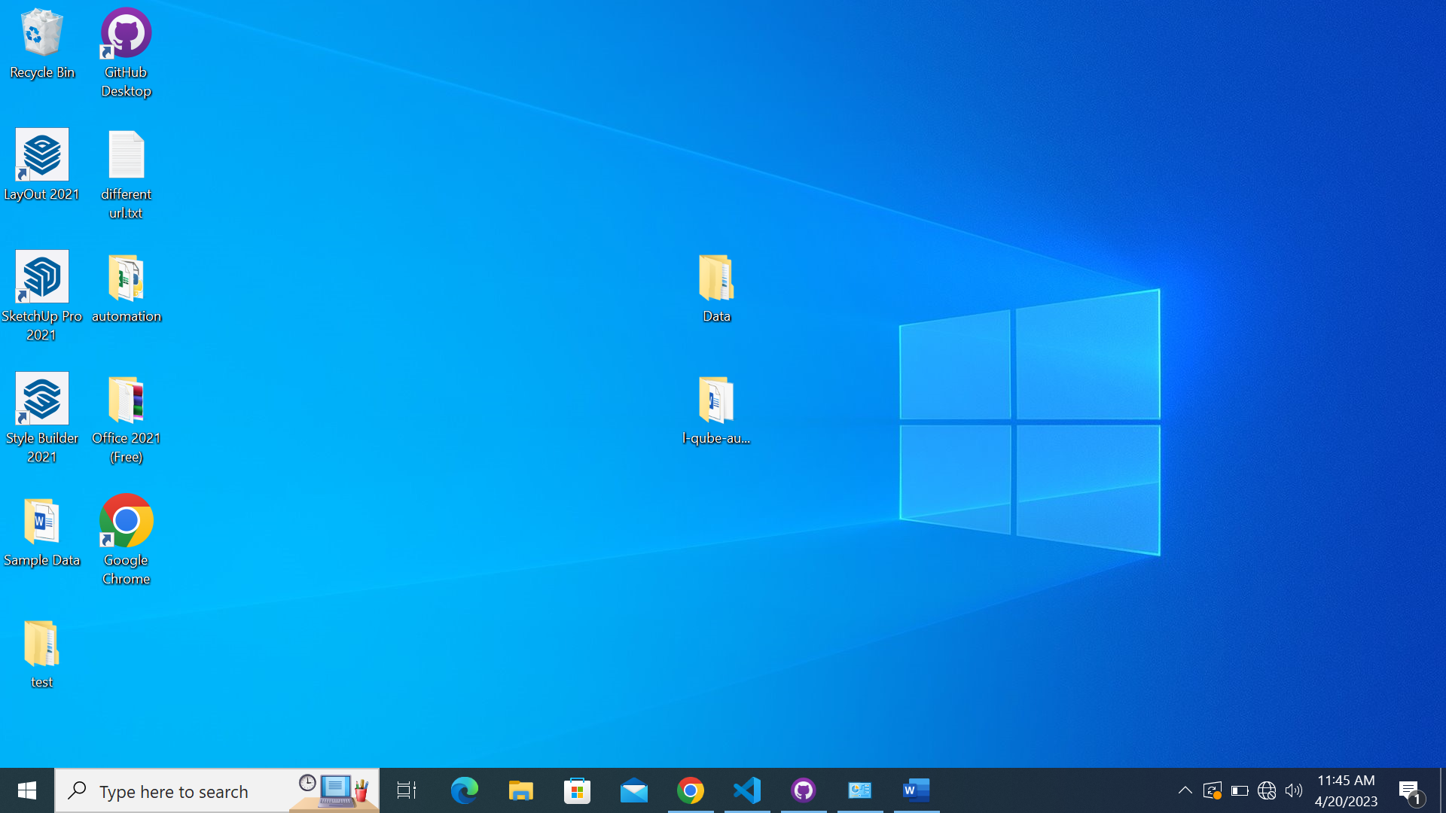

A shortcut of Google Chrome will automatically be created on the Desktop. This verifies that Google Chrome has been successfully installed.

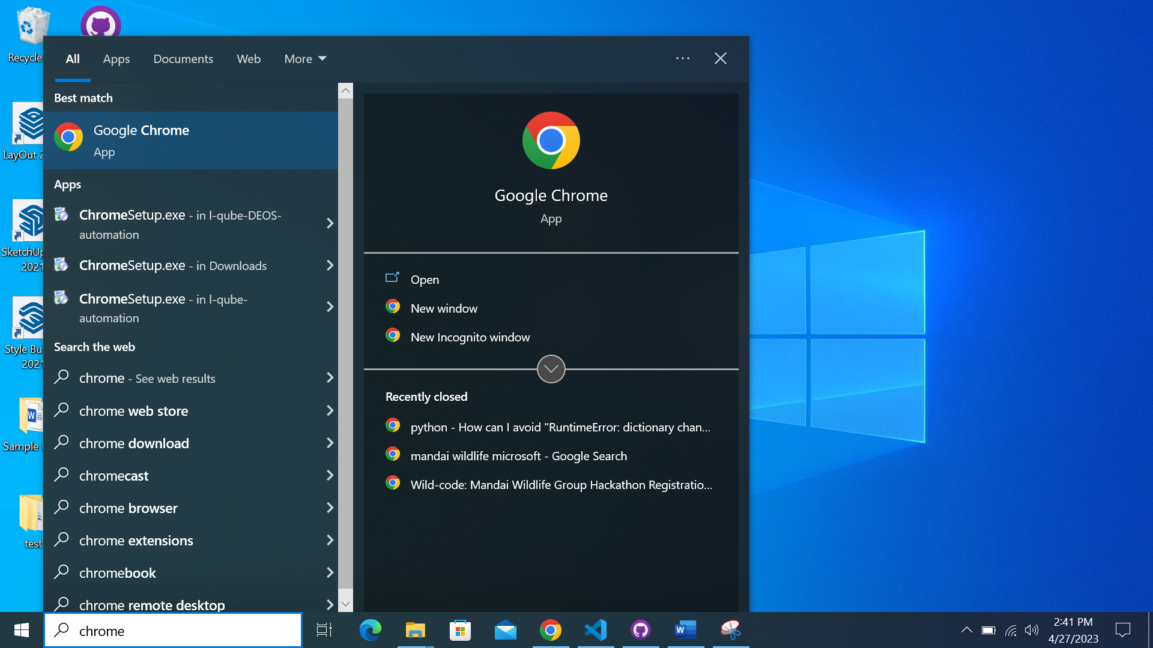

Another way of verification:

Typing ‘chrome’ in the search bar should lead to ‘Google Chrome’ showing up. This verifies that Google Chrome has been successfully installed.

# Pre-requisites for installing Chromedriver

## Setting Chromedriver PATH

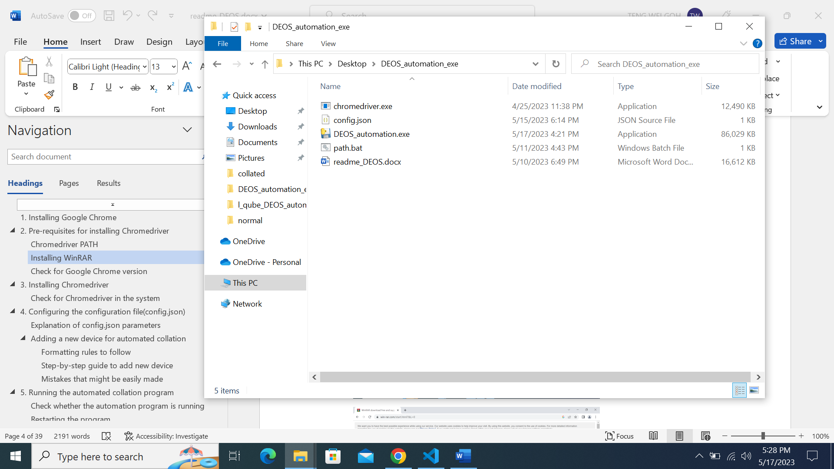

Navigate to the folder where the files are



Click on the white space on the right of the directory

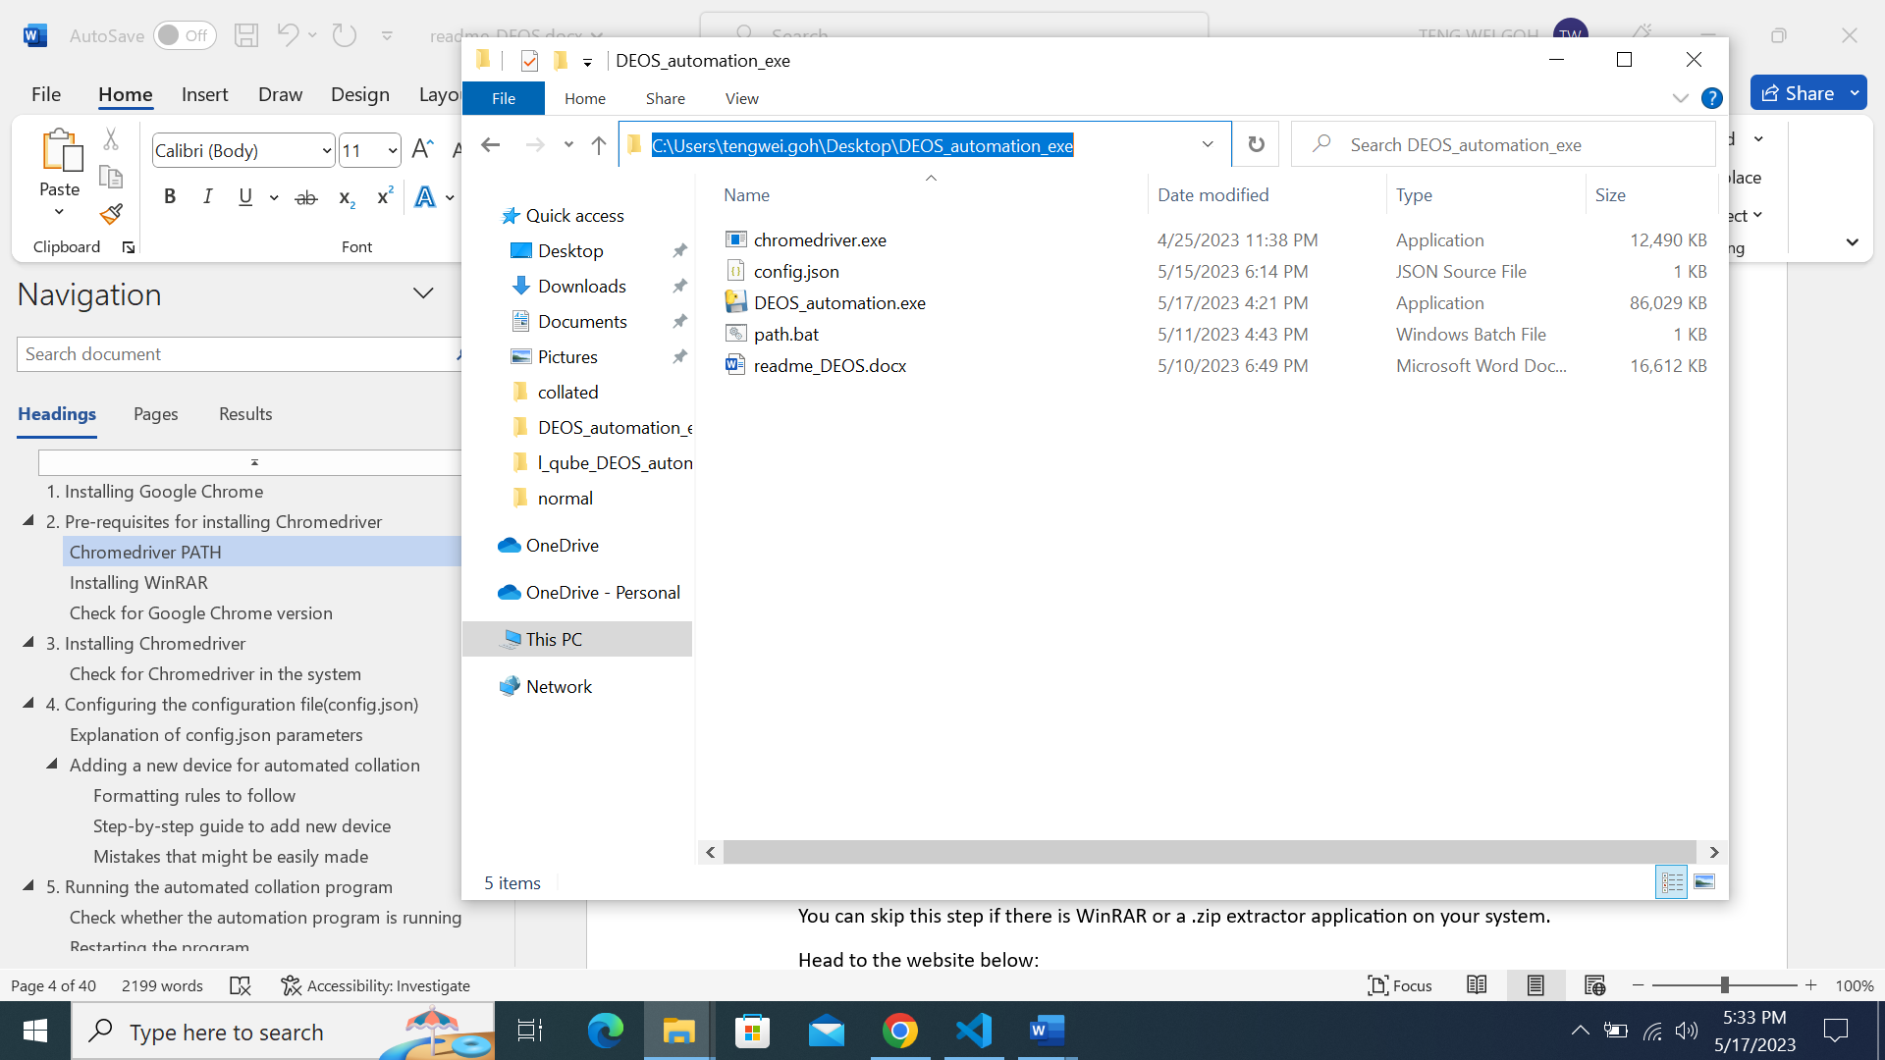

The directory will then be highlighted in blue

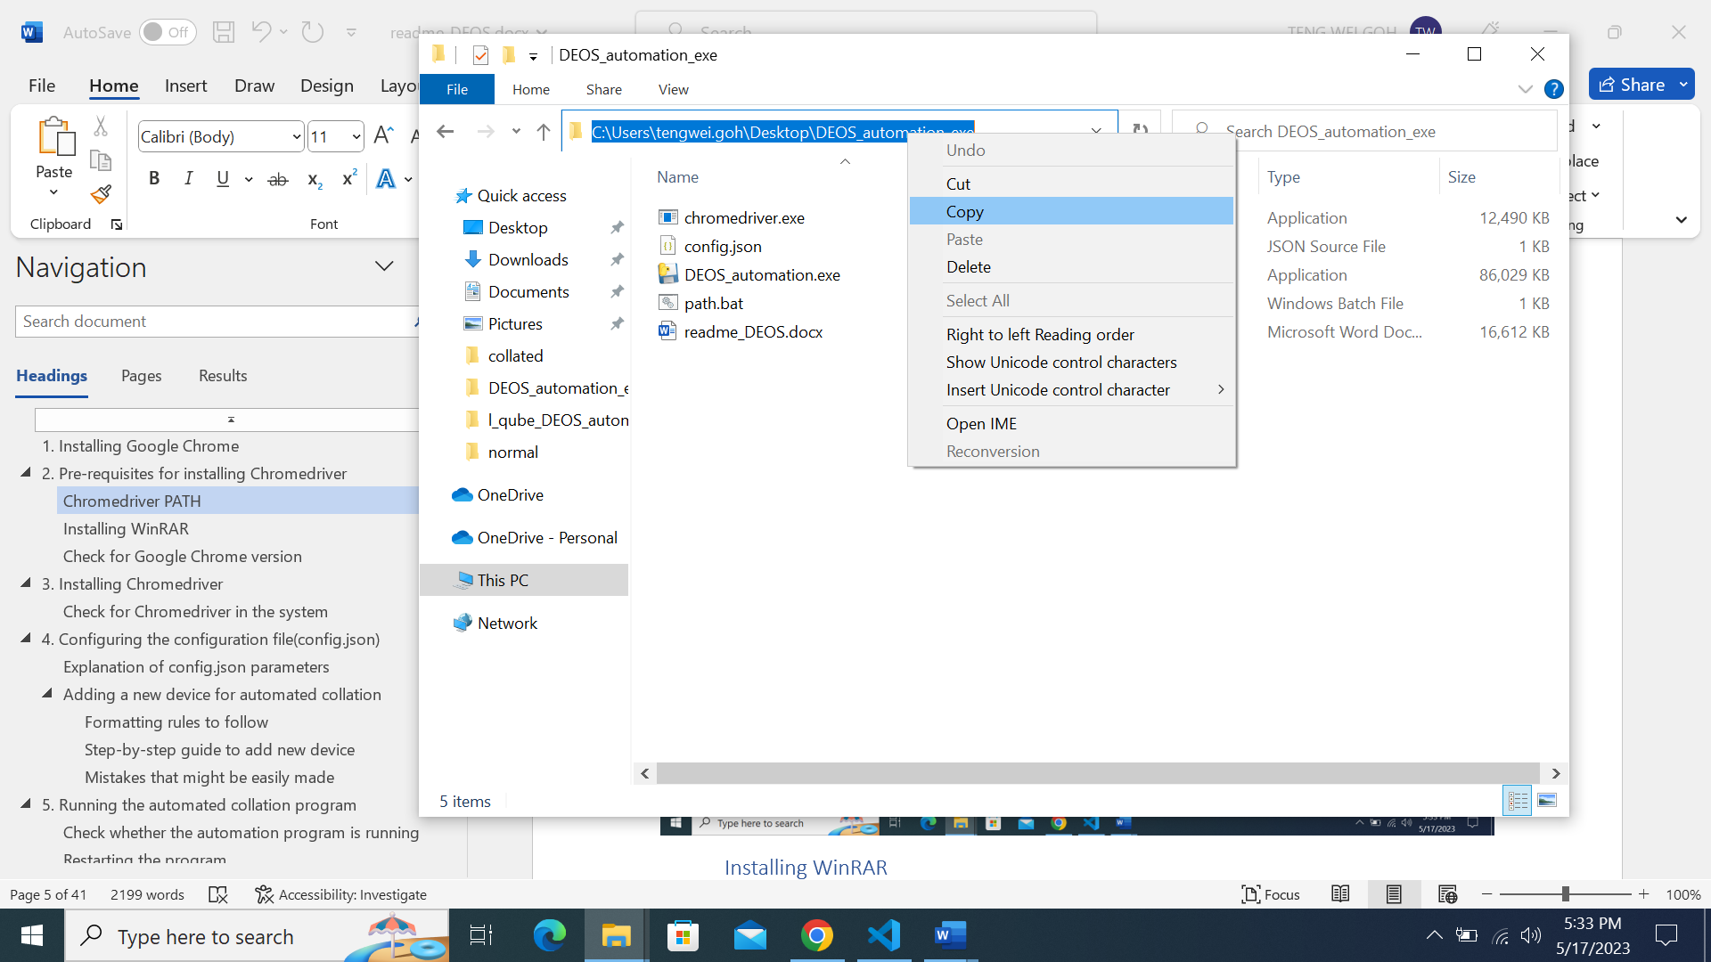

Right-click on the highlighted directory and click on ’Copy’ option

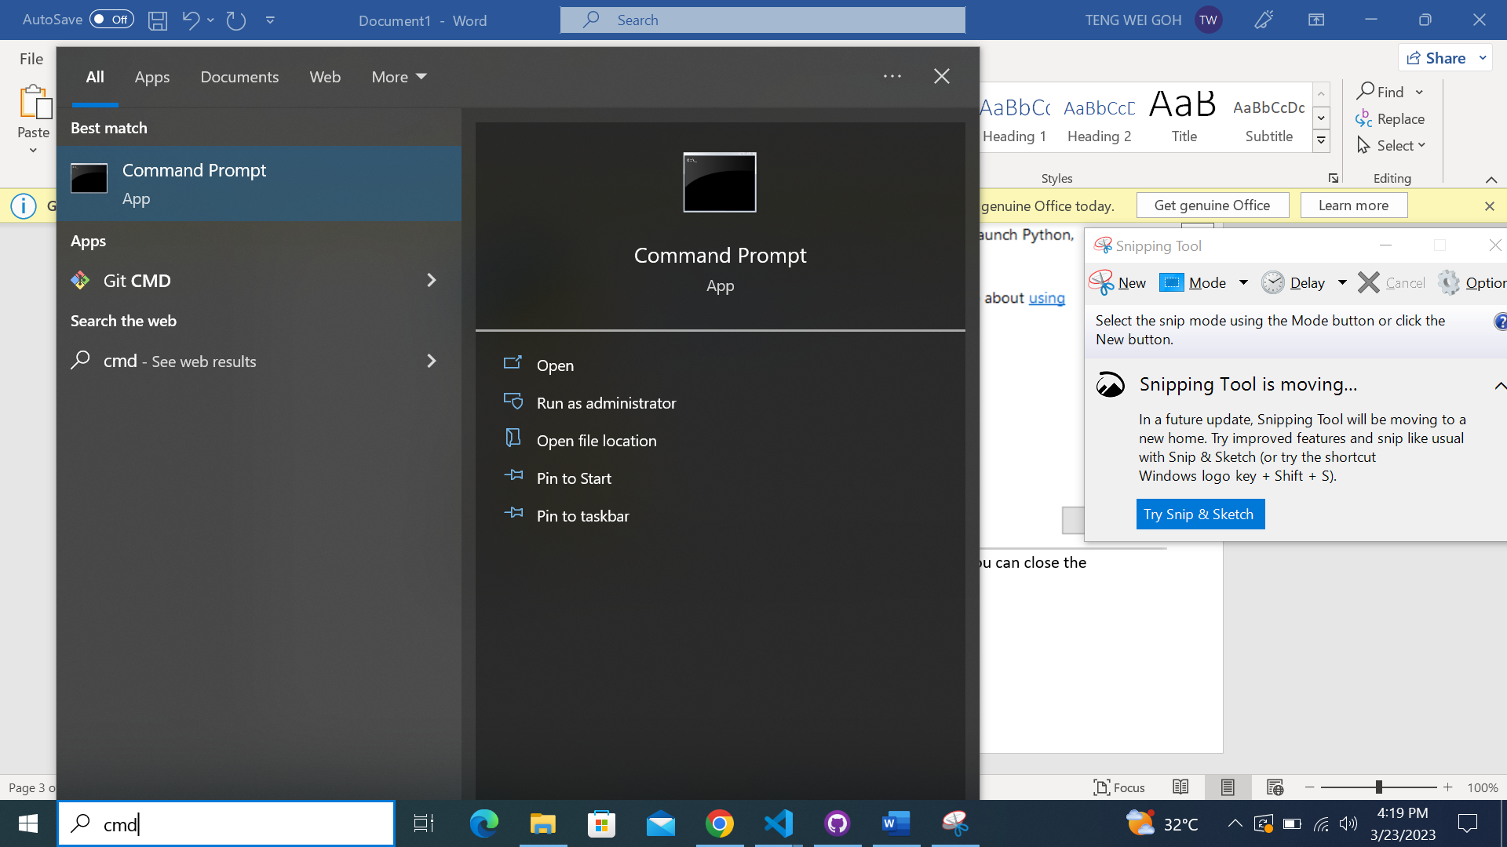

2

1

2. Click the Command Prompt App shown under ‘Best match’

1. Type in ‘cmd’ into the search bar on Windows

2

1

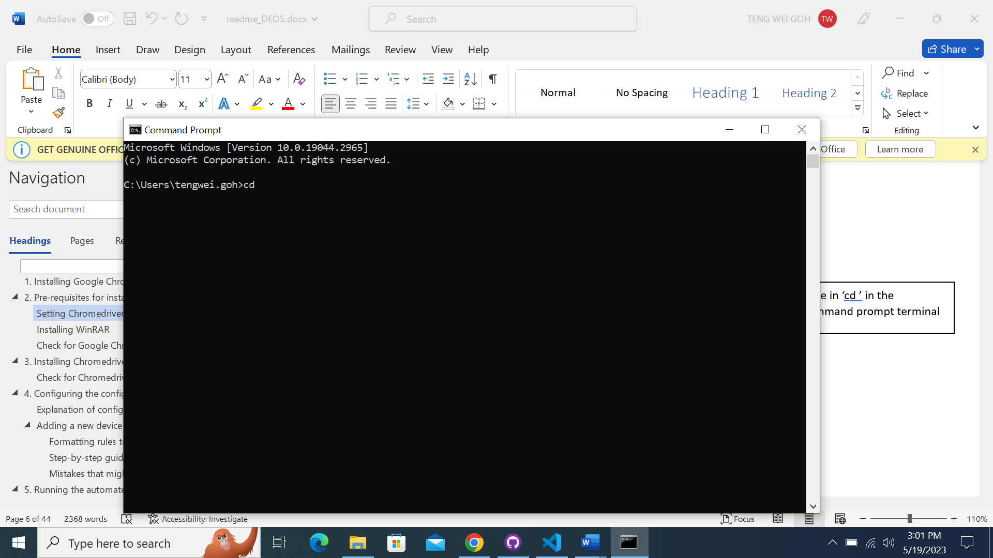

Type in ‘cd ’ in the command prompt terminal

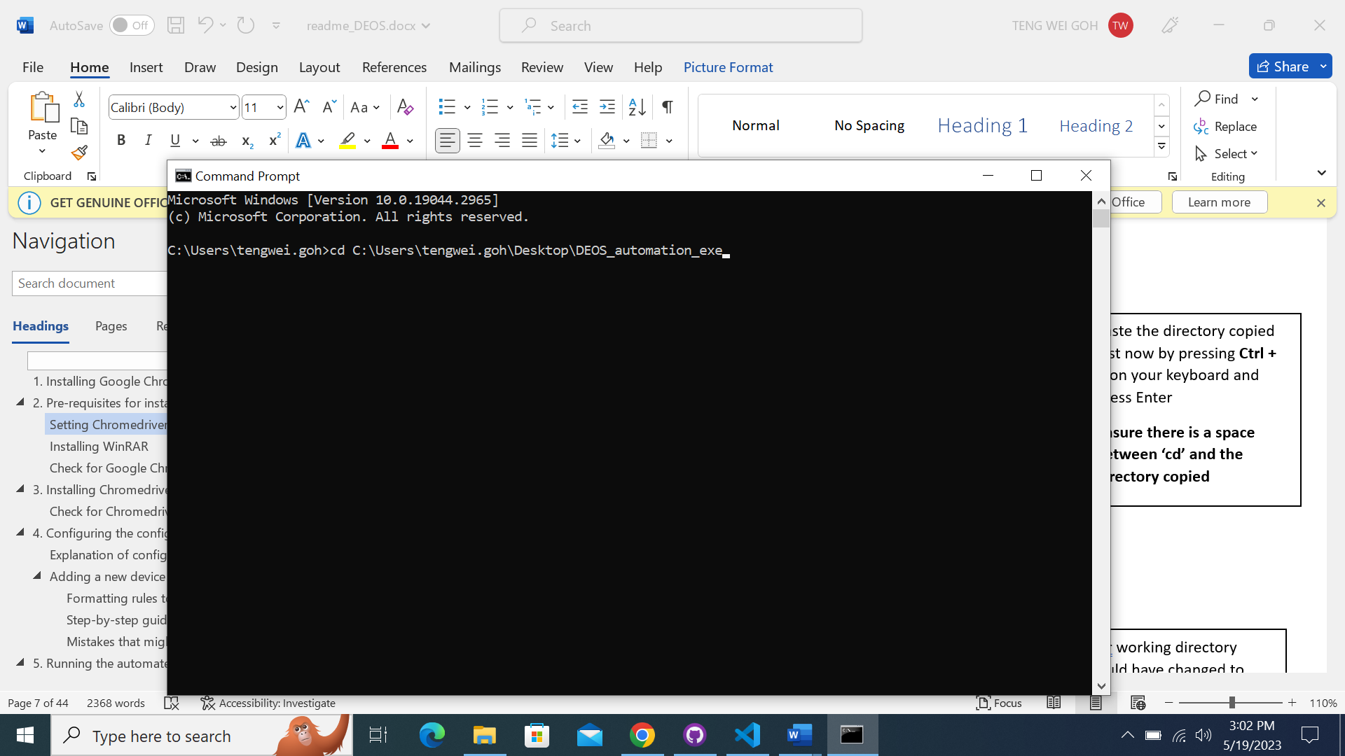

Paste the directory copied just now by pressing **Ctrl + V** on your keyboard and press Enter

**Ensure there is a space between ‘cd’ and the directory copied**

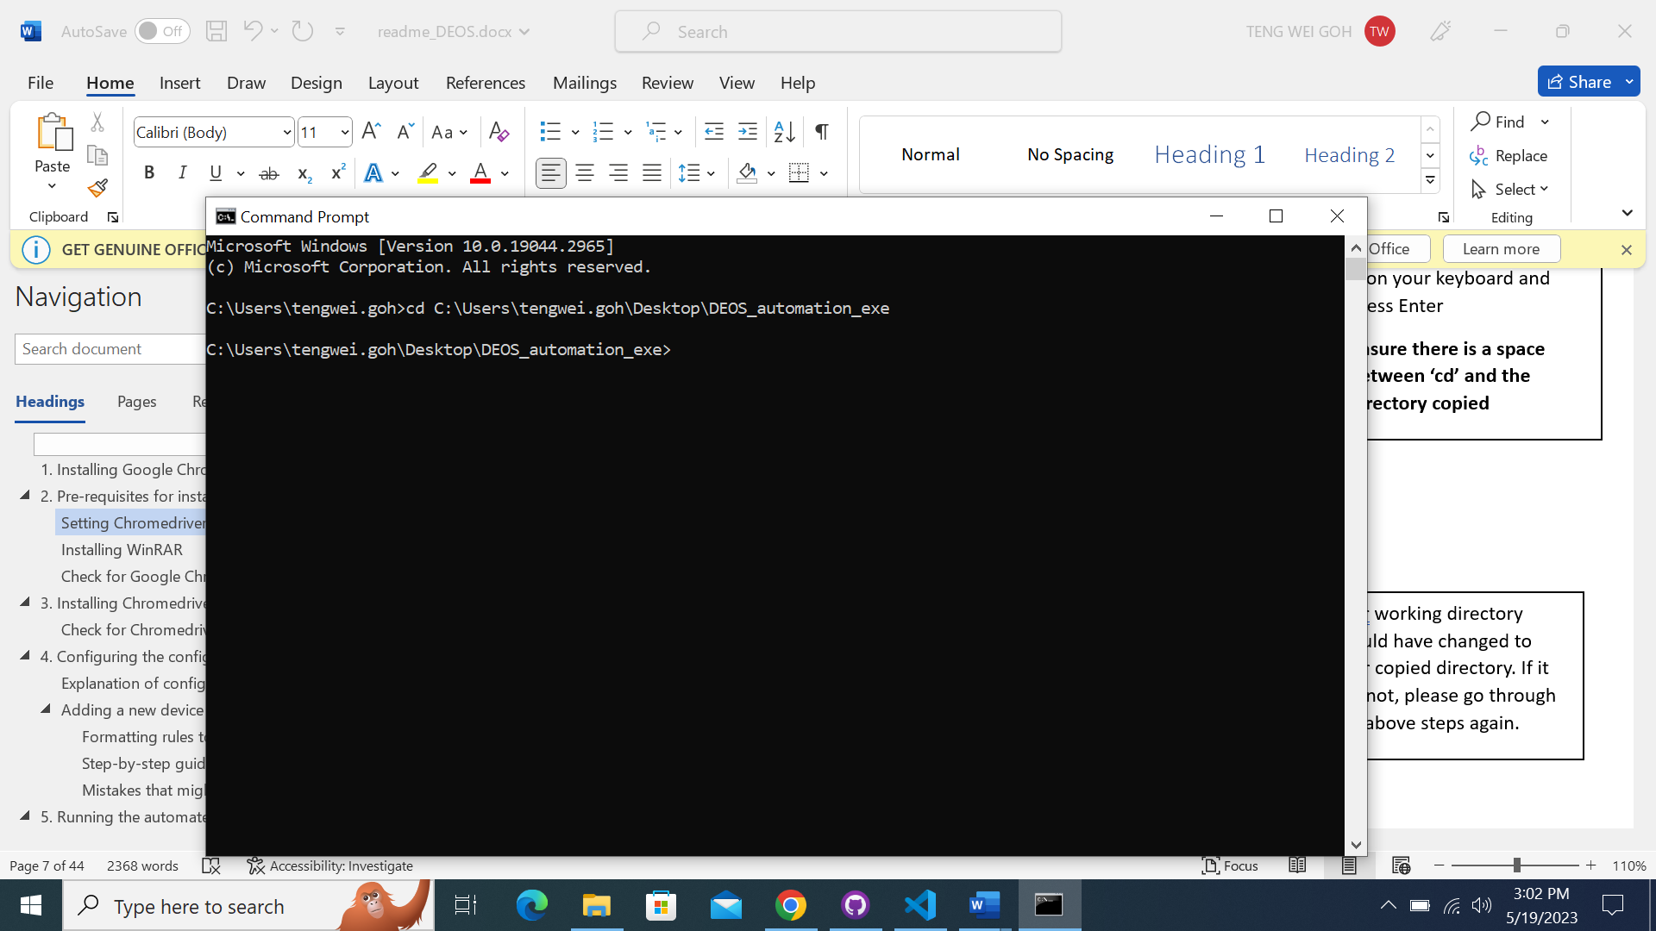

Your working directory should have changed to your copied directory. If it has not, please go through the above steps again.

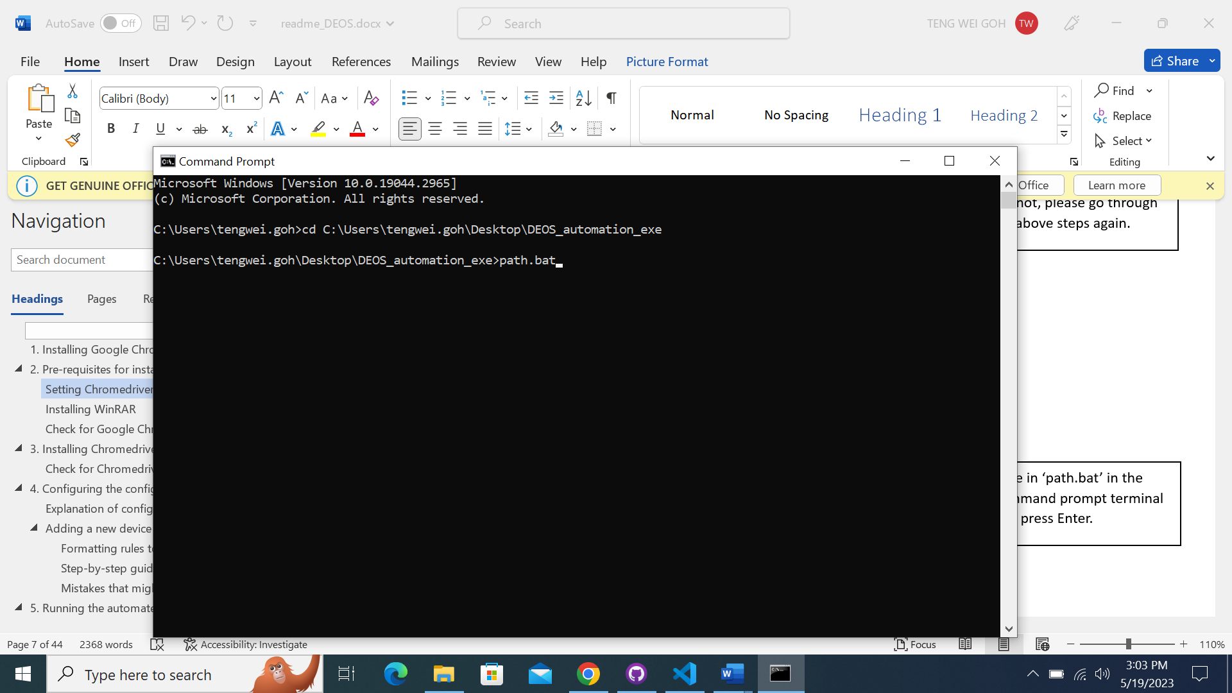

Type in ‘path.bat’ in the command prompt terminal and press Enter.

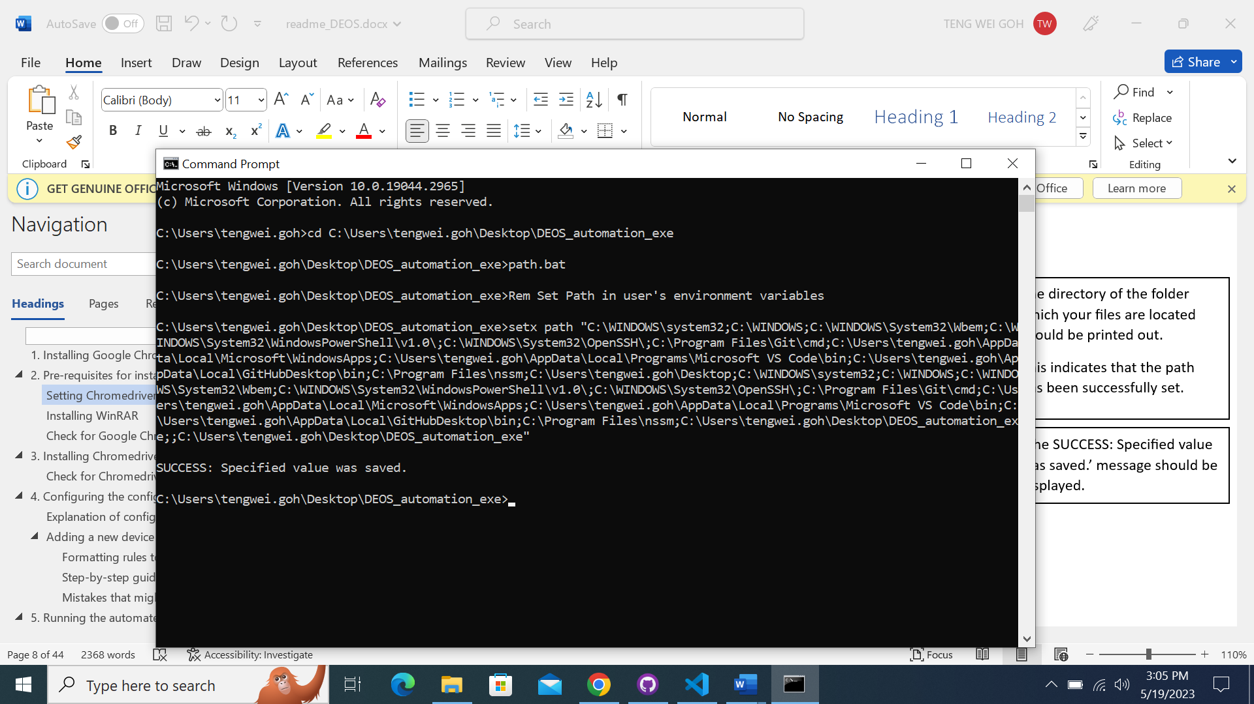

‘The SUCCESS: Specified value was saved.’ message should be displayed.

The directory of the folder which your files are located should be printed out.

This indicates that the path has been successfully set.

You can exit the terminal after ensuring that the directory has been added successfully

## Installing WinRAR

You can skip this step if there is WinRAR or a .zip extractor application on your system.

Head to the website below:

[https:/www.win-rar.com/start.html?&L=0](https://www.win-rar.com/start.html?&L=0)

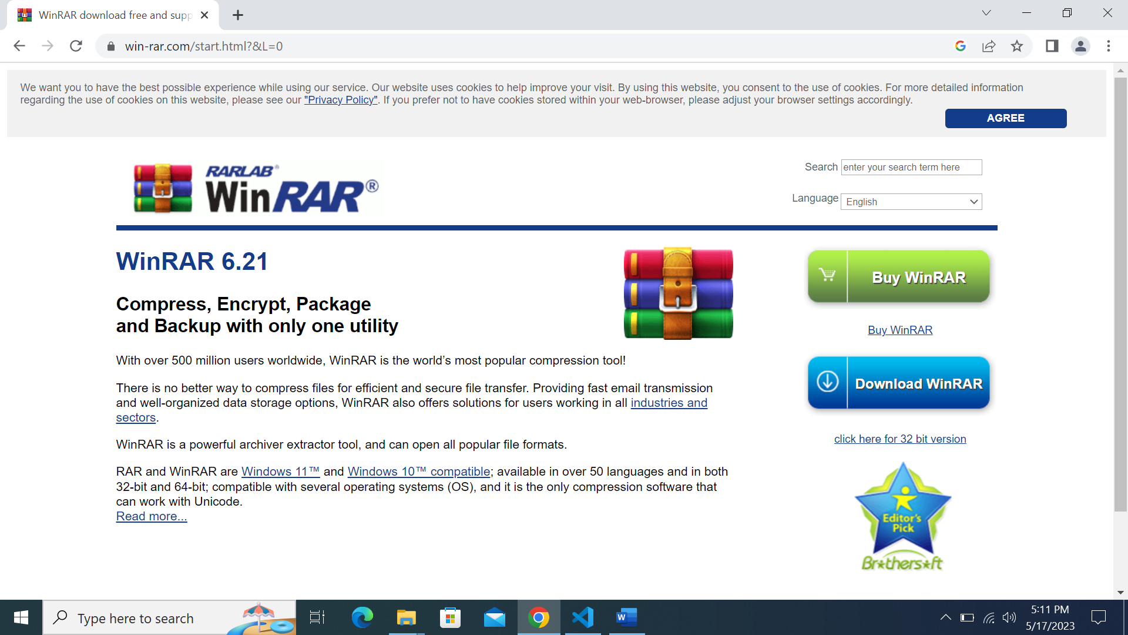

You should be led to this page.

If for some reason the URL has been changed, please Google Search ‘winrar download’. It should be the first result displayed.



Click on ‘Download WinRAR’

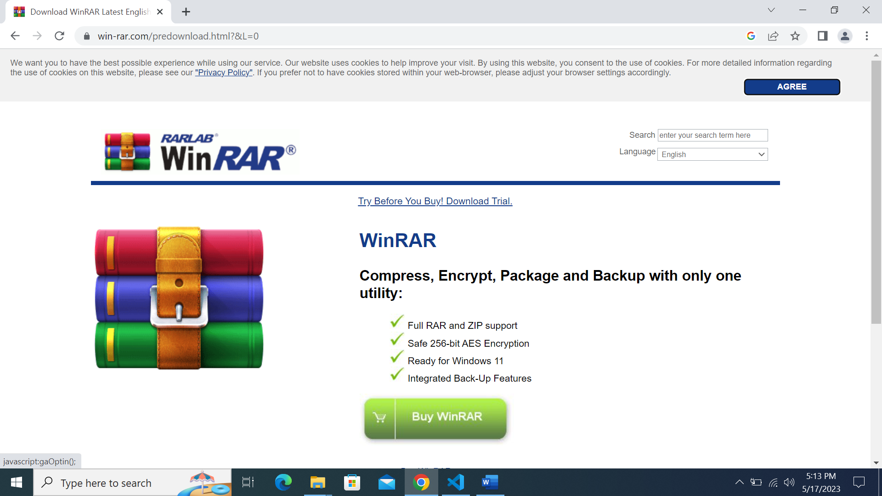

You should be led to this page.

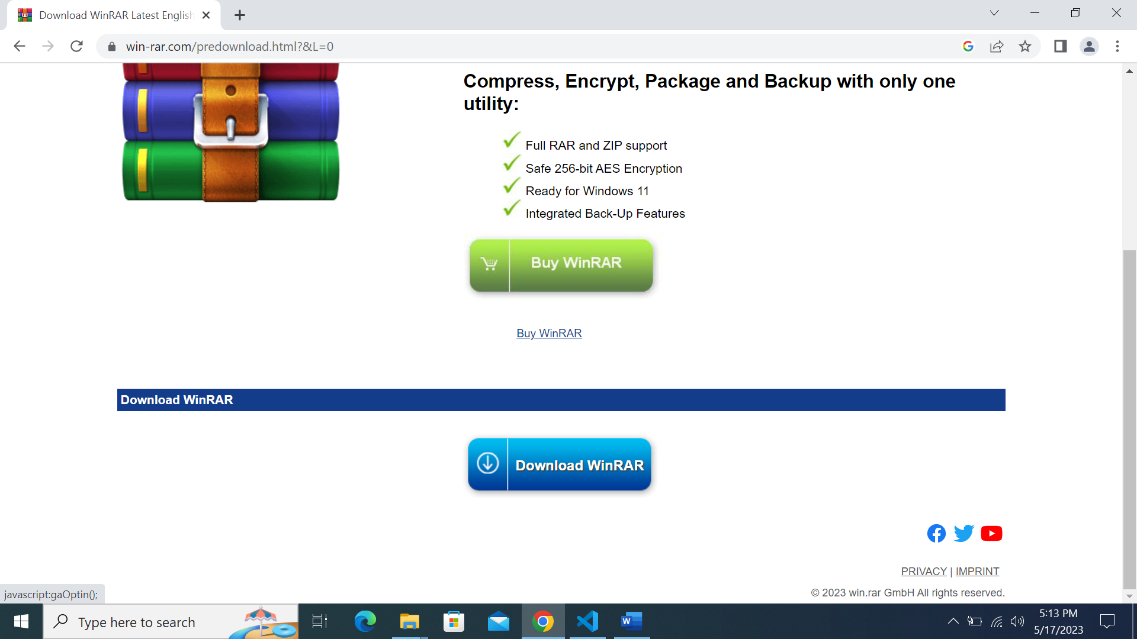

Scroll down and click ‘Download WinRAR’

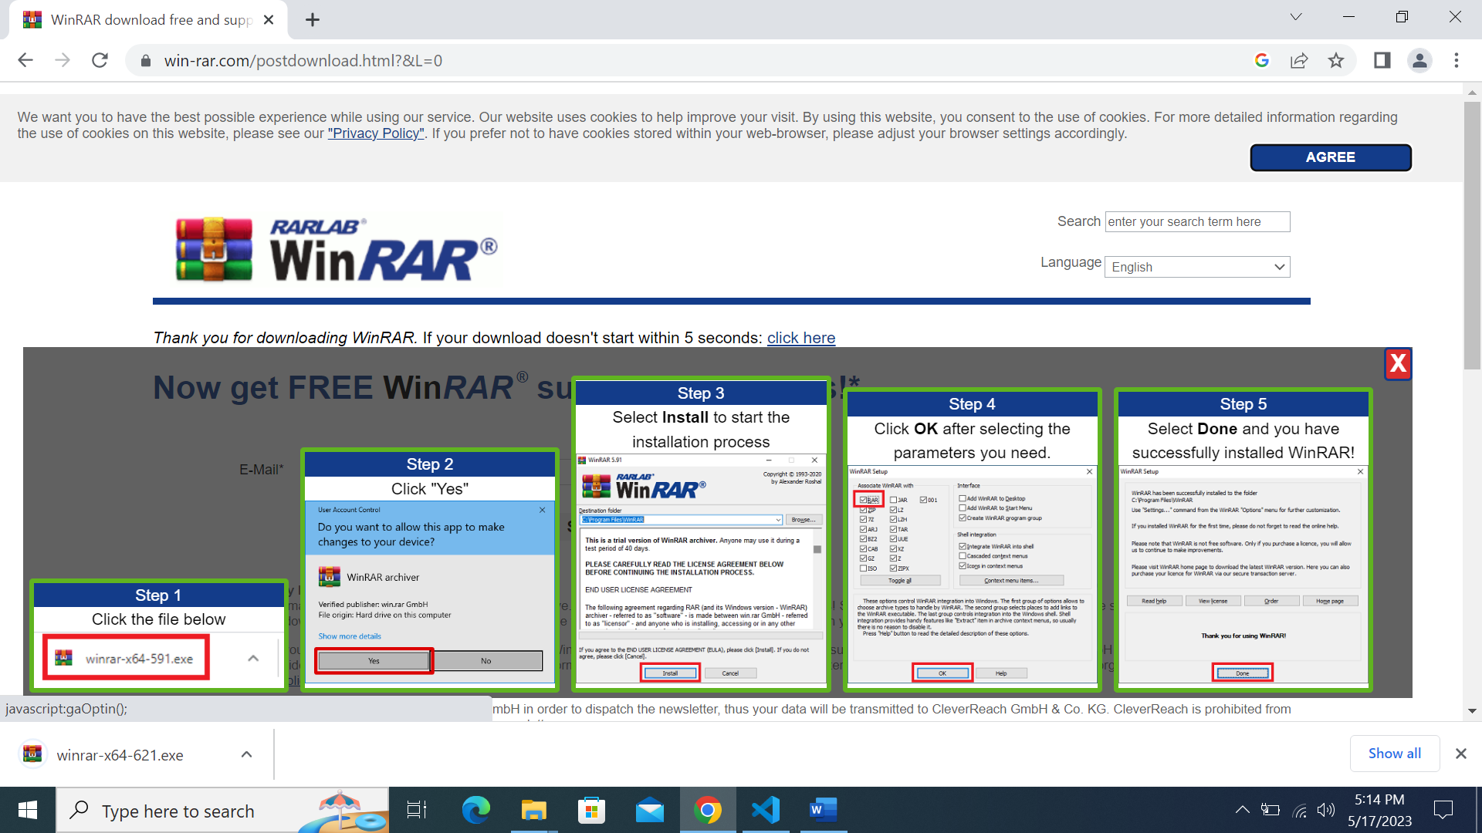

Download will begin automatically and you can follow the instructions provided by the WinRAR website.

## Check for Google Chrome version

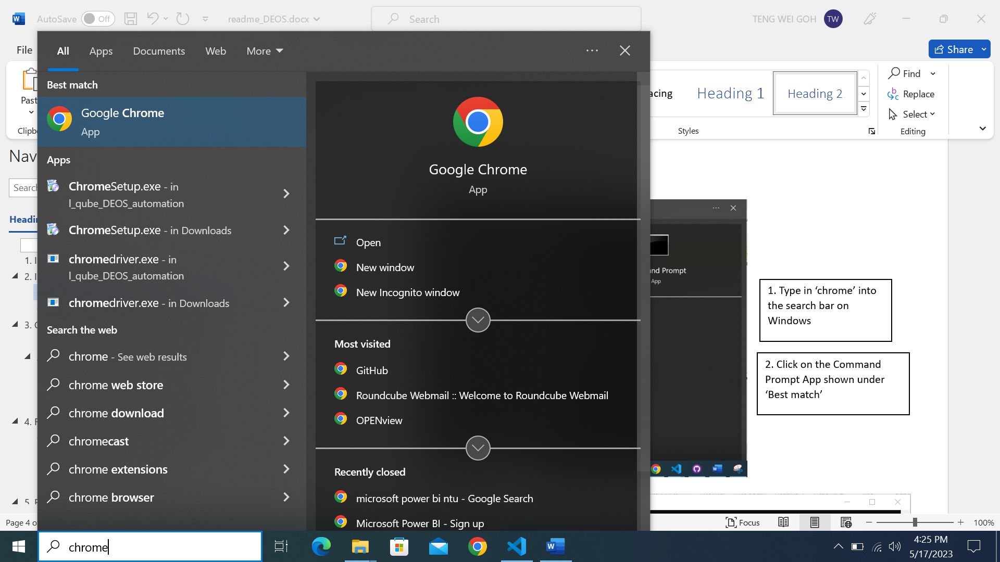

2. Click on the Google Chrome App shown under ‘Best match’

1. Type in ‘chrome’ into the search bar on Windows

1

2

1

2

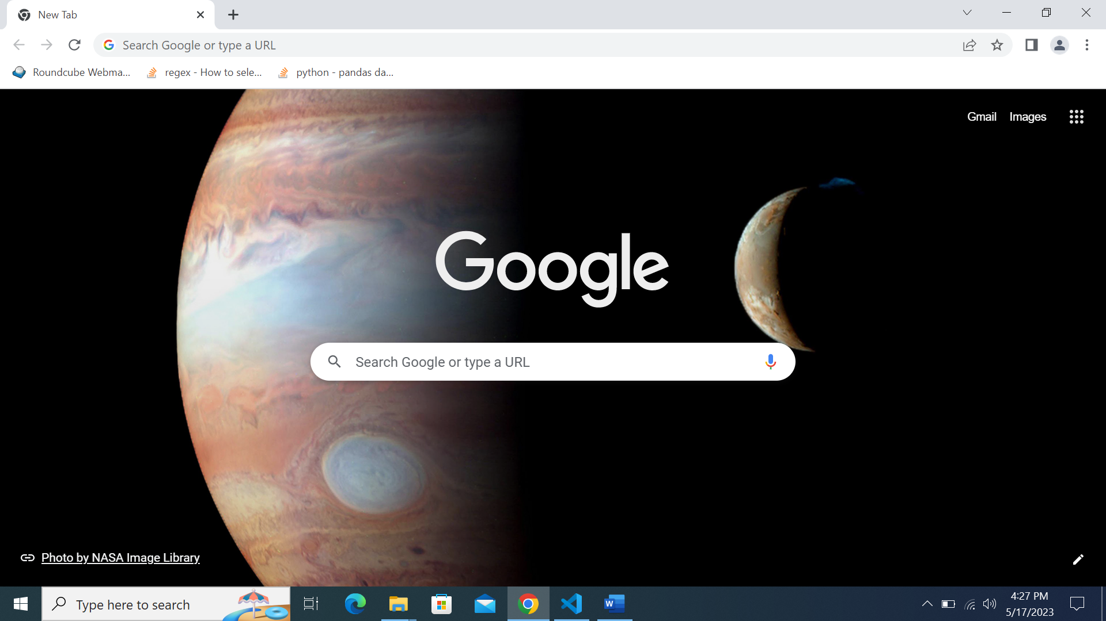

A similar display will be shown once the Google Chrome browser is launched.



At the top right, click More 

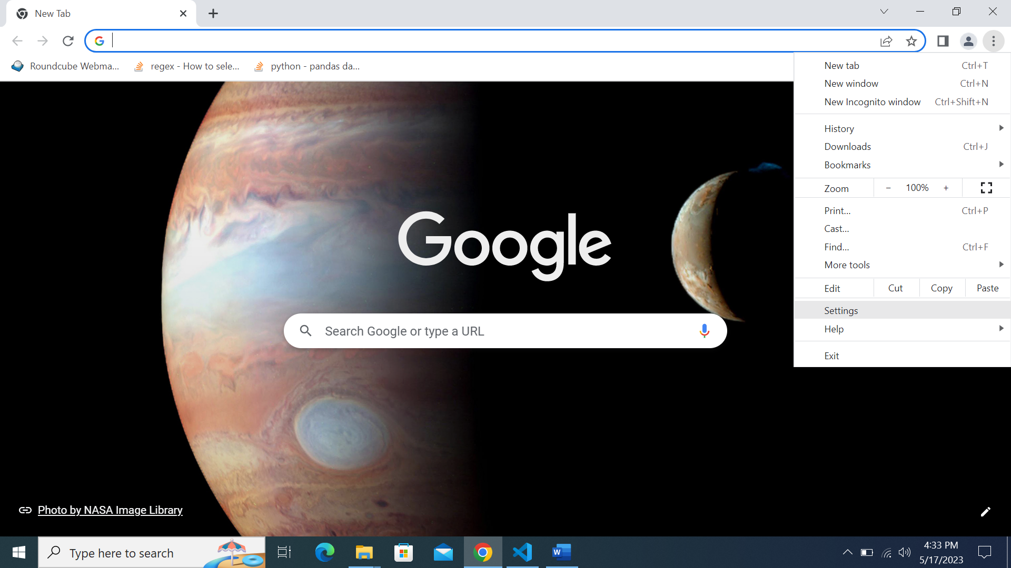

Click Settings

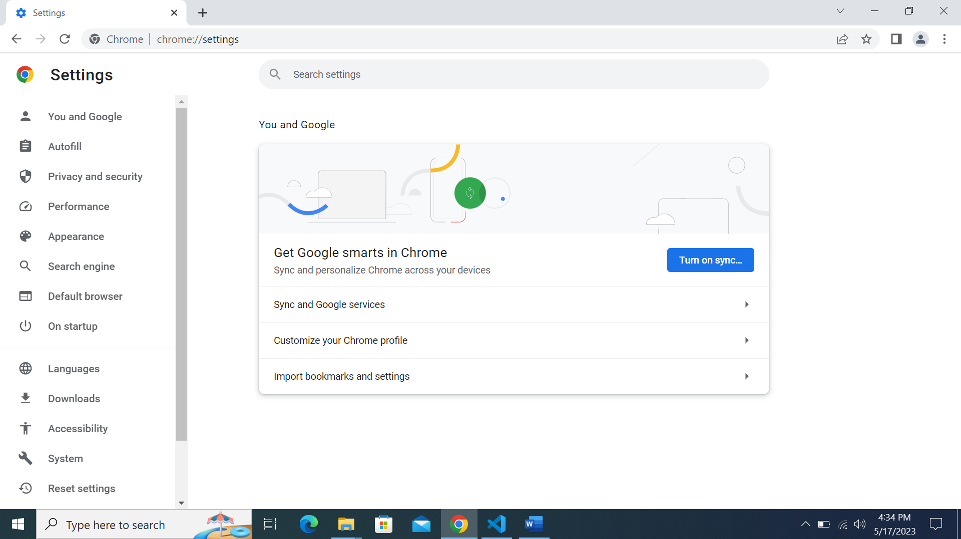

You should be directed to this page

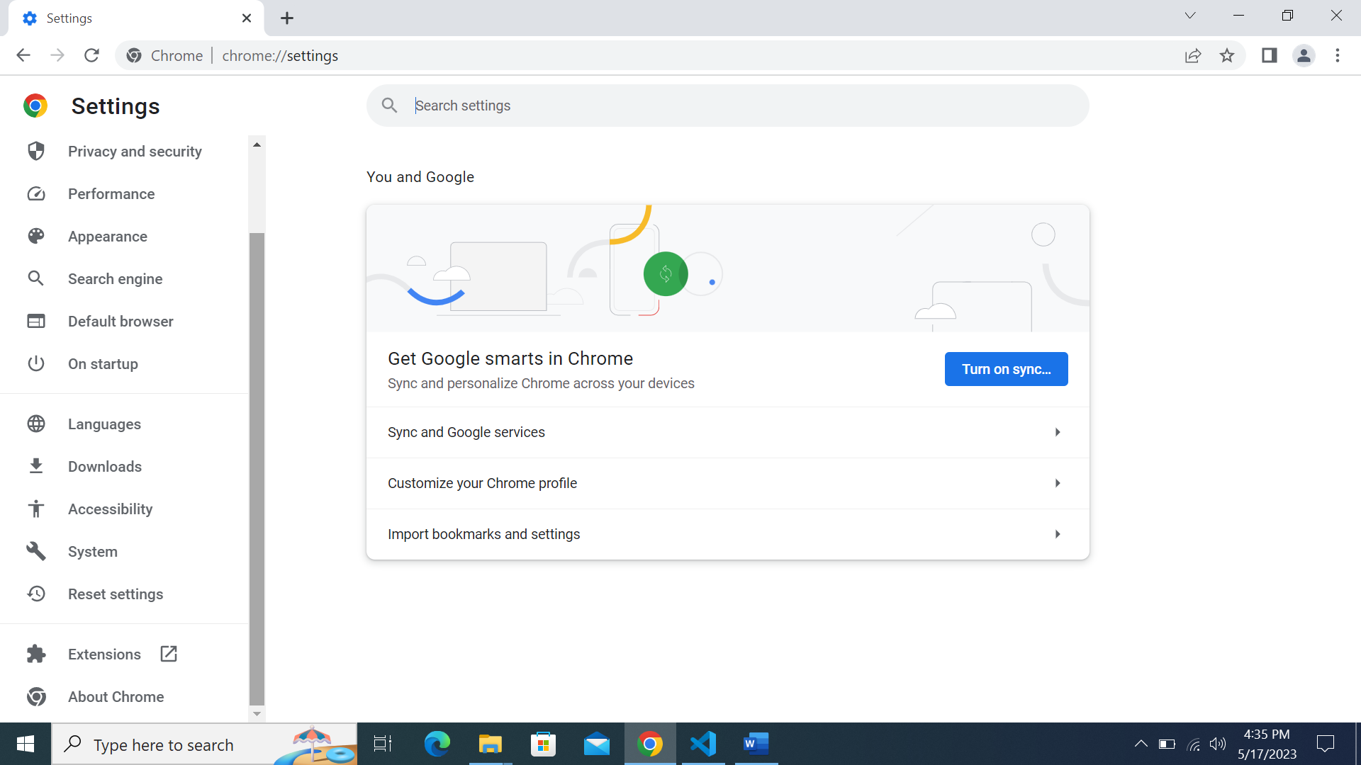

Scroll down using the scroll bar on the left

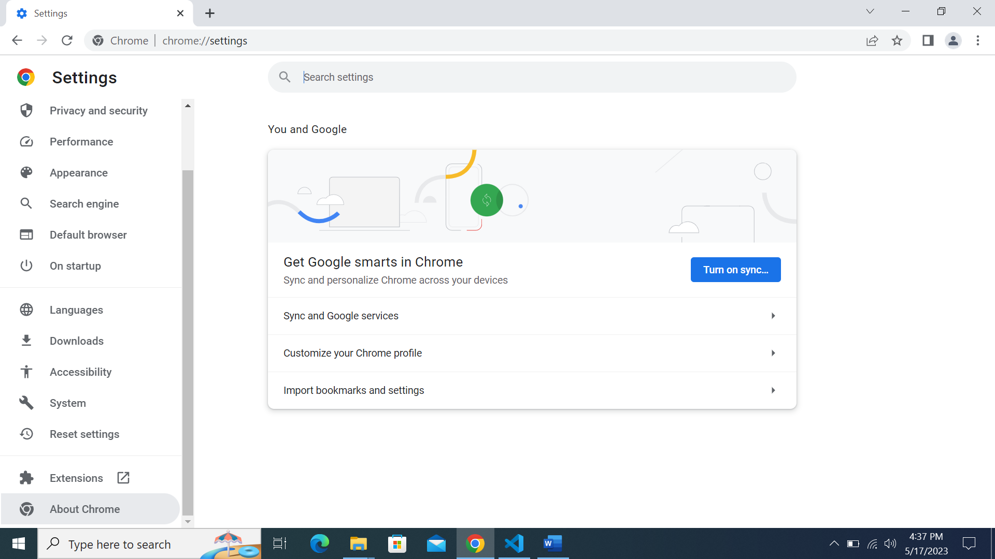

Click on ‘About Chrome’

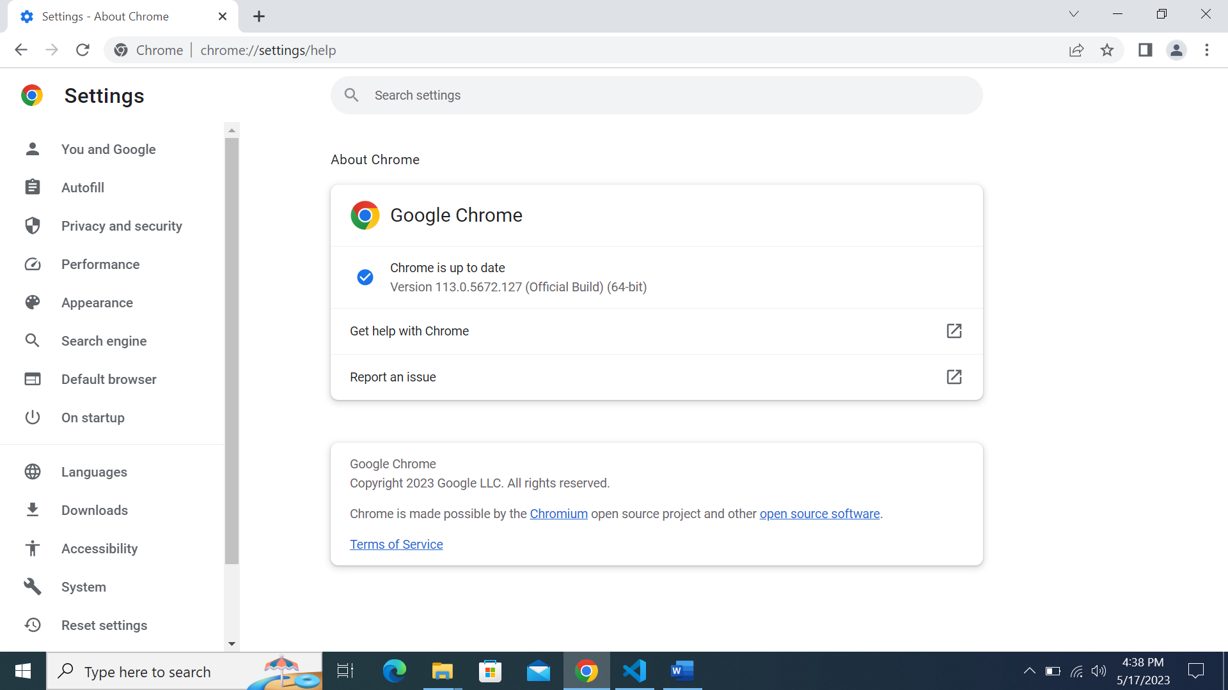

You should be brought to this page



Take note of the version of Google Chrome, which will be used later.

Only the major version number is required.

I.e., In this case, the version of Chrome we are using is 113.

# Installing Chromedriver

Head to the website below:

[https:/chromedriver.chromium.org/downloads](https://chromedriver.chromium.org/downloads)

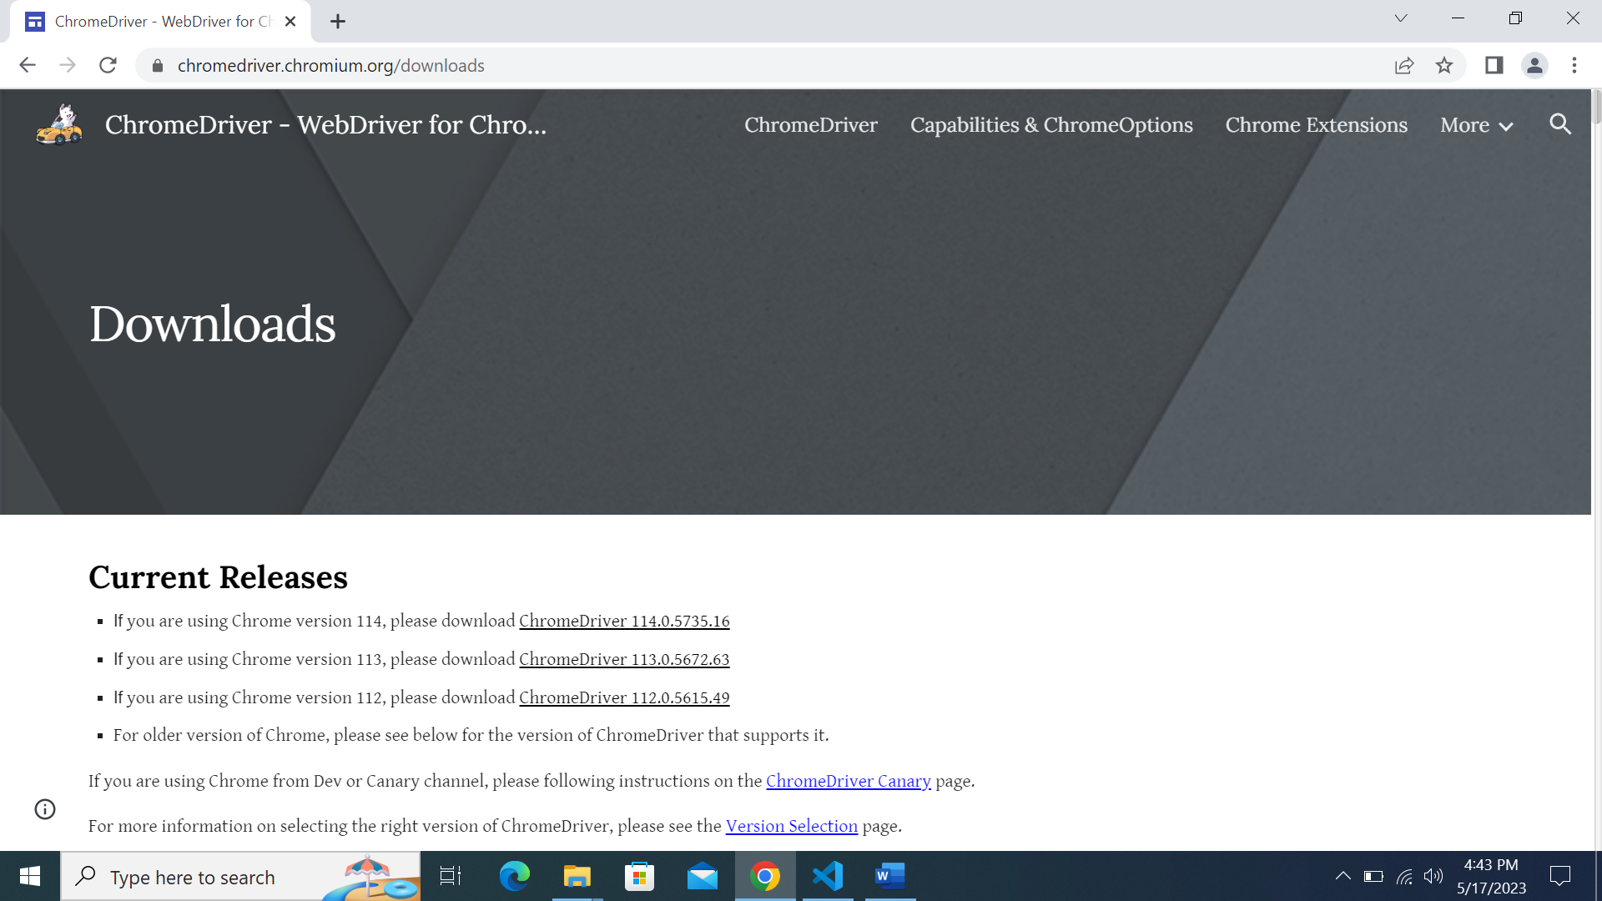

You should be led to this page.

If for some reason the URL has been changed, please Google Search ‘Chromedriver download’. It should be the first result displayed.



Remember the version of Google Chrome we checked earlier?

The version of Google Chrome will be used to download the corresponding version of Chromedriver.



In my example, I am using Chrome version 113. Hence, I will click on the Chromedriver for Chrome version 113.

Please download the corresponding Chromedriver w.r.t your Chrome version.

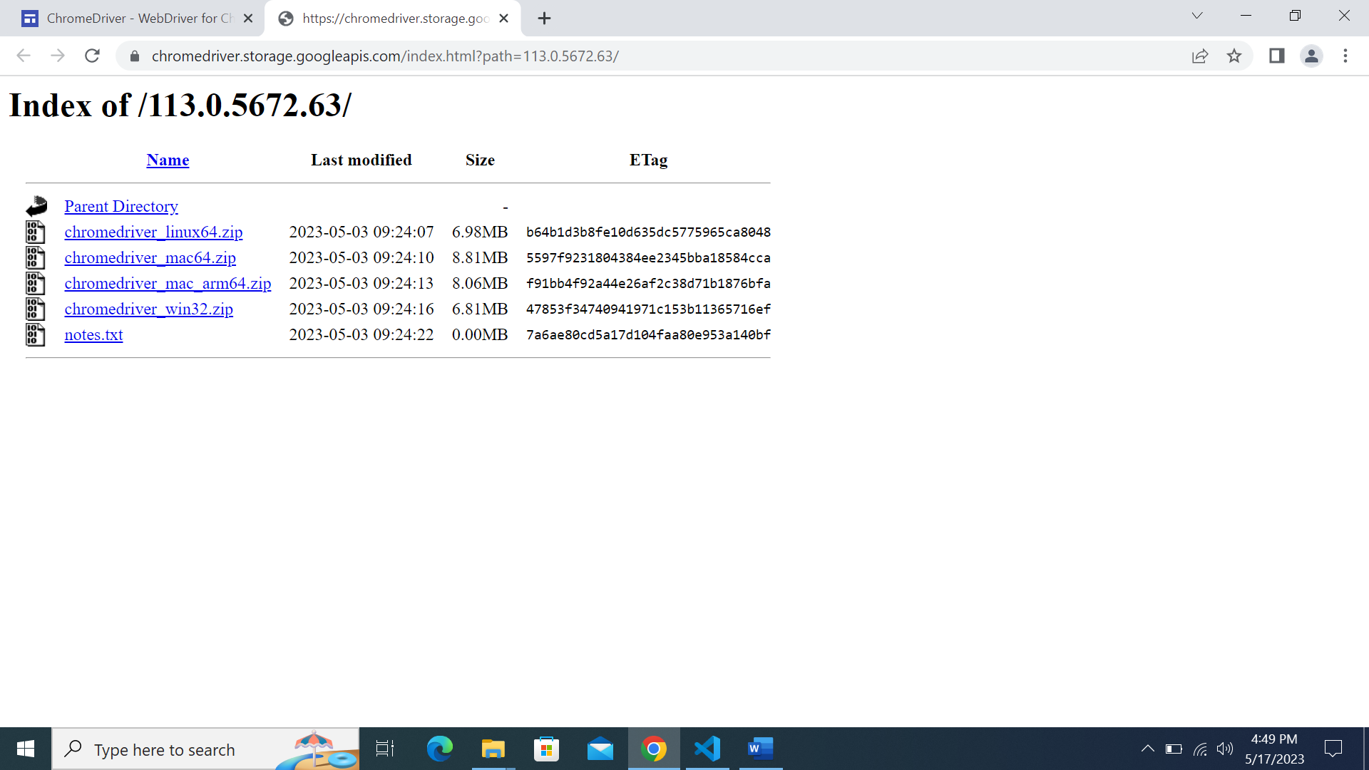

You should be brought to this page after clicking on the Chromedriver download link.

Take note that you are on the right Chromedriver version required.



Click on ‘chromedriver_win32.zip’.

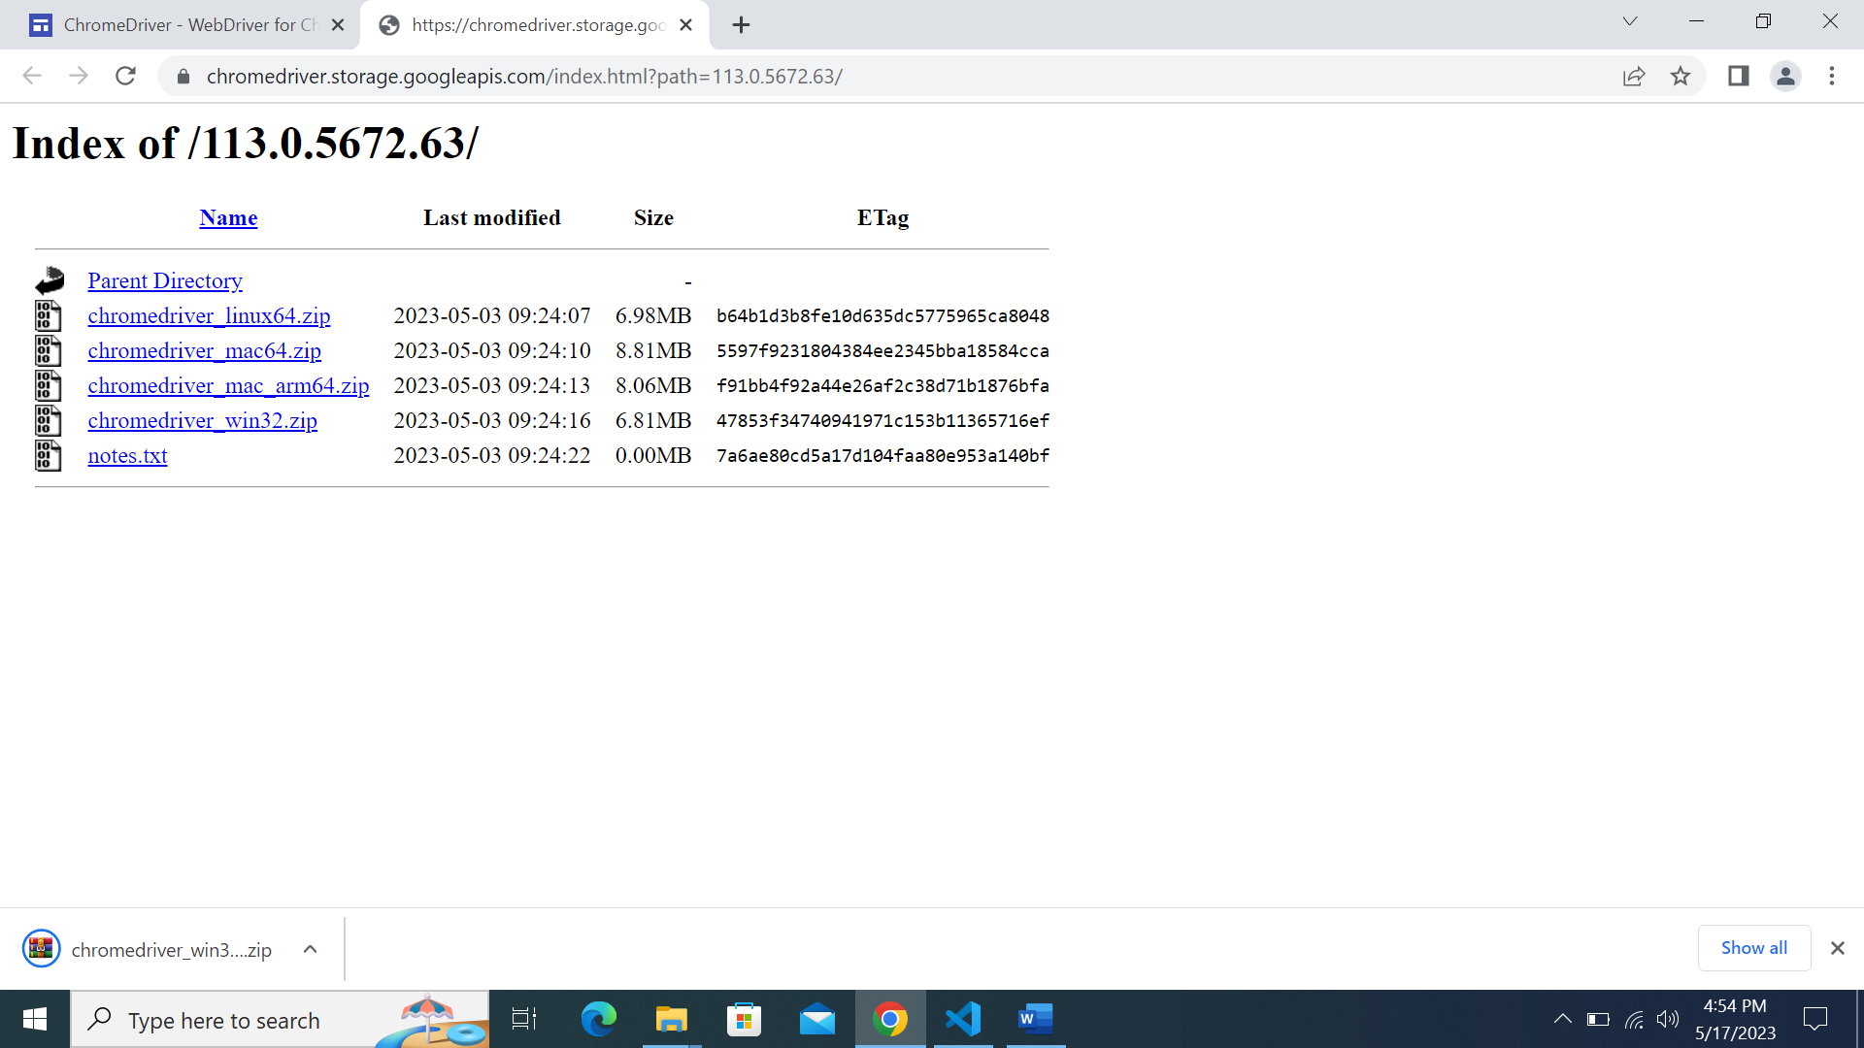

The download will begin automatically.

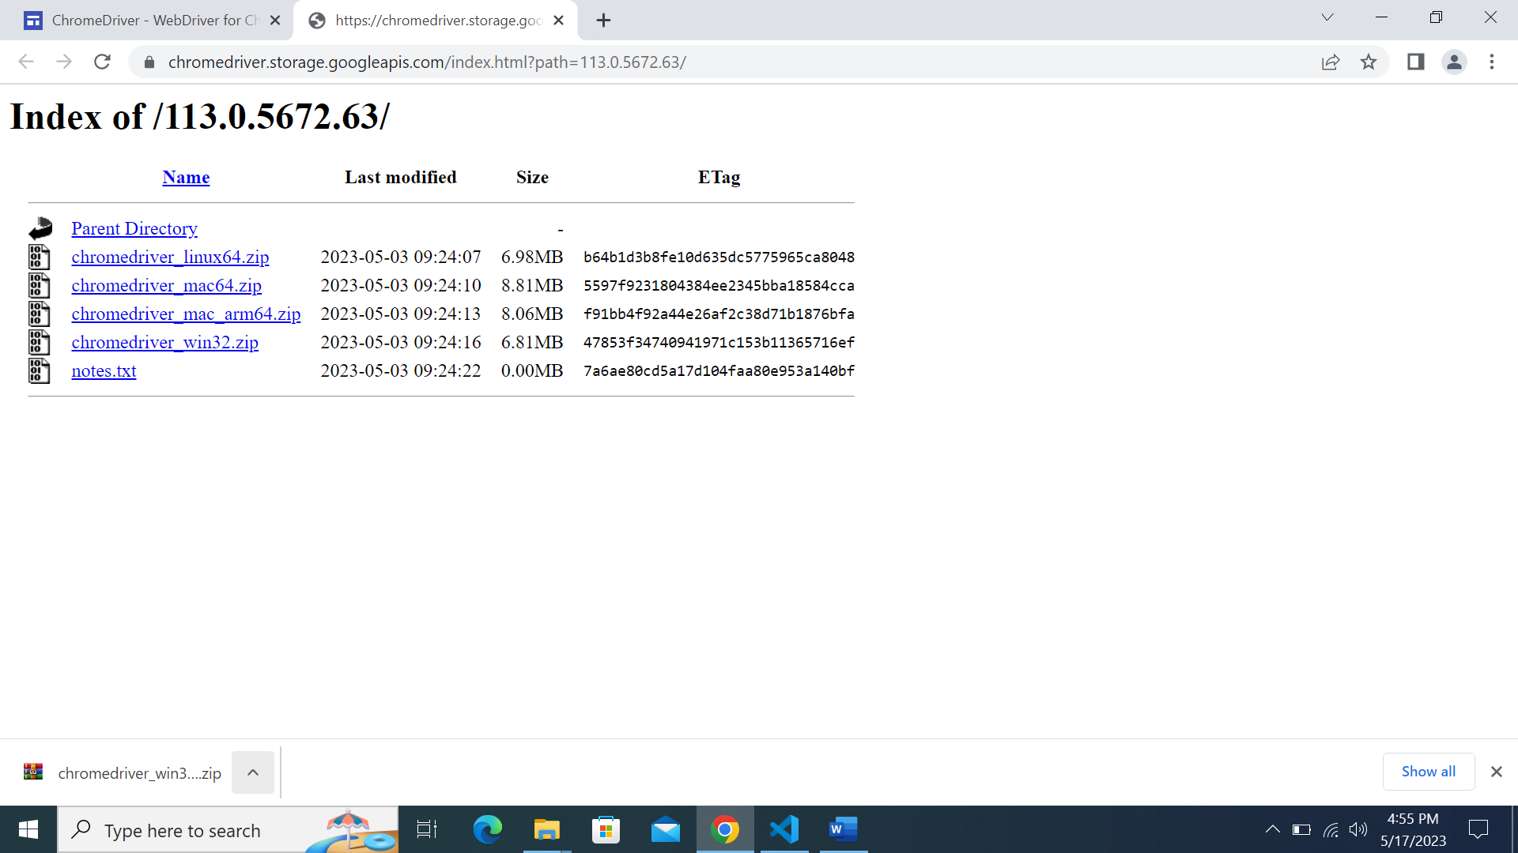

After the download finishes, click on the ^ button

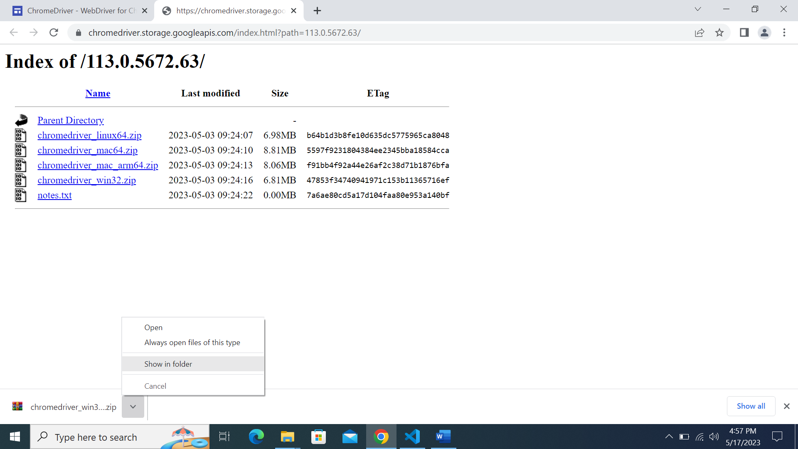

Click on ‘Show in Folder’ option

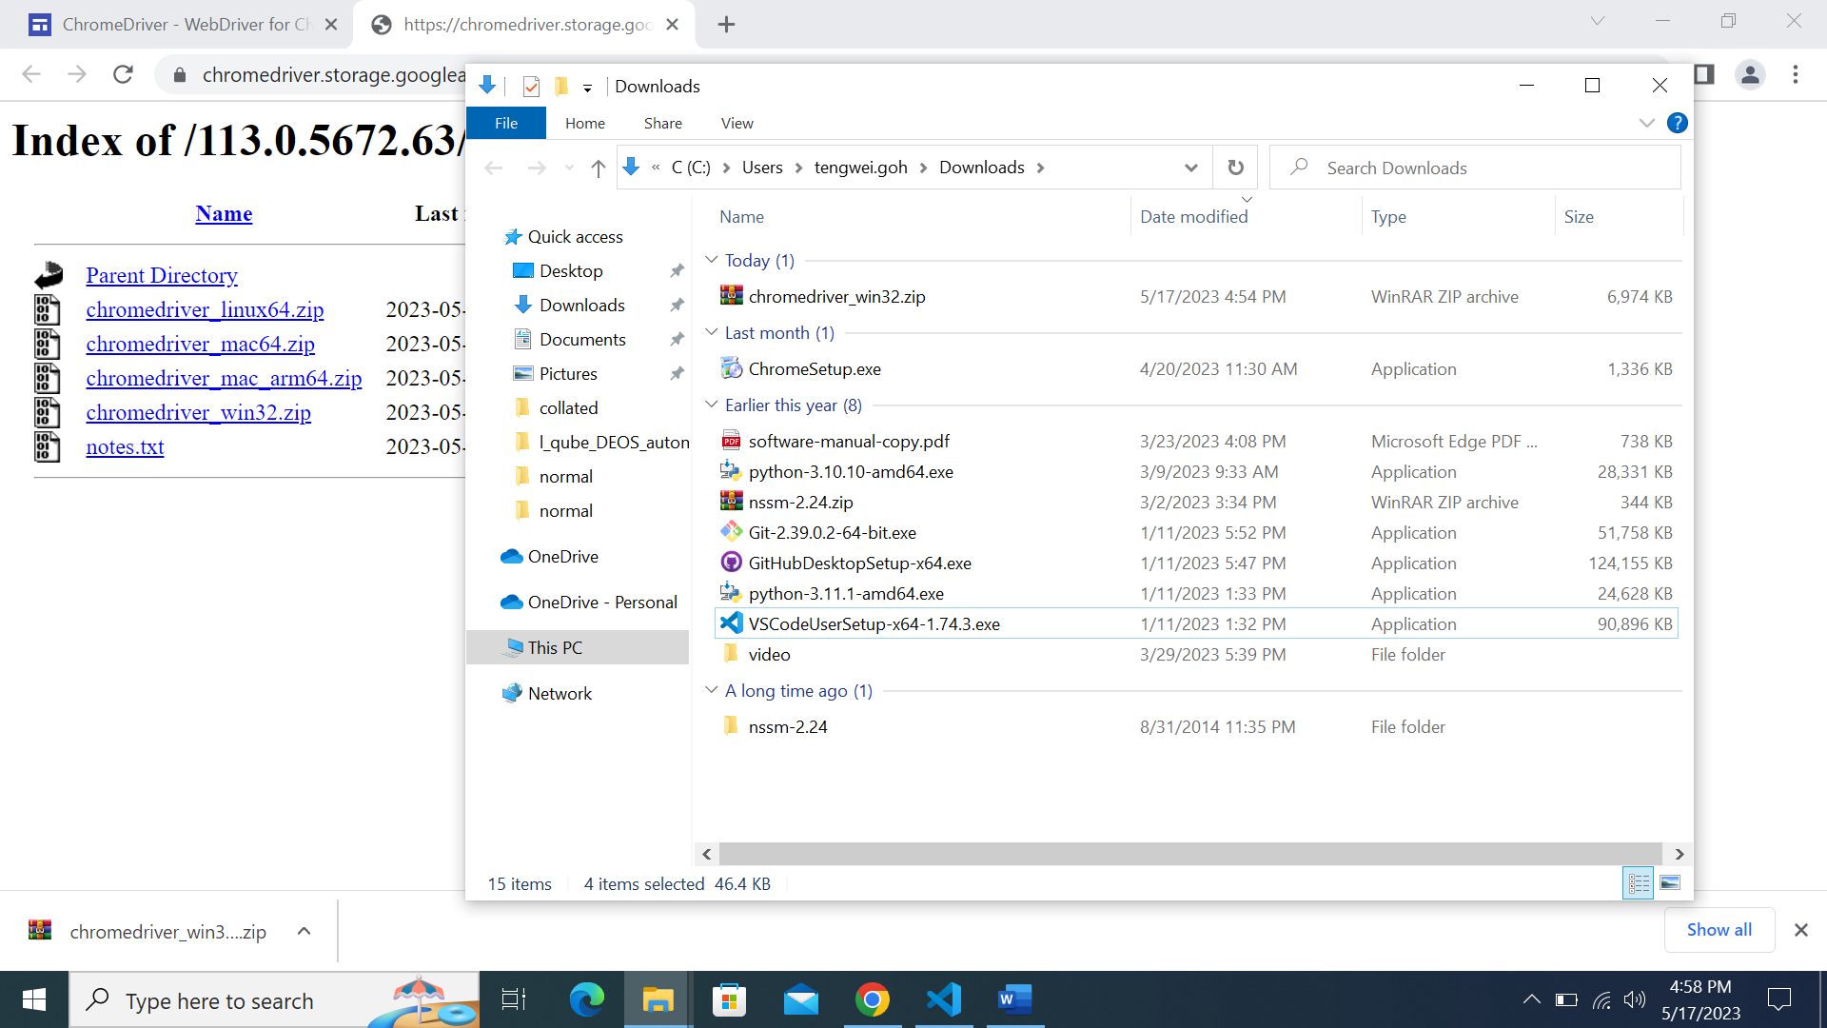

You should be brought to your Downloads directory with the downloaded chromedriver_win32.zip

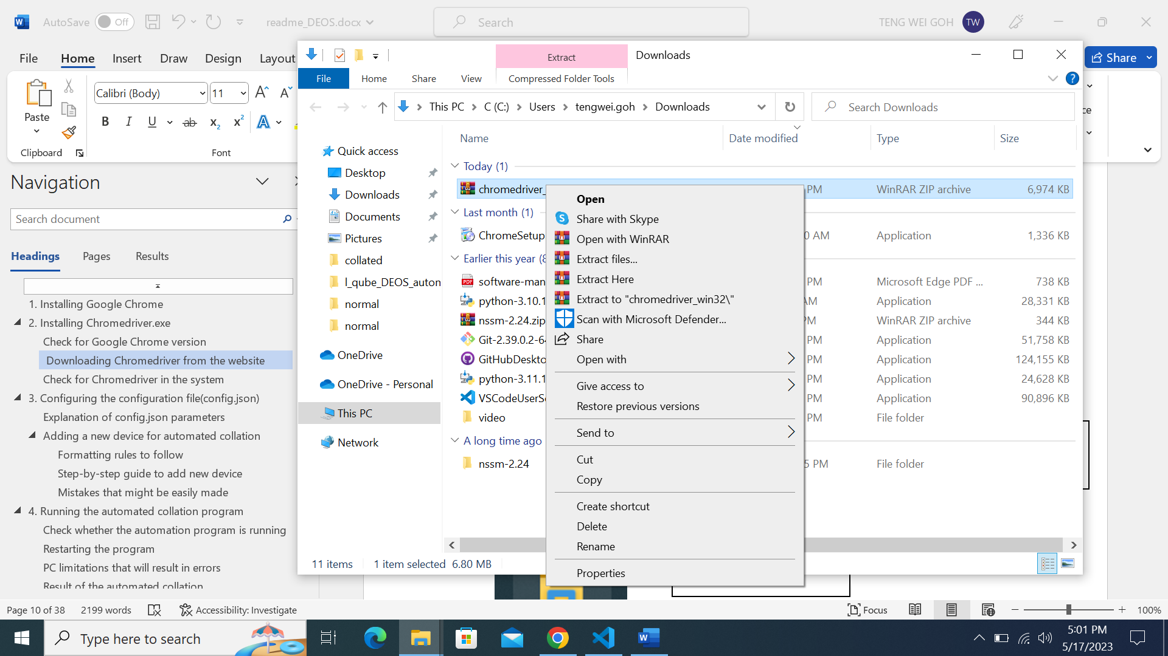

Right-click on the file

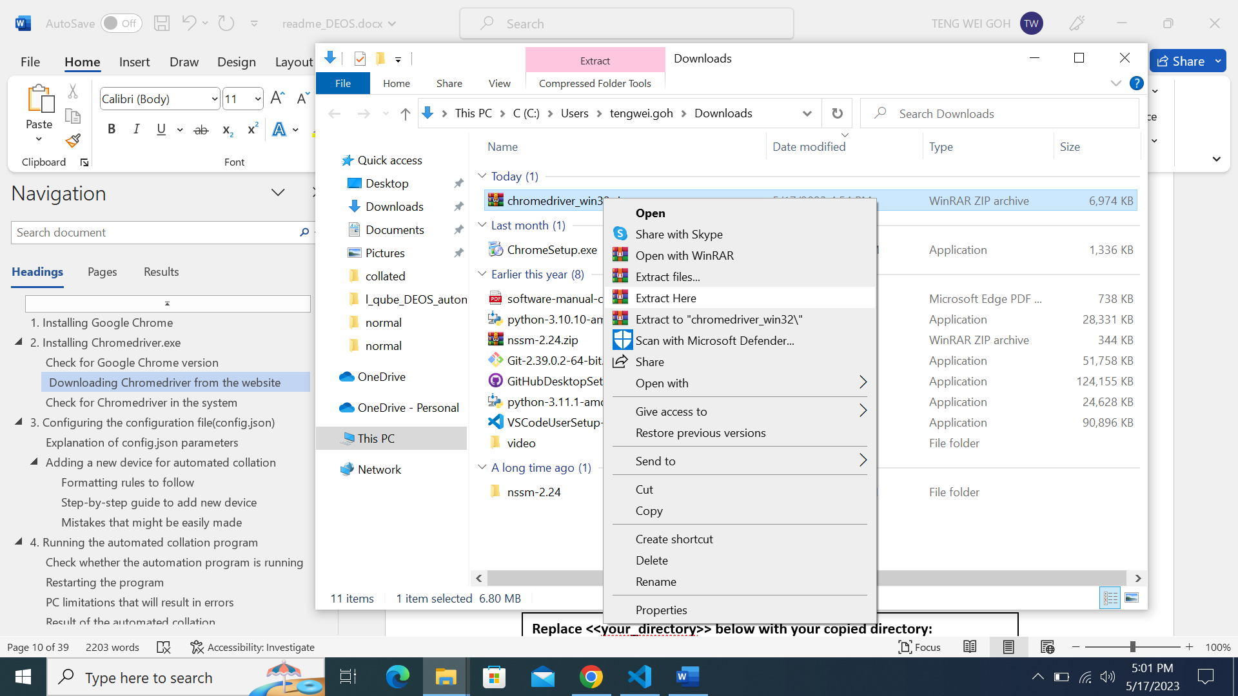

Click on ‘Extract Here’ option

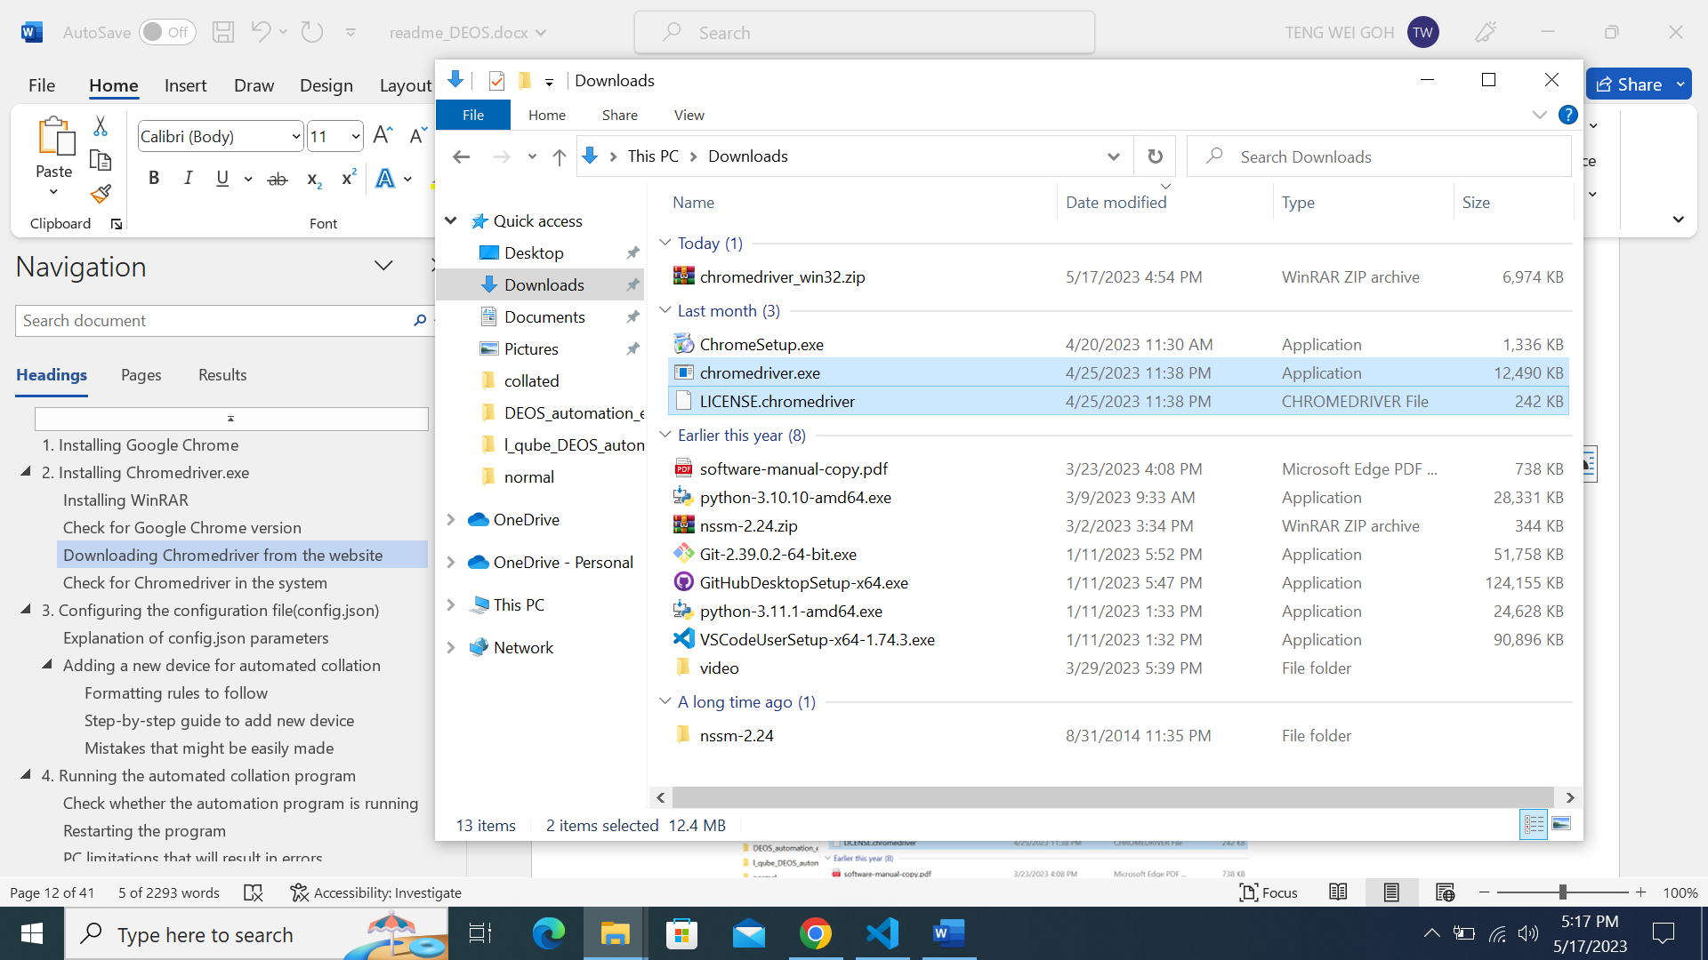

These 2 files should be extracted

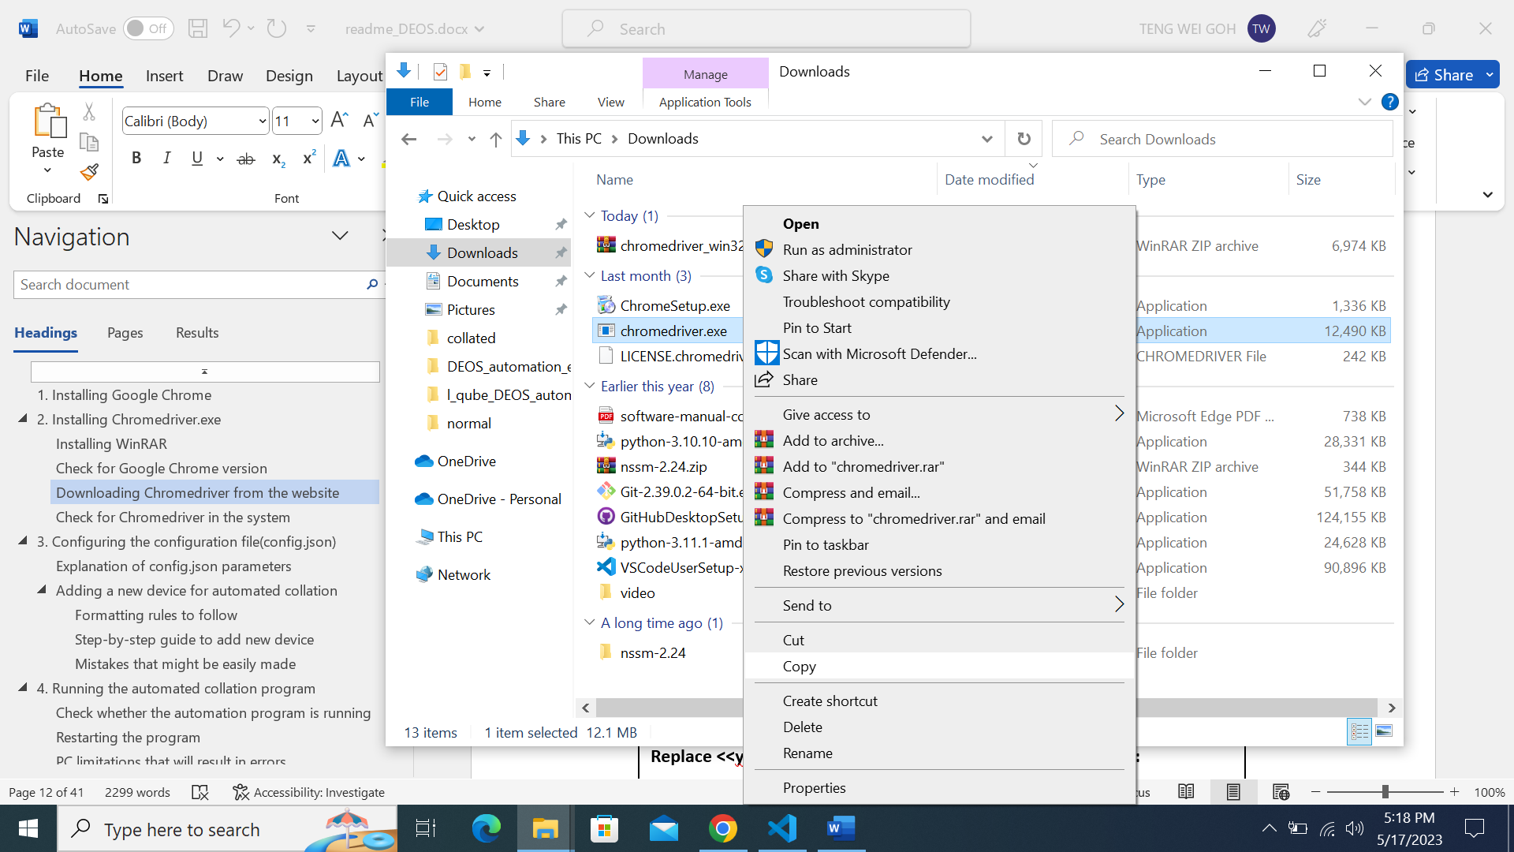

Copy chromedriver.exe: Right-click ‘chromedriver.exe’ file and click on ‘Copy option.

Or

CTRL + C

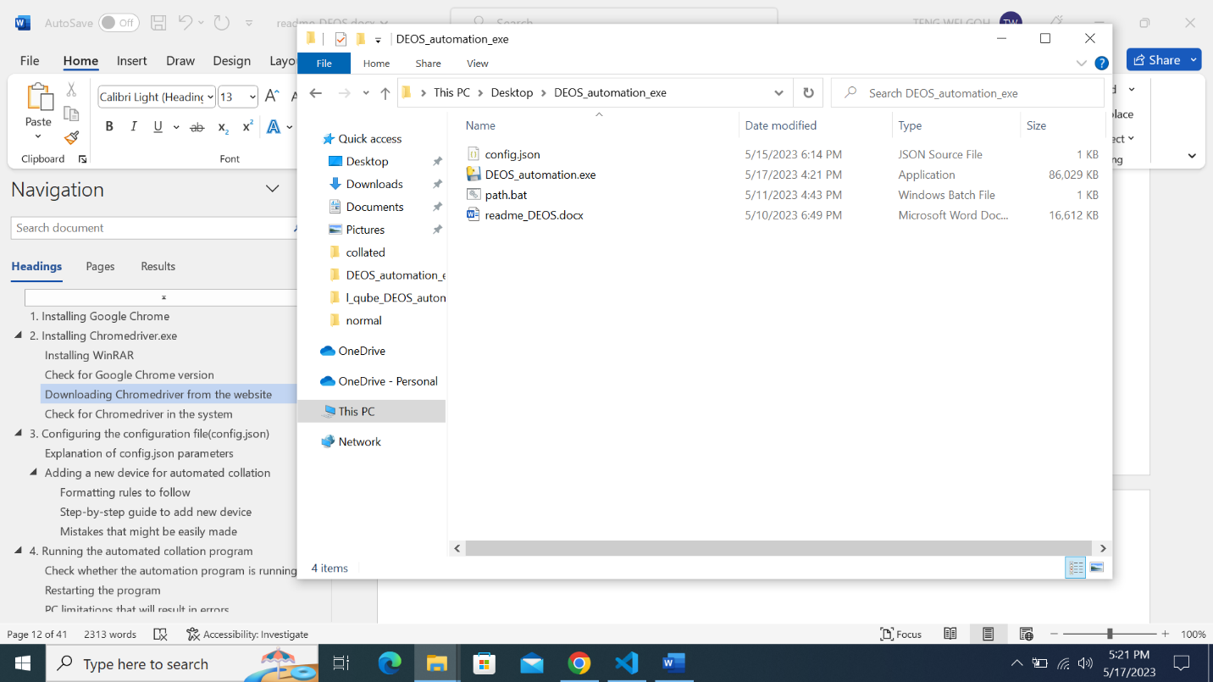

Navigate to the folder where the files are located

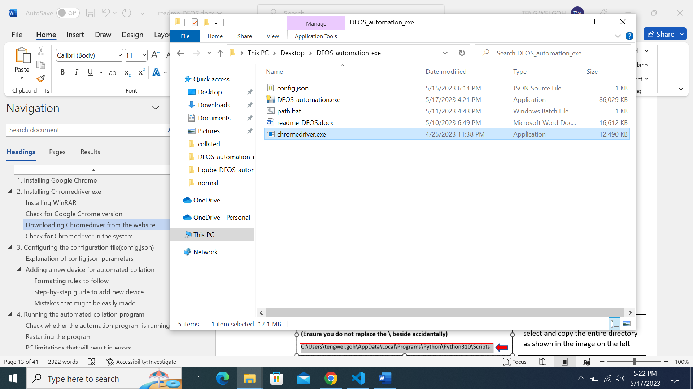

Paste the copied chromedriver.exe into the folder as shown and you are done for this step

## Check for Chromedriver in the system



2. Click on the Command Prompt App shown under ‘Best match’

1. Type in ‘cmd’ into the search bar on Windows

2

1

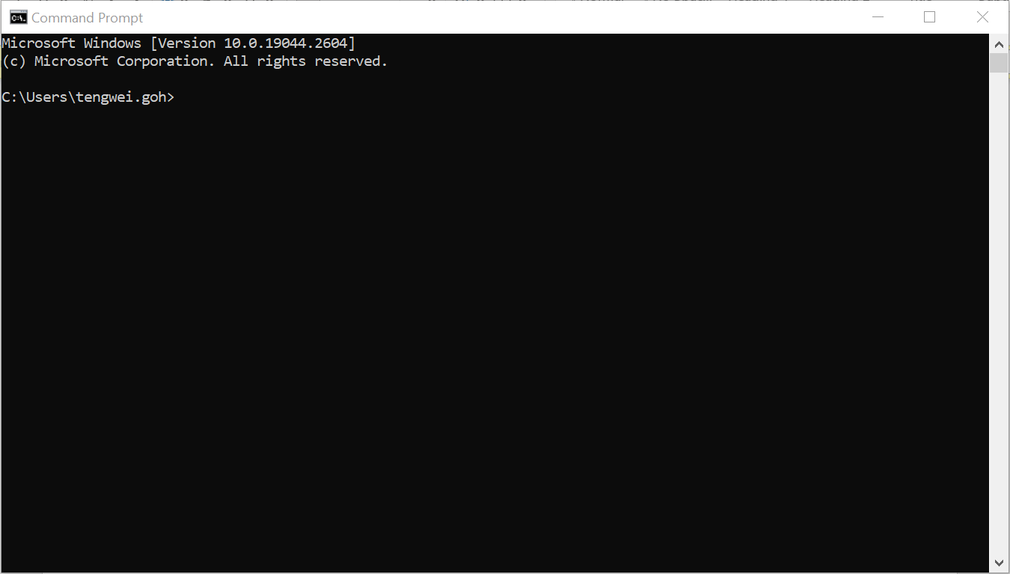

This terminal will show up once the Command Prompt App is Clicked

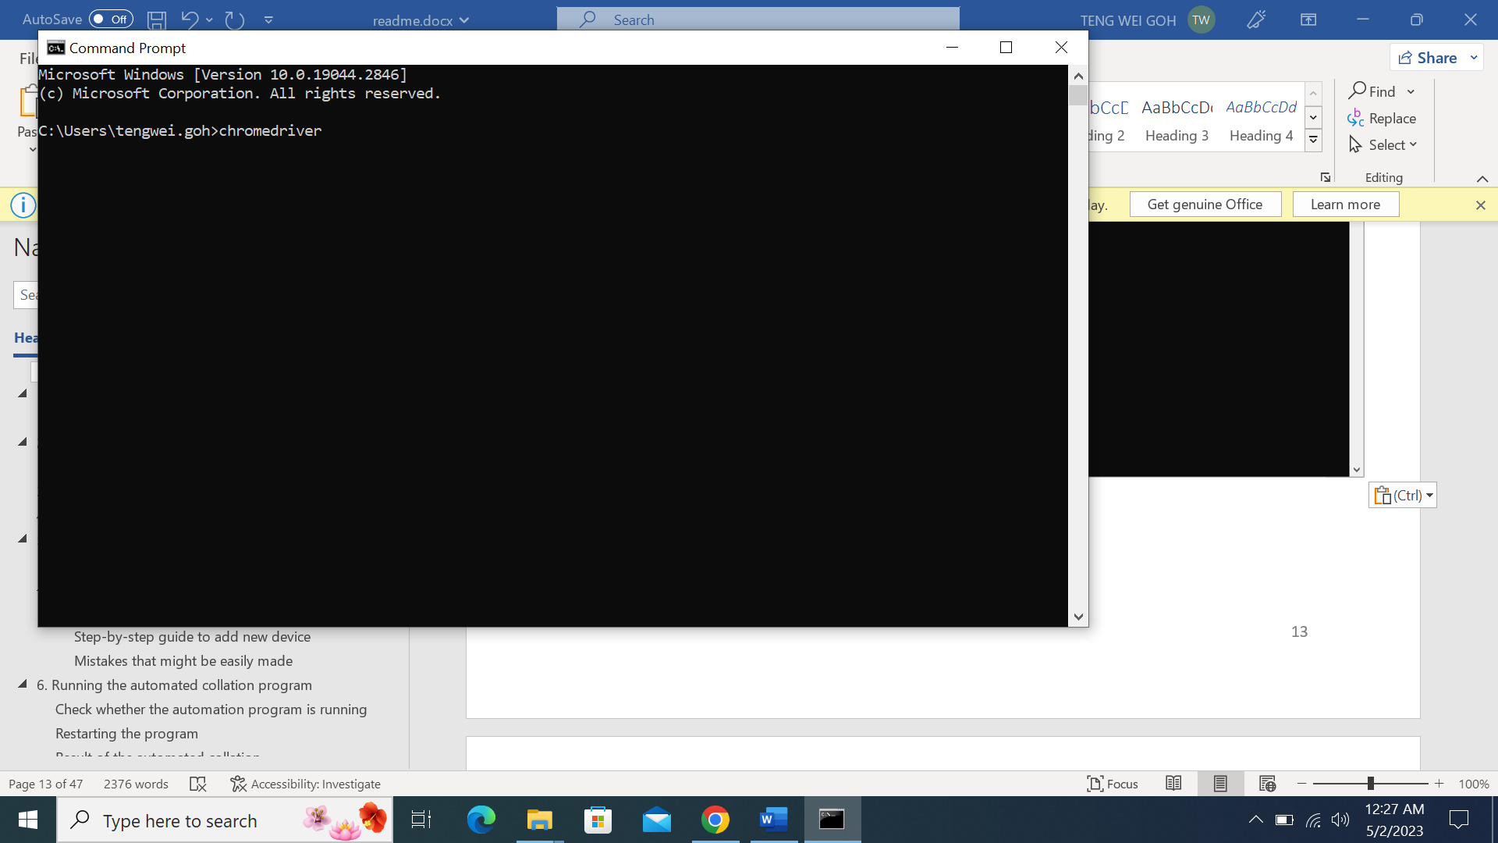

Type in ‘chromedriver’ into command prompt and press Enter

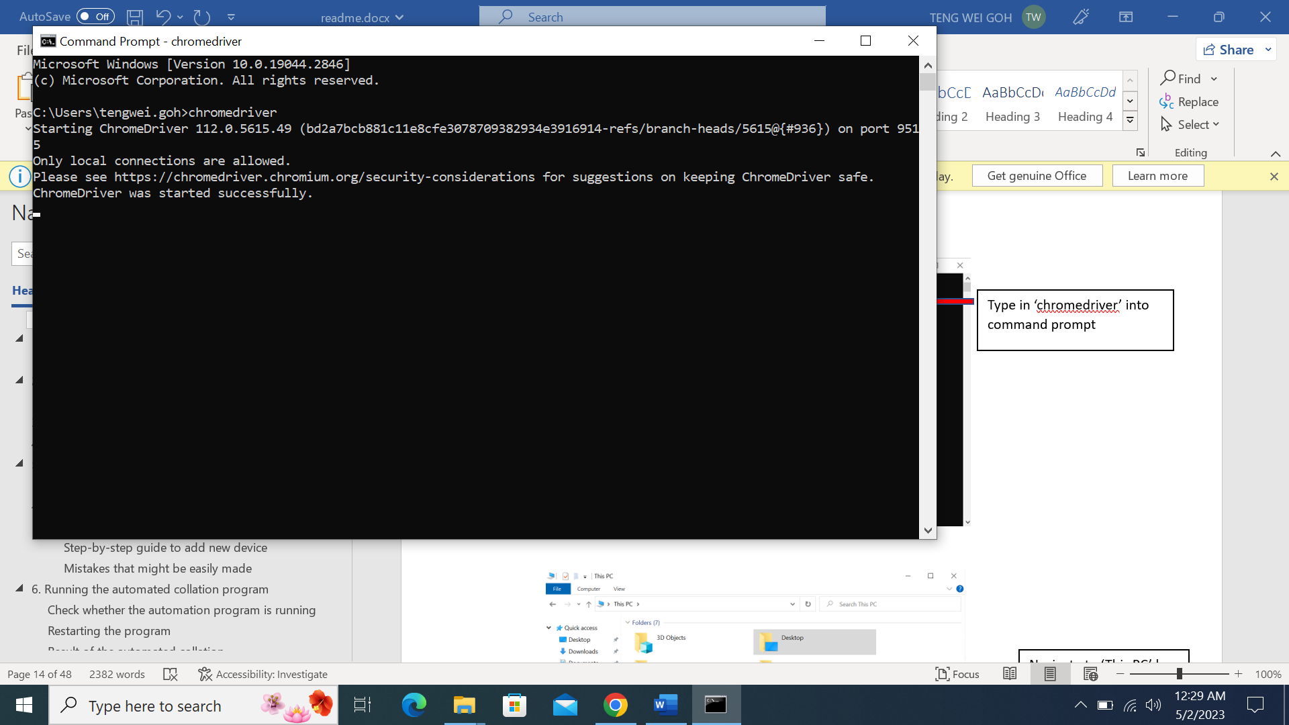

You should see the following message printed. This means that chromedriver has been successfully installed and you can close the command prompt and the file explorer.

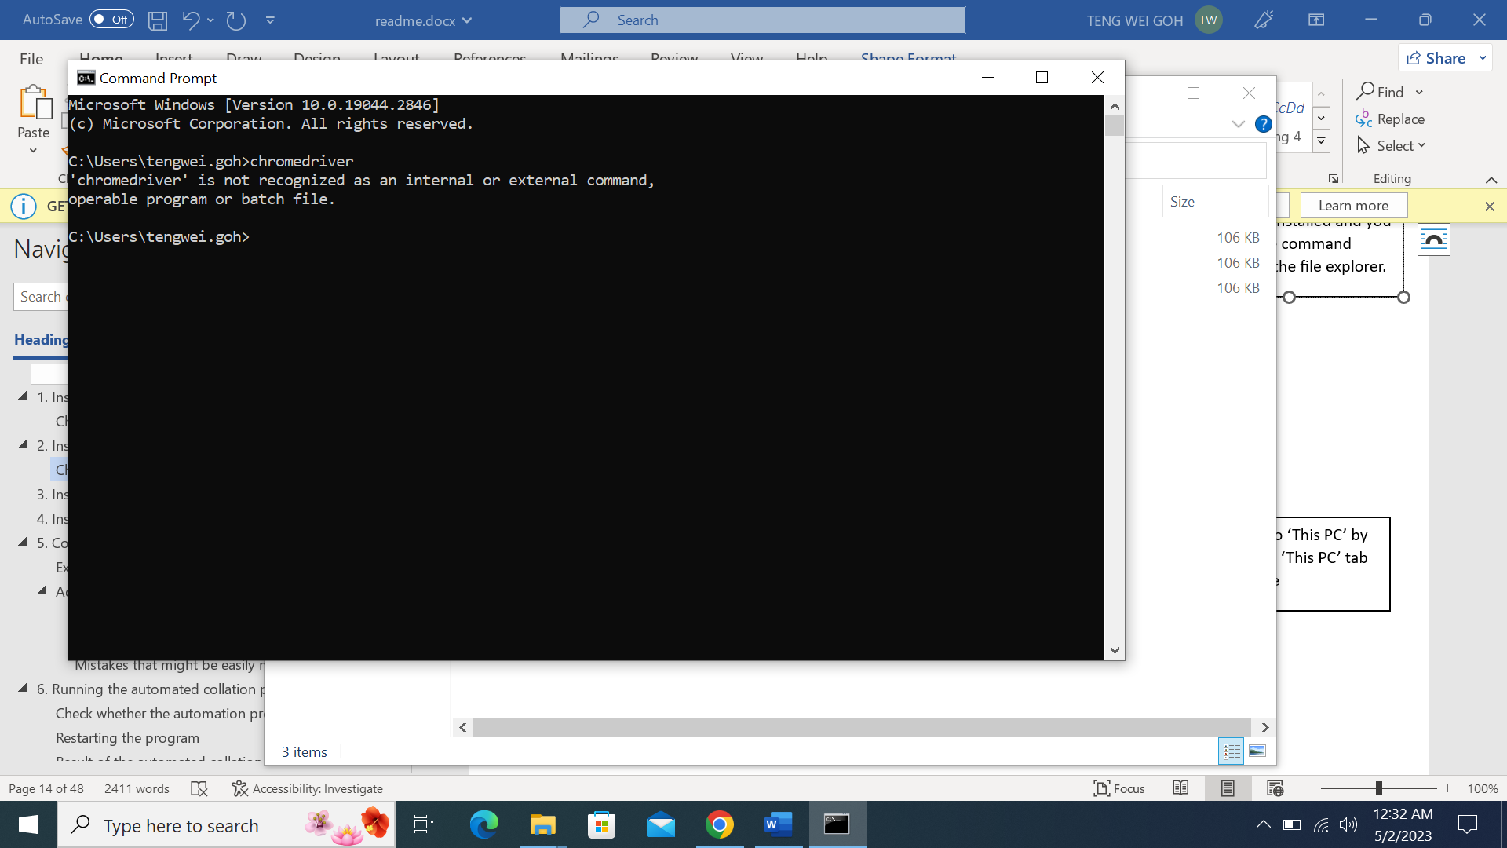

If the chromedriver.exe is not present in the directory set previously, then this message will be printed.

Please repeat the steps above to ensure chromedriver is successfully installed.

# Configuring the configuration file(config.json)

**You do not need the Internet for the rest of the steps in this readme. Feel free to disconnect from the Internet if you wish to.**

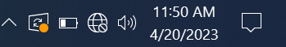

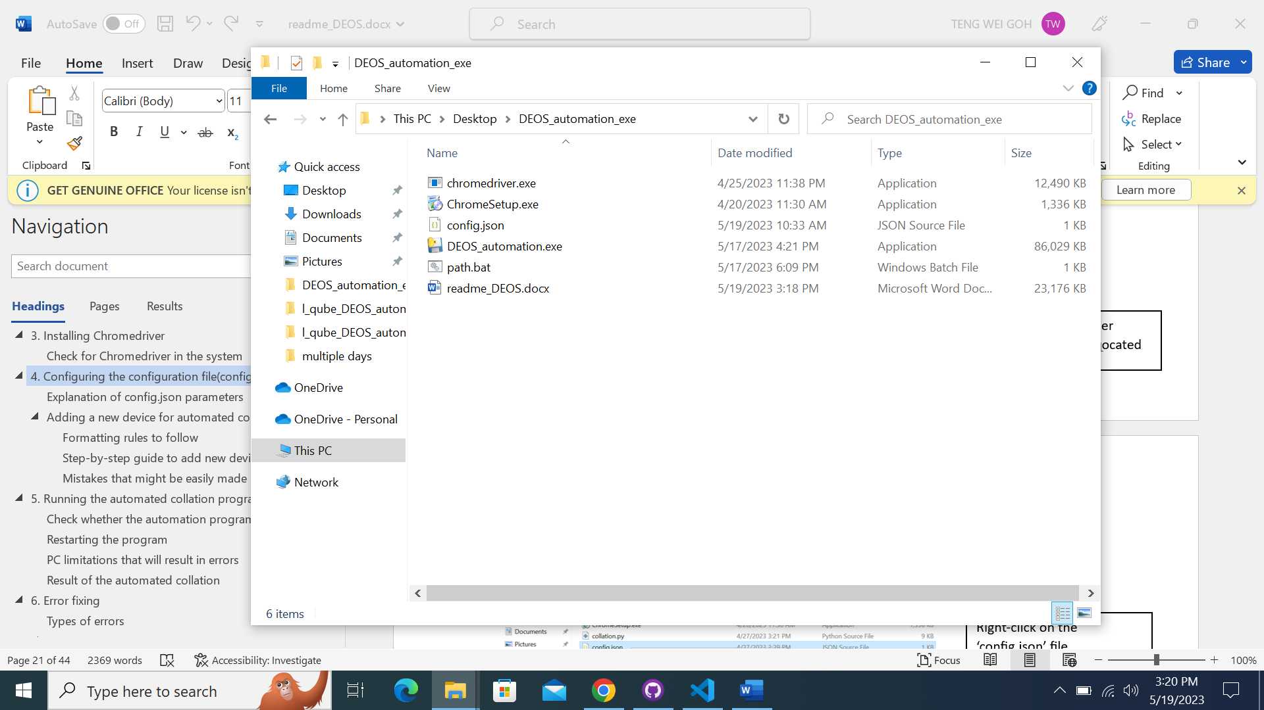

Navigate to the folder where the files are located

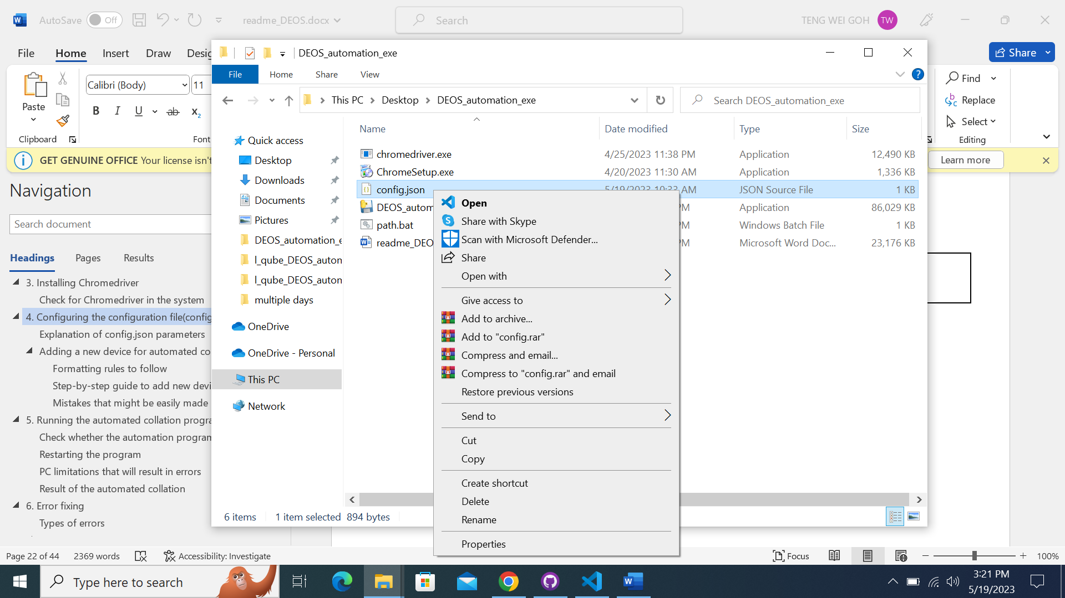

Right-click on the ‘config.json’ file

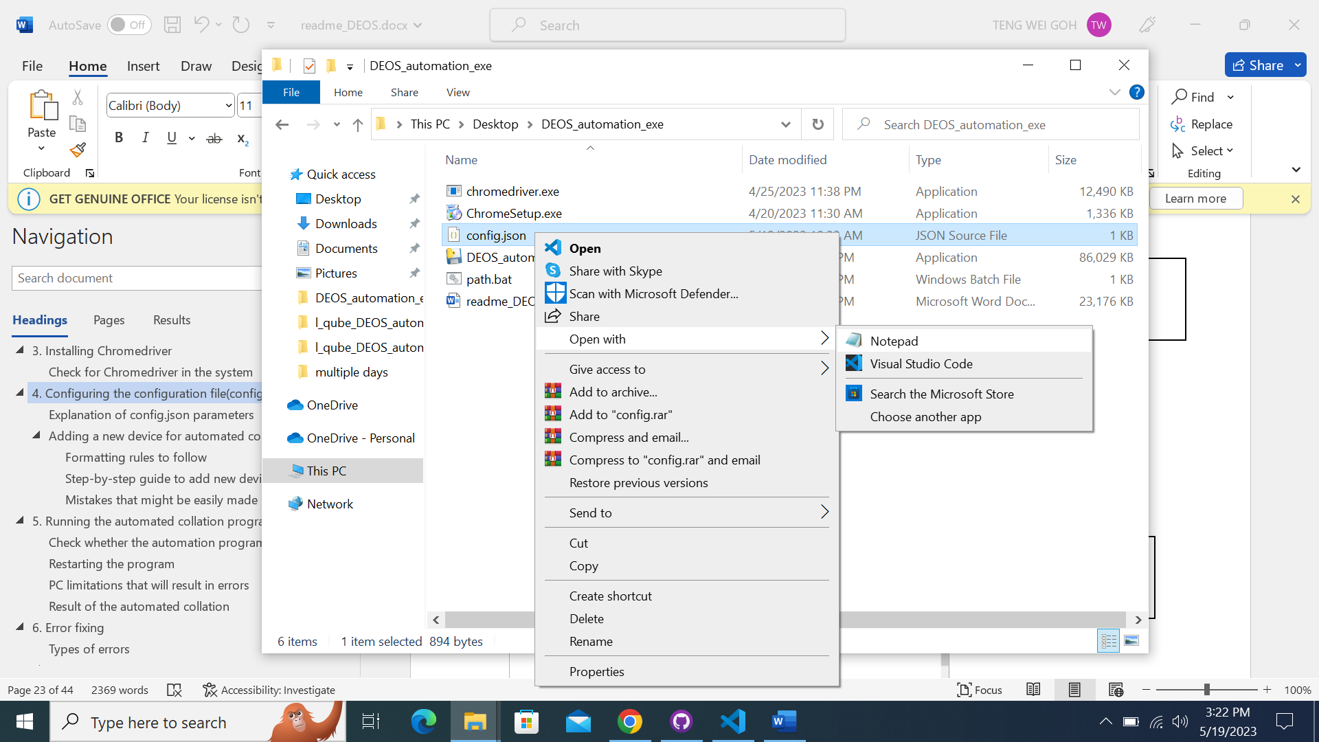

Navigate to ‘Open with’ option and click on ‘Notepad’

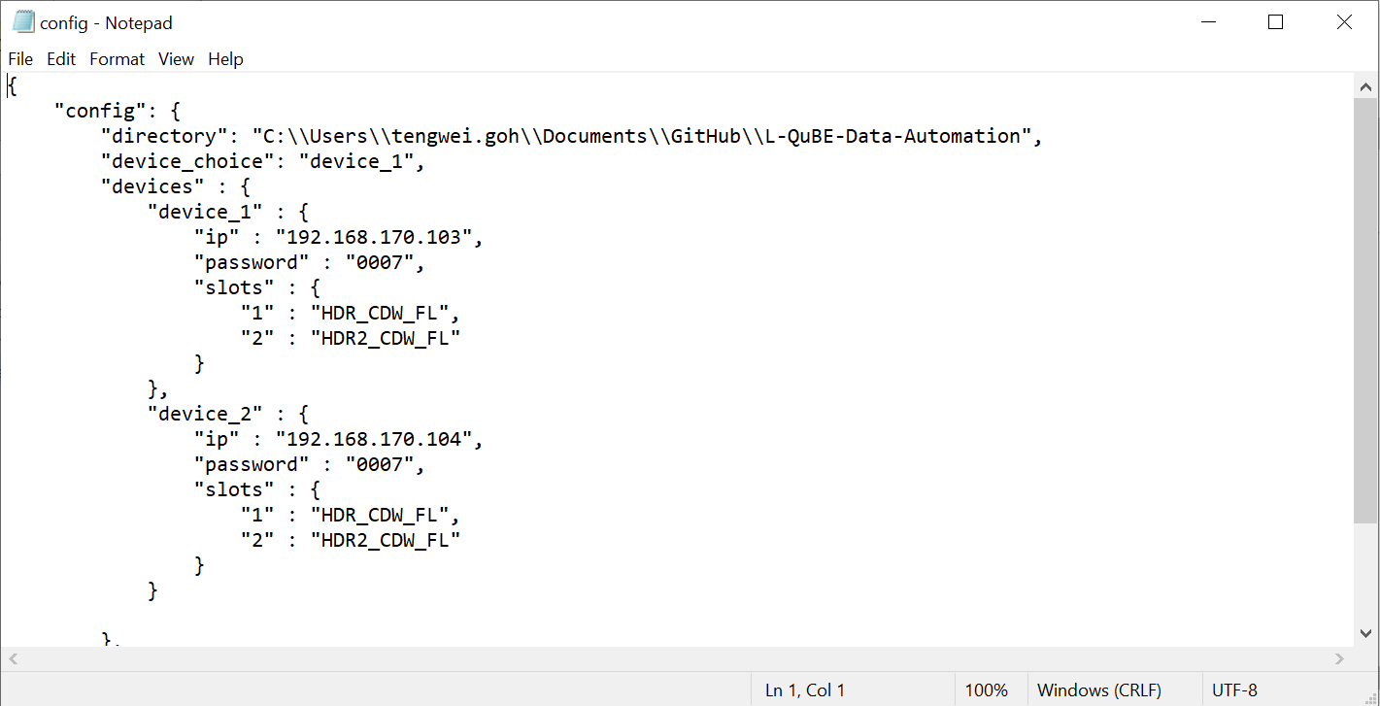

You should see this display after going through the steps above.

## Explanation of config.json parameters

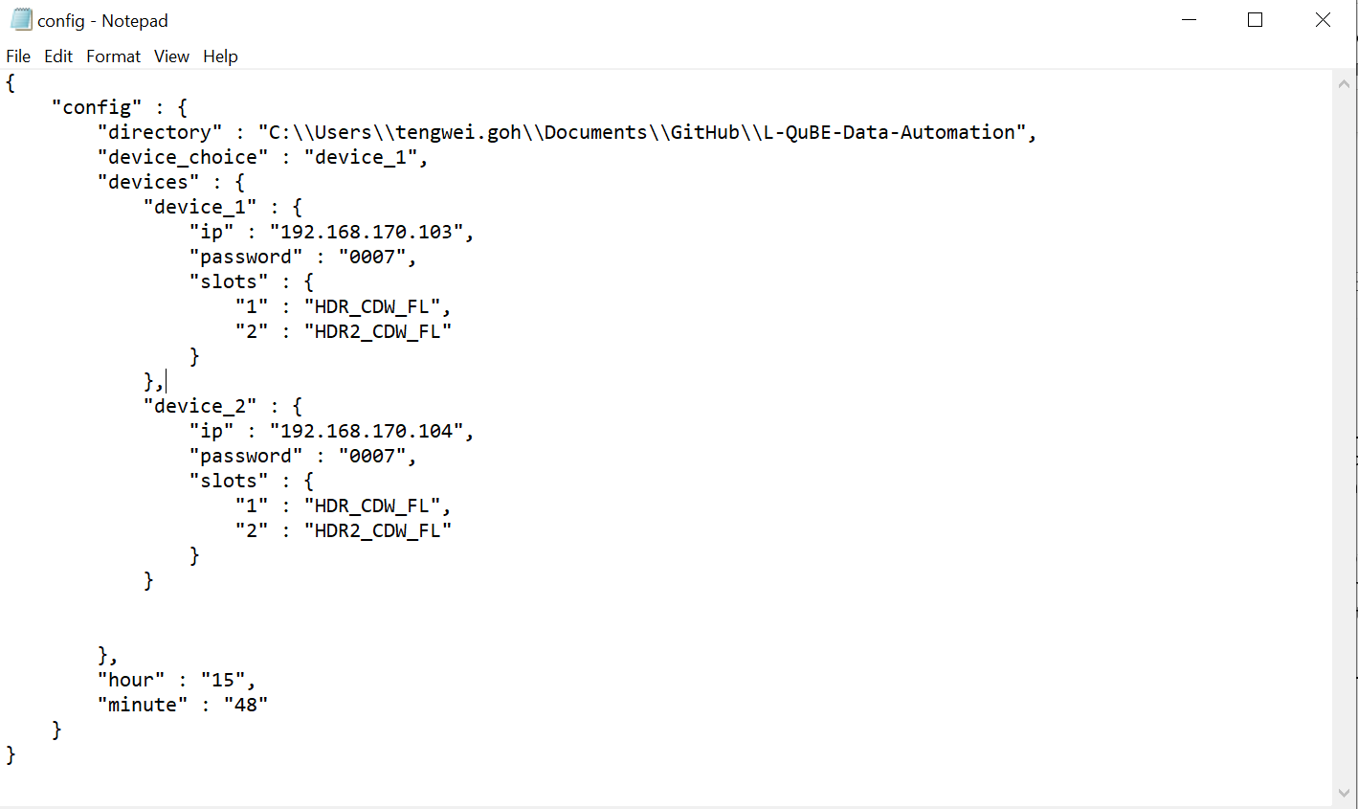

‘directory’ is the directory you would like the collated files to be in.

If the directory does not exist, the given directory will be created for the collated files to be stored in.

**ENSURE that the directory is separated with two \\ instead of one \**



‘device_choice’ is the device which you would like to select and collate specific slots.

This is irrelevant to the daily automation and will only be in use when you select the third option, ‘3. Choose specific slots to collate’



This is the parameter for the configurations of the training devices.

Input the IP address, password and specific slots you would like to collate everyday accordingly.

If there are no slots you would like to collate, you can leave it empty.

**Ensure that the slot name is exactly the same as what is shown in the trend export page of the DEOS training device.**

I will show you how to add a new device below.



“hour” and “minute” is the time when you would like the automated collation to occur.

The “hour” value has a 24hour format.

Range of value for hour: 0 – 23

Range of value for minute: 0 – 59

Advisable to run the automation at a time when no one is using the system, i.e.

“hour”: “03”,

“minute”: “00”

This means that the automated collation will run at 3:00 am every day.

## Adding a new device for automated collation

### Formatting rules to follow

1. Ensure there is **a comma after the closing curly bracket for the previous device**

2. Ensure **every parameter is opened and closed with “ (double quotation)** and not ‘ (single quotation)

3. Ensure **there are commas** after the value for “ip” and “password”

4. If you do not want to choose any specific slots to download daily, **leave the values for the “slots” parameter empty**. Else, follow the format for the “slots” parameter in previous devices.

5. Ensure **there are NO comma** after the closing curly bracket for the **last, final device added**

6. Ensure there is no comma after the last slot added.

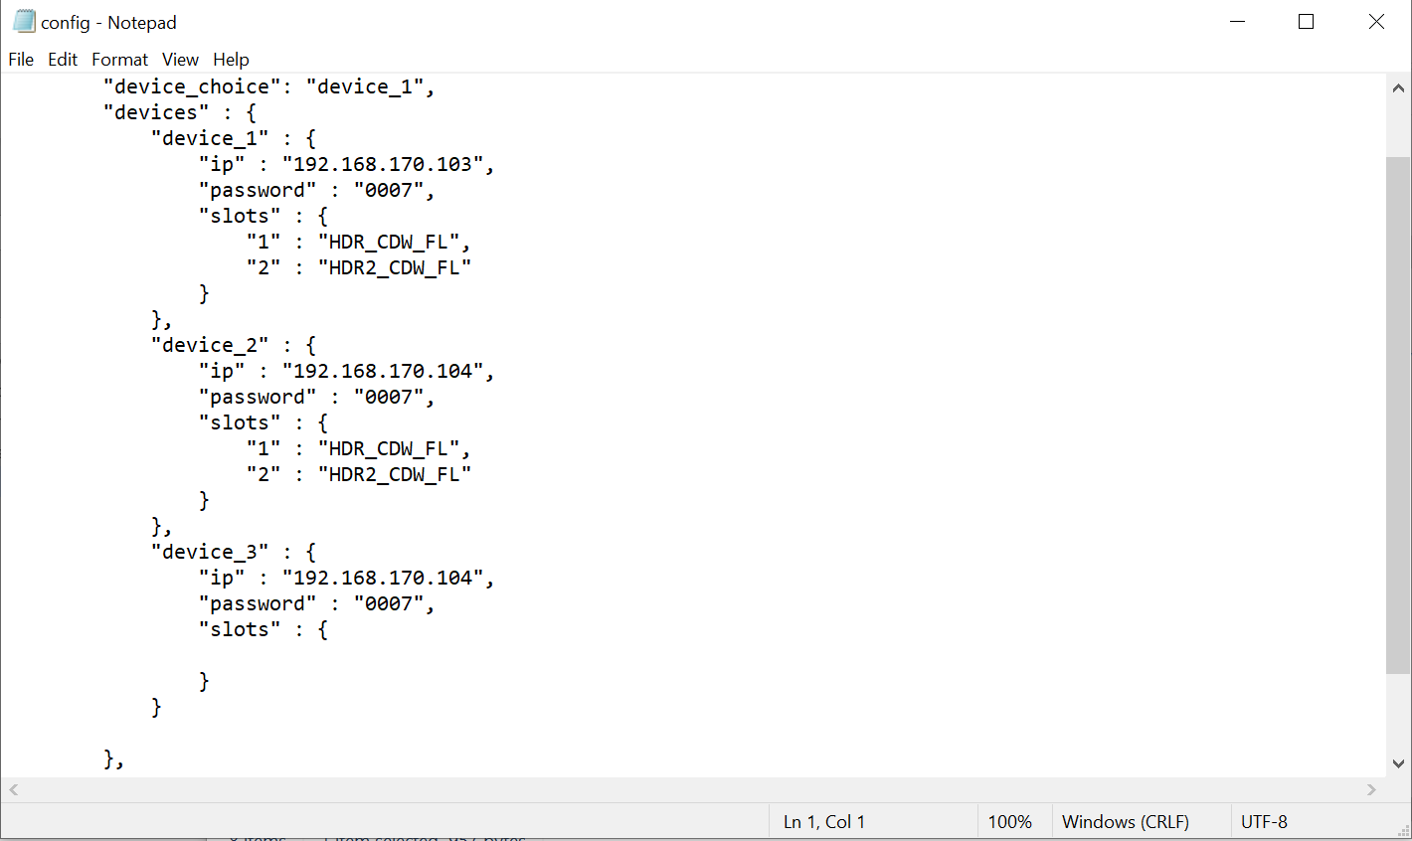

6

4

5

3

2

1

### Step-by-step guide to add new device

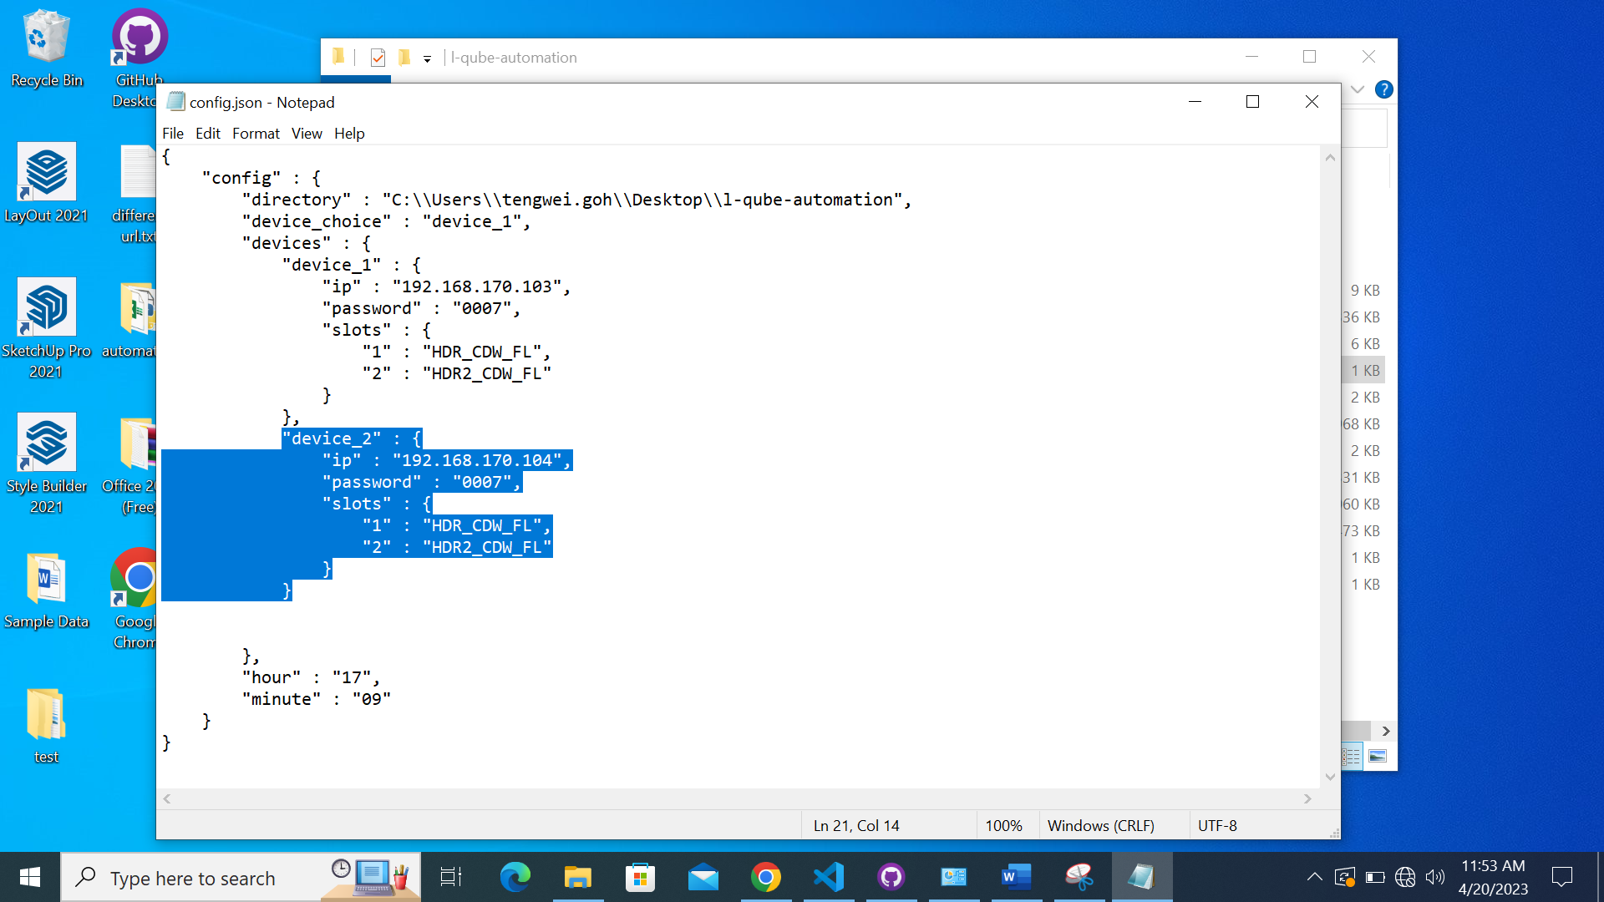

1. Select the configurations for device_2 as shown in the image.

2.

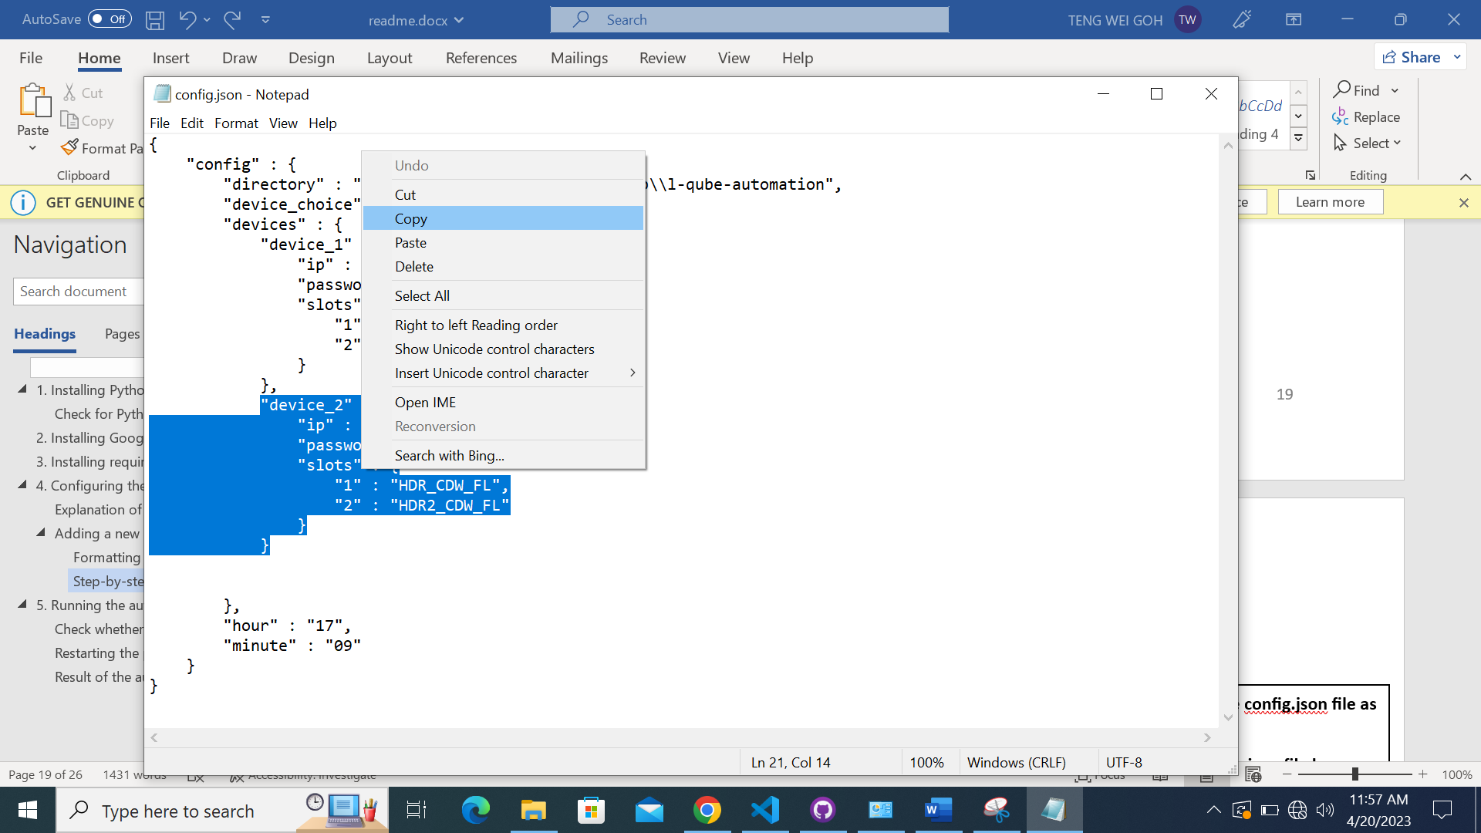

2. Right-click the selected portion and click ‘Copy’. (Or you can press CTRL + C)

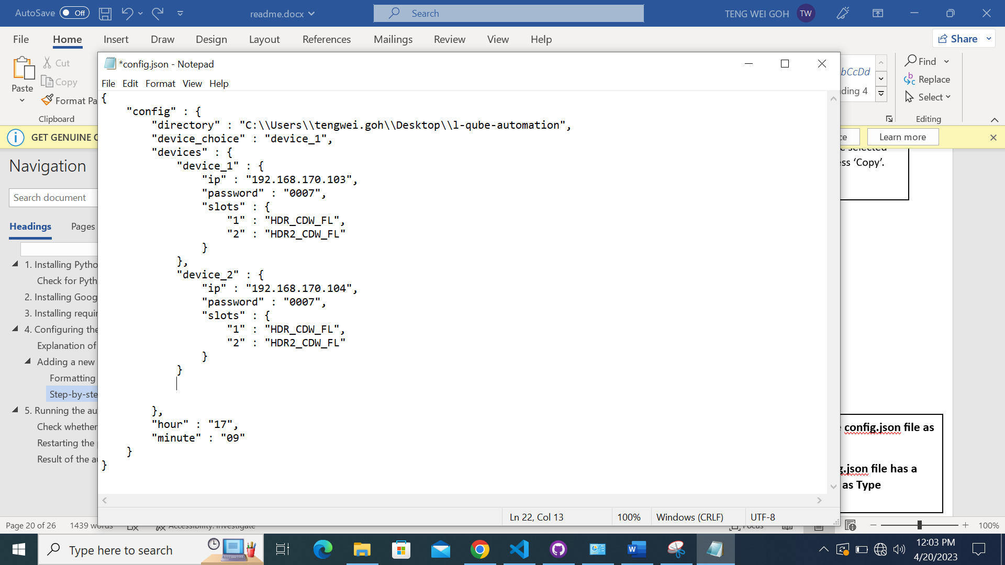

3. Click the space below the curly bracket. Ensure the cursor is below the curly bracket.

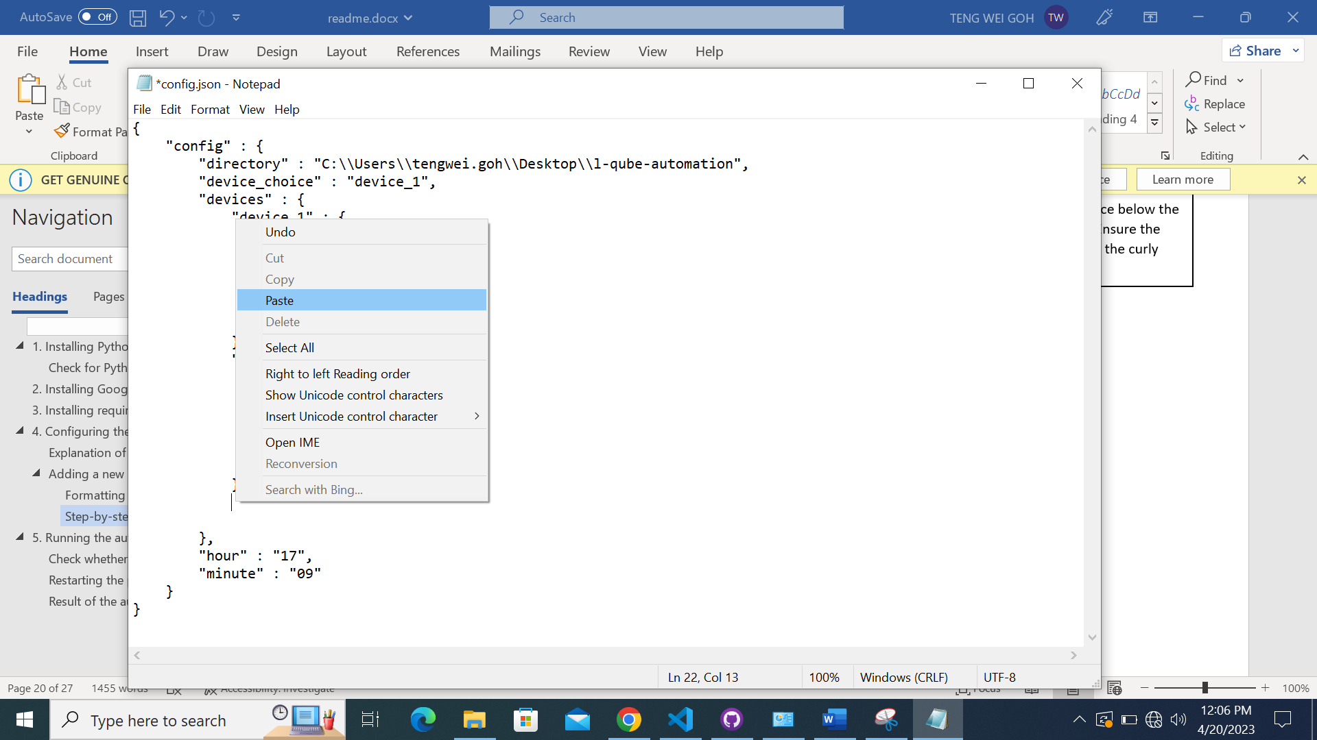

4. Right-click on the space selected and click ‘Paste’. (Or you can press CTRL + V)

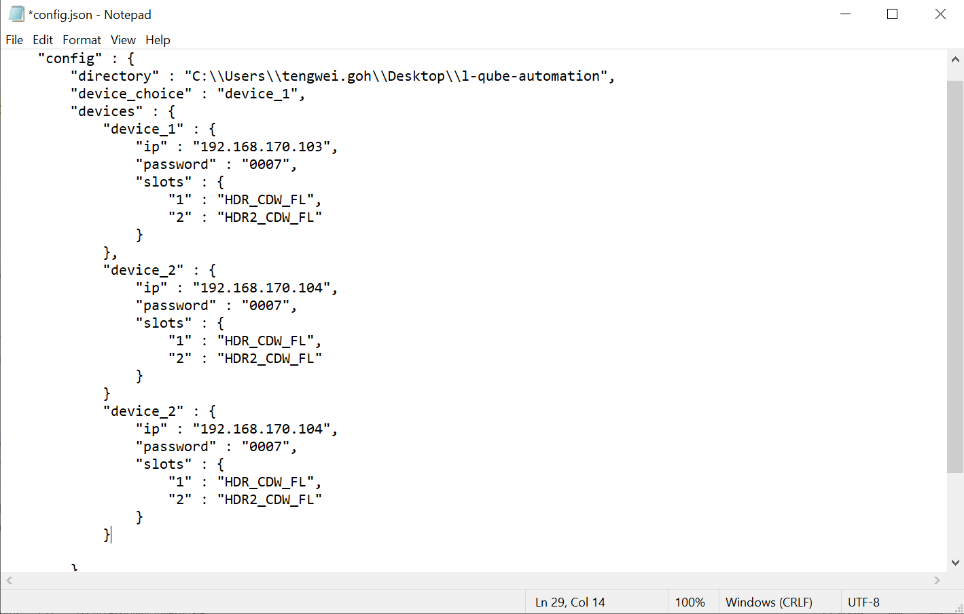

5. The configurations for device_2 should be pasted in the way shown in the image.

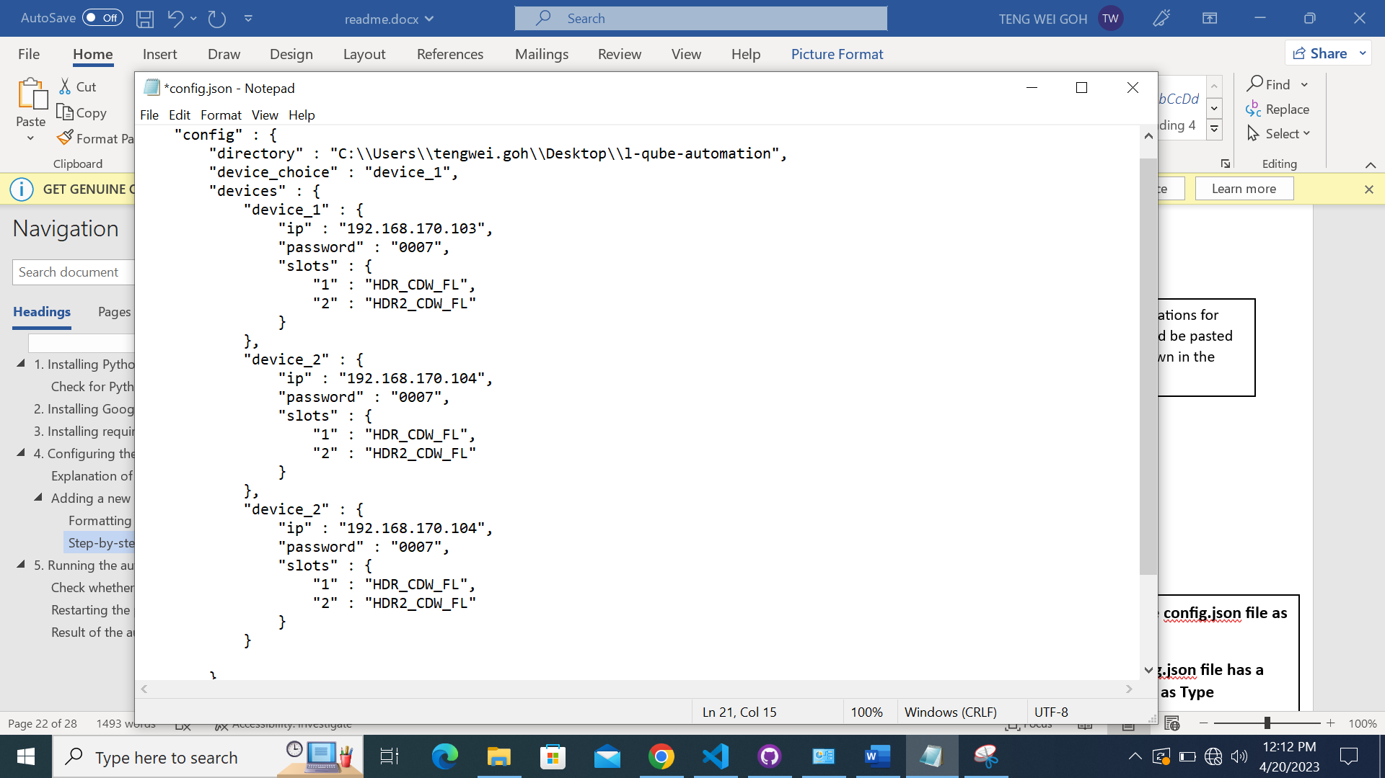

6. Add a , to the preceding device curly bracket.

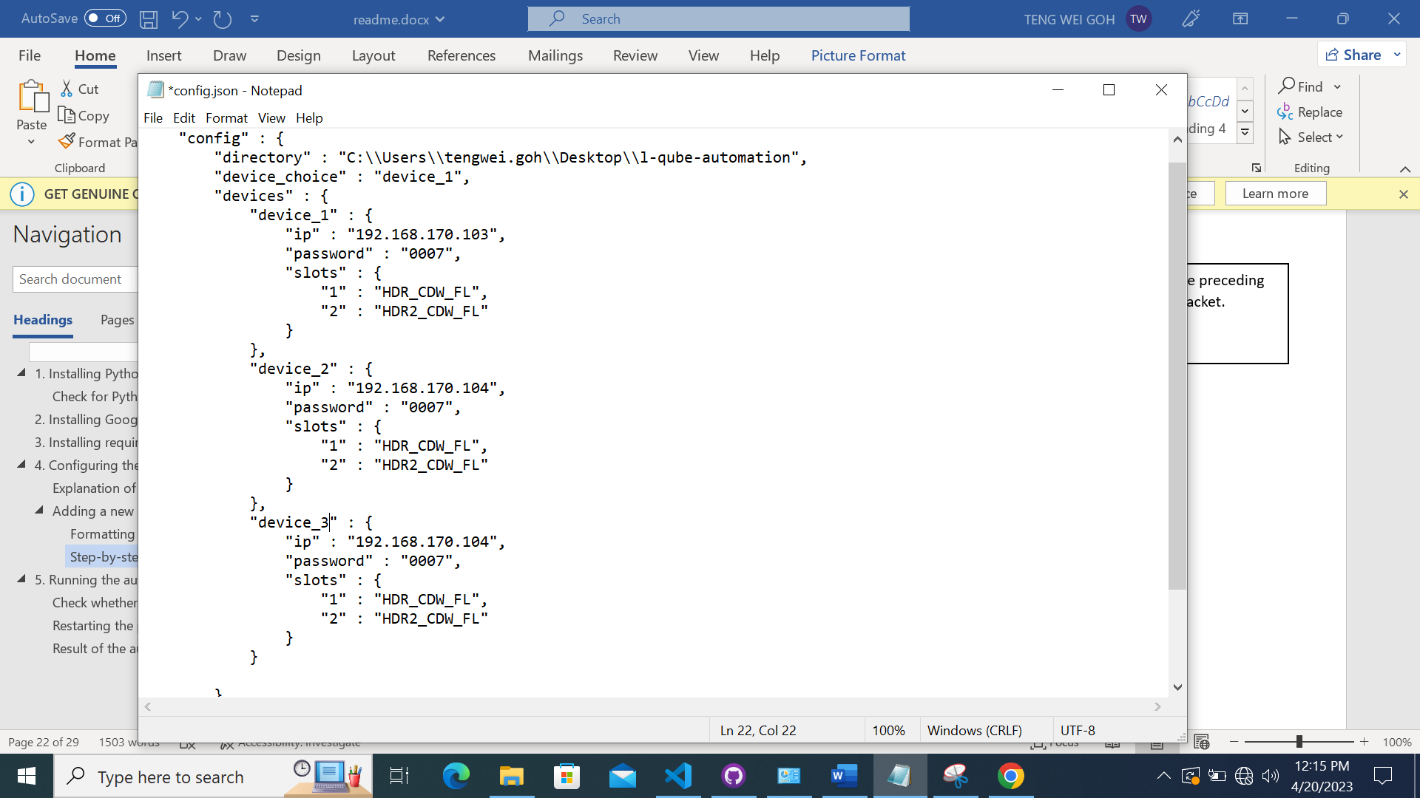

7. Change from device_2 to device_3. If more devices are added, just change the device_(number) to be 1 more than the last device number.

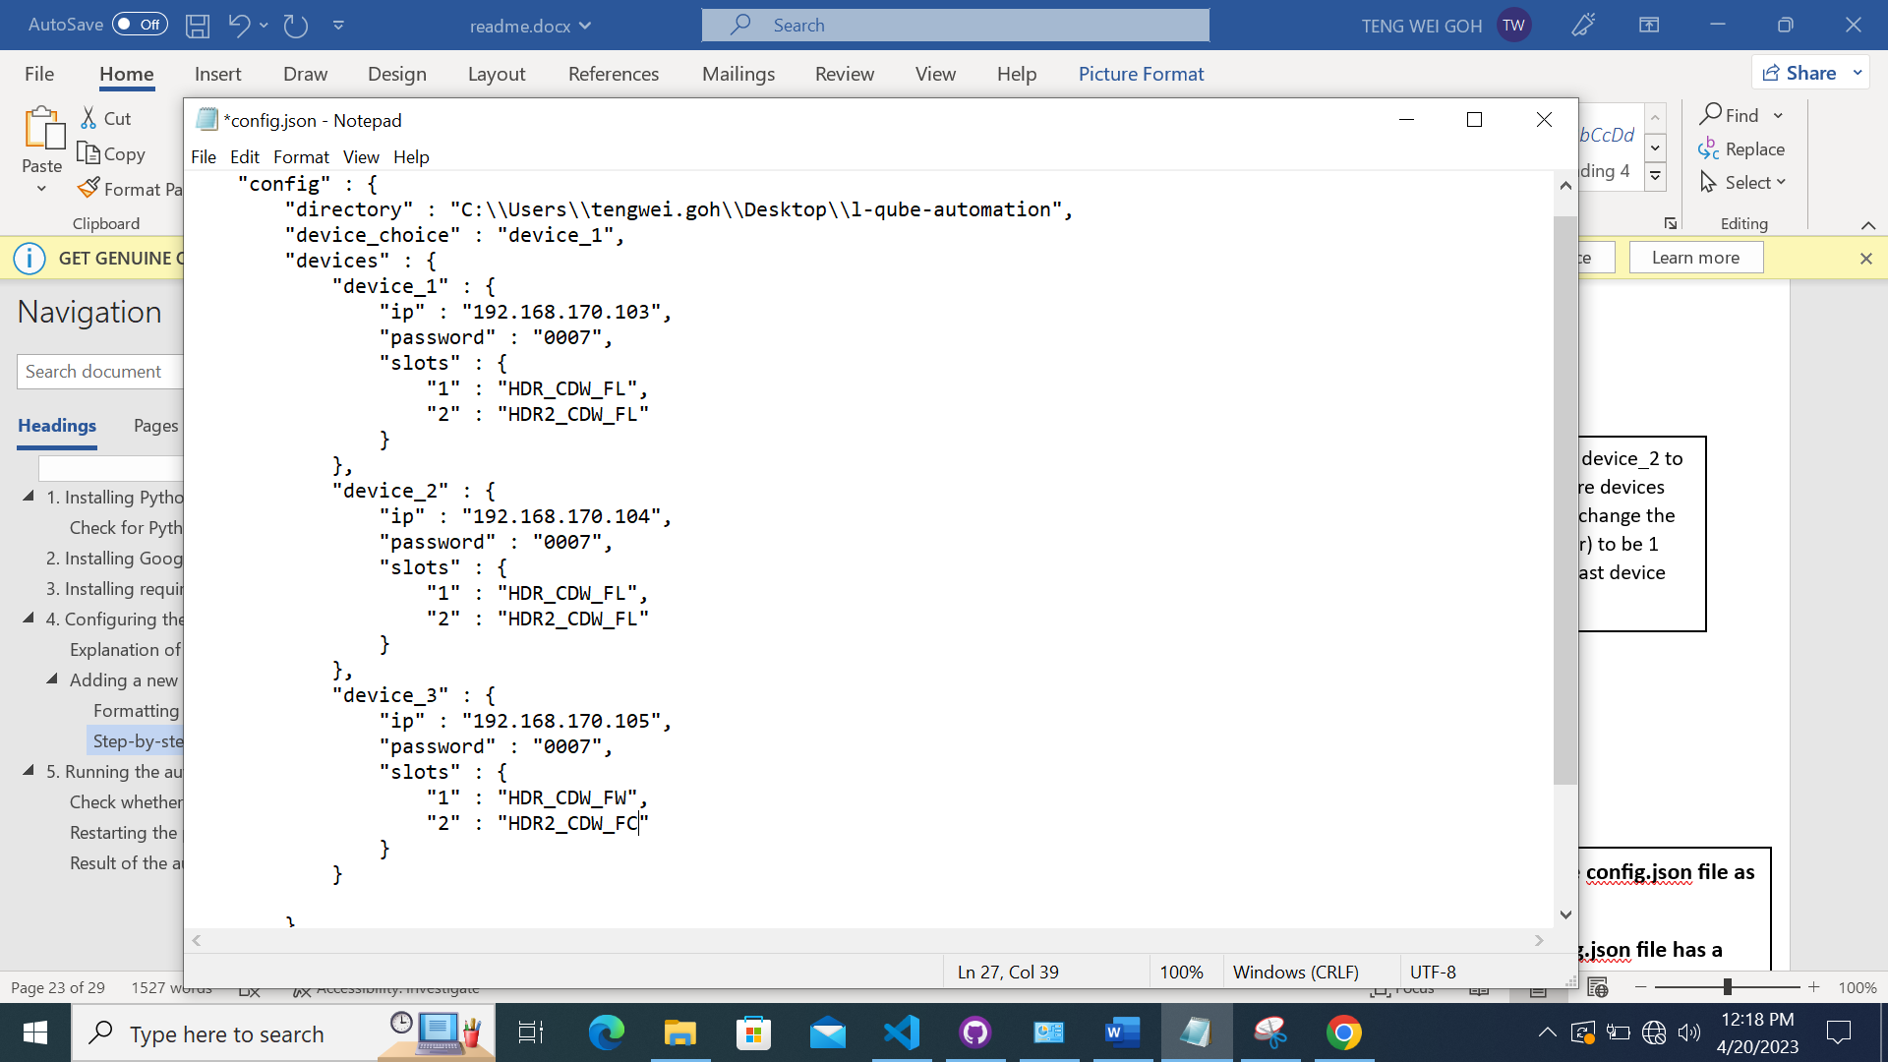

8. Change the ip, password and slots accordingly.

### Mistakes that might be easily made

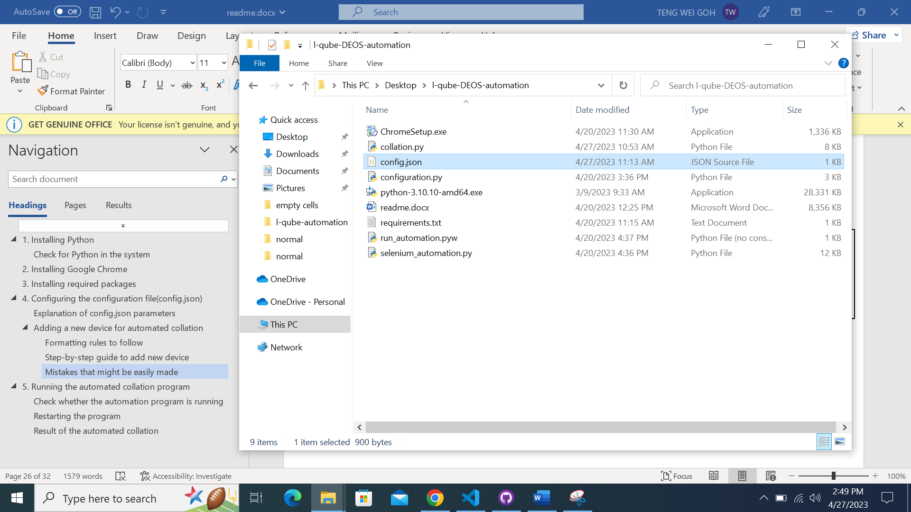

**DO NOT save the config.json file as a .py file!**

**Ensure the config.json file has a JSON Source File as Type**

**Remember to save your changes by pressing CTRL + S before exiting the config.json file!**

# Running the automated collation program

**Please ensure that the PC is connected to the devices before proceeding!**



Double-click the ‘DEOS_automation’ file and the program will run.

You will not see a terminal window appearing as the program is hidden, to prevent other users from accidentally closing the program

Navigate to the folder where the files are located

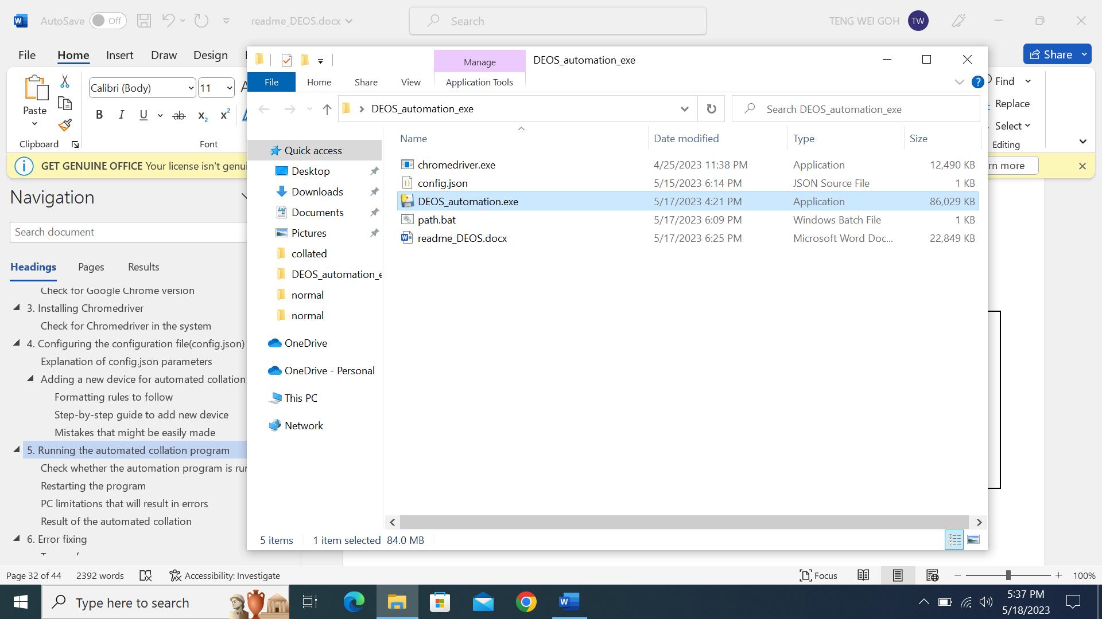

## Check whether the automation program is running

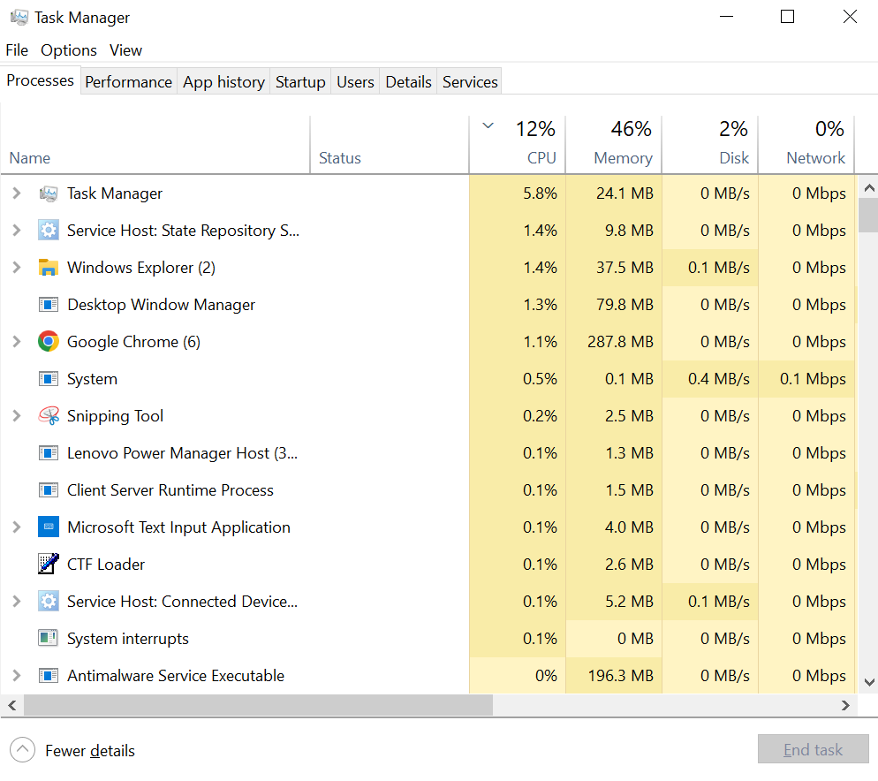

Open the Task Manager by pressing Ctrl + Shift + Esc together at the same time on the keyboard

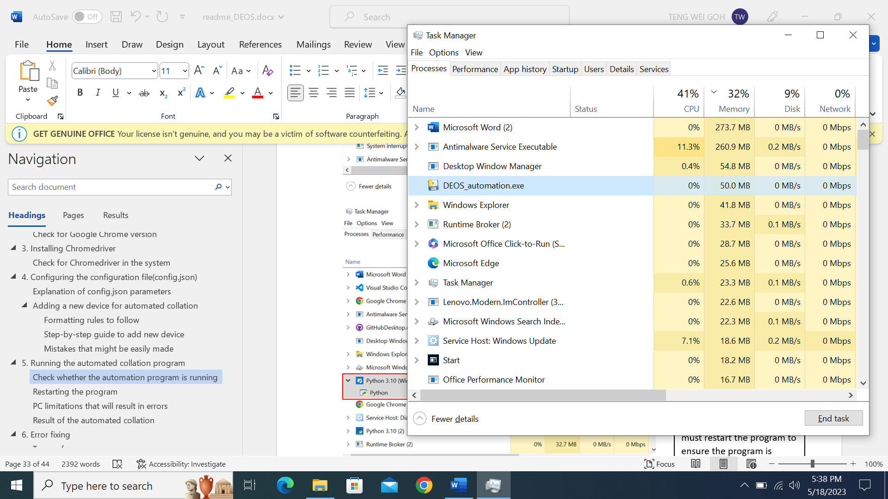

You should see the application taking up approximately 48~50MB of Memory.

This shows that the automated program is running properly.

If there are any changes to the config.json file, you must restart the program to ensure the program is running with the new configurations.

Click on ‘Memory’ **twice** to sort the processes in **descending order**.

## Restarting the program

If there are any changes to the config.json file, you must **restart the program** to ensure the program is running with the new configurations.



2

1

1. Click on the application and ensure it is highlighted blue as shown

2. Click on the ‘End task’ button

3. Repeat the steps in ‘5. Running the automation program’ to run the program with the new configurations.

You would see flashes of 4 black screen if you are present at the system when the program executes, which is evidence that the collation is being successfully executed.

## PC limitations that will result in errors

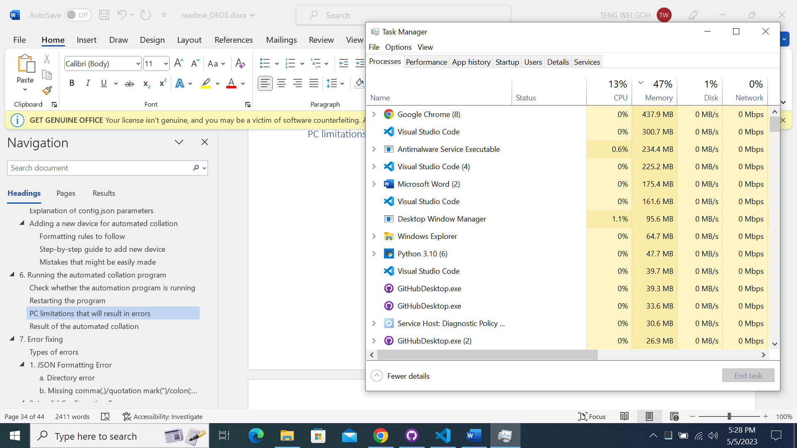

If any of the 3 resources are at 100% capacity, then the program will not be able to run due to the lack of resources. Ensure that there are sufficient resources available for the program.

## Result of the automated collation

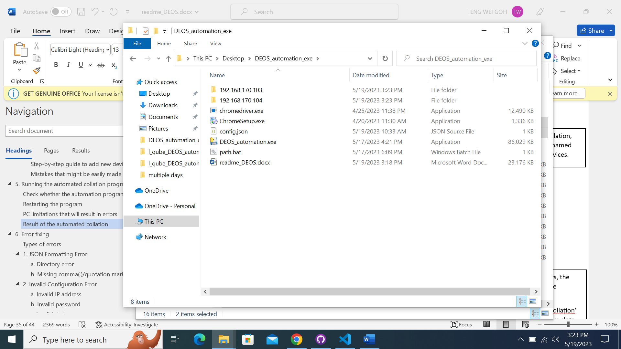

After the daily automated collation, you would see these folders named after the IP of the training devices.

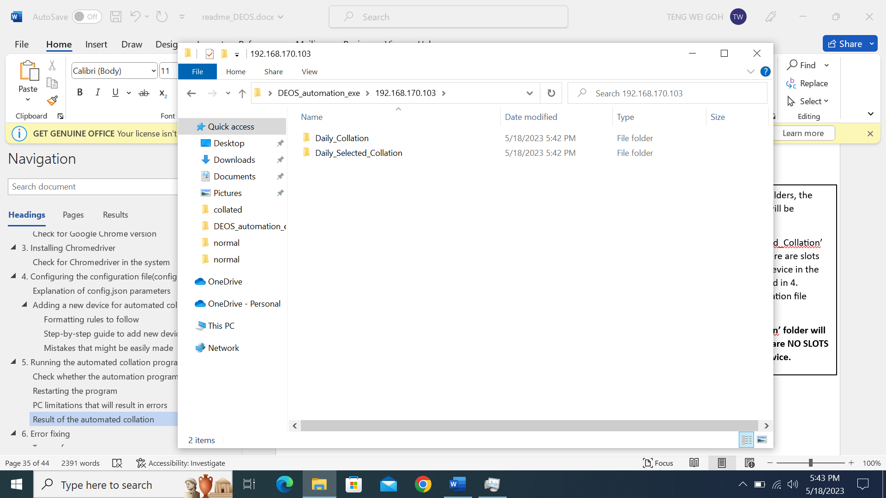

Inside each of these IP folders, the folder ‘Daily_Collation’ will be created.

The folder ‘Daily_Selected_Collation’ will also be created if there are slots that correspond to the device in the config.json file mentioned in 4. Configuring the configuration file (config.json).

**’Daily_Selected_Collation’ folder will NOT be created if there are NO SLOTS corresponding to the device.**

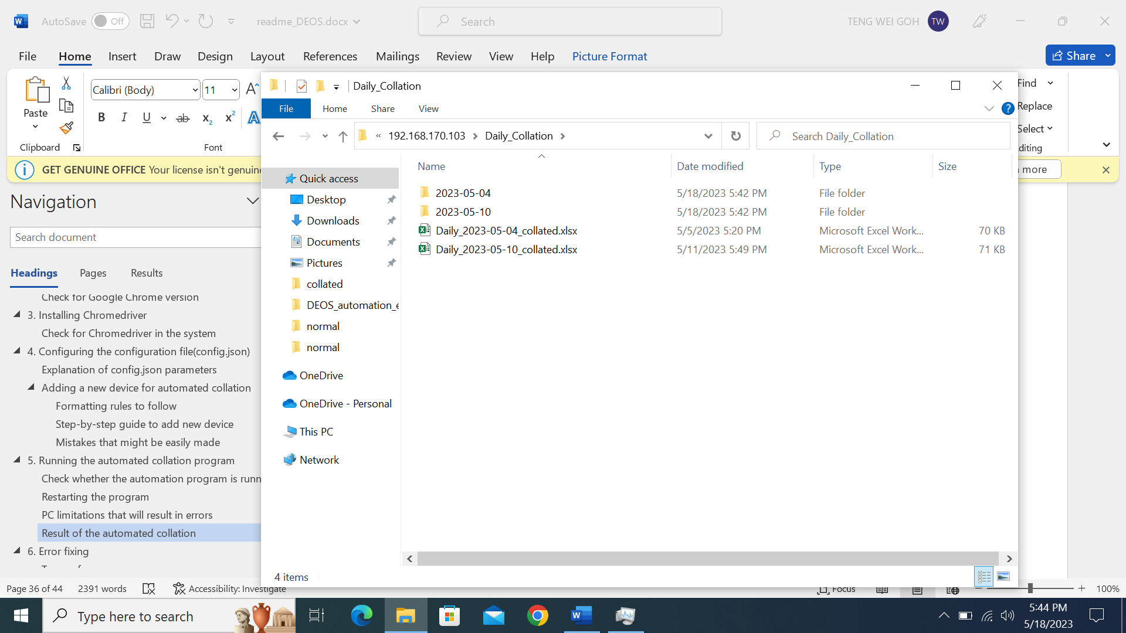

Inside each of the folders, there will be folders named after every day’s date.

Inside each of the folder will be the raw data of each slot.

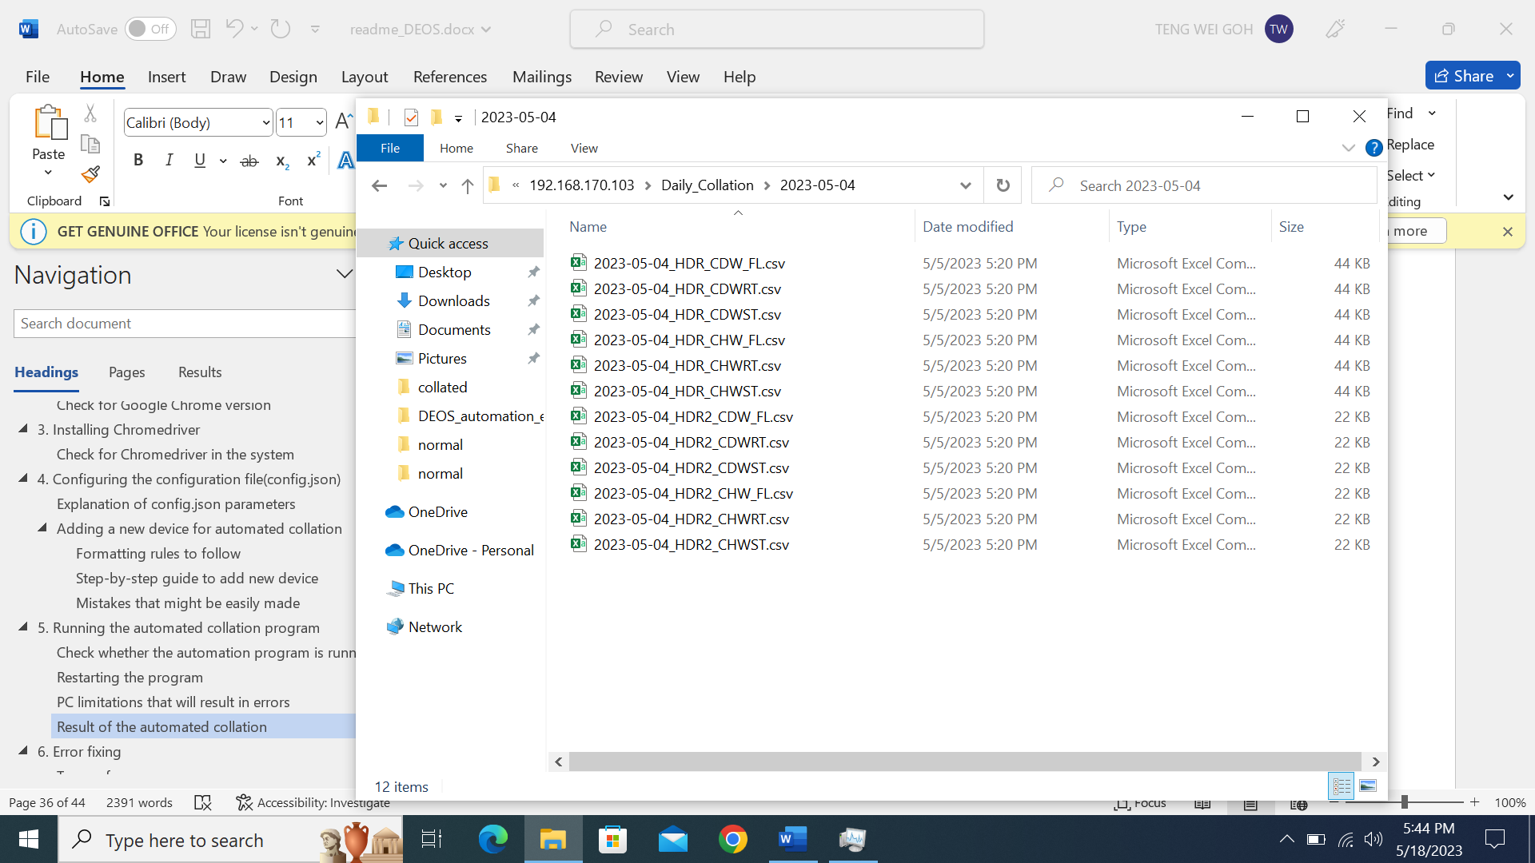



The content inside the collated excel file will be similar to this, with all the slots matched to their corresponding timestamp

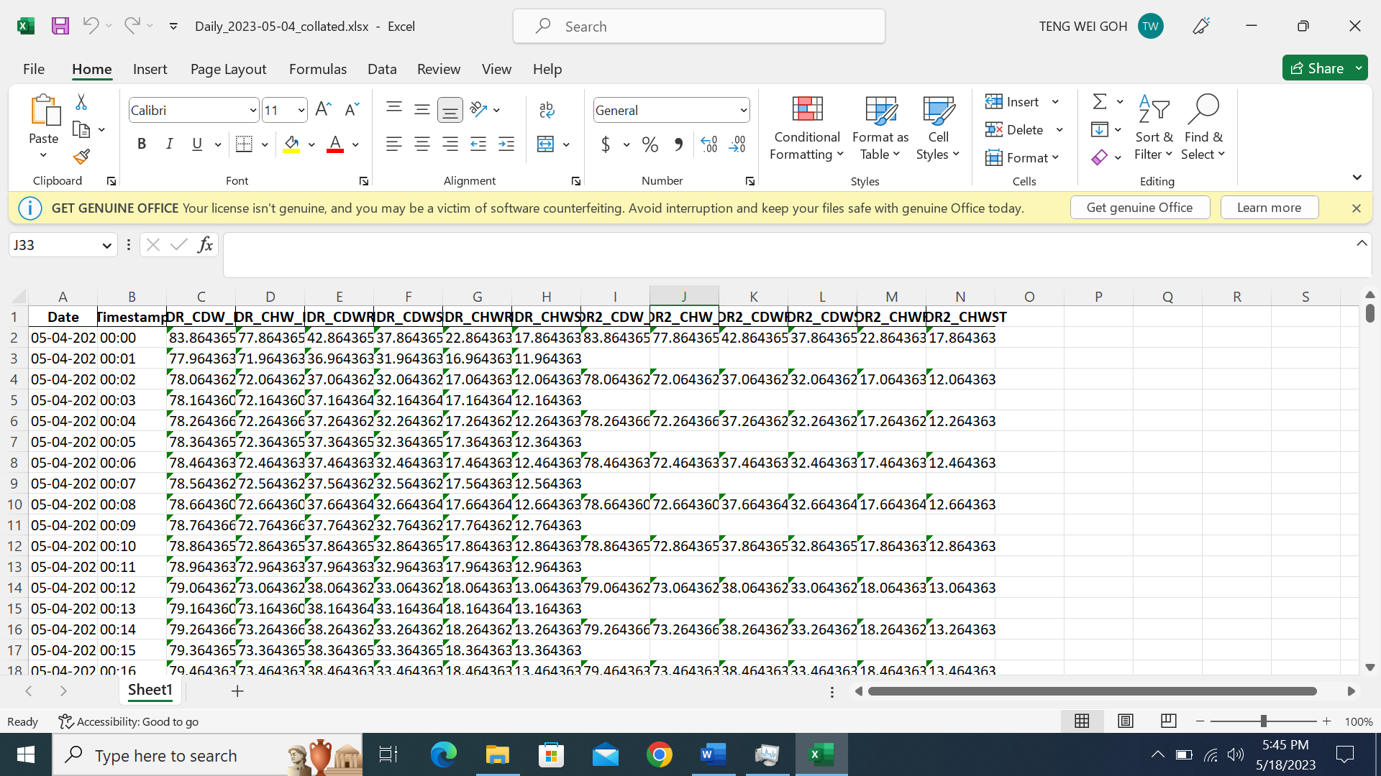

After ensuring the program is running properly, you can lock the windows using Windows Key + L. The program will still run as per usual, downloading and collating the files when the time in the config.json file is reached.

# Error fixing

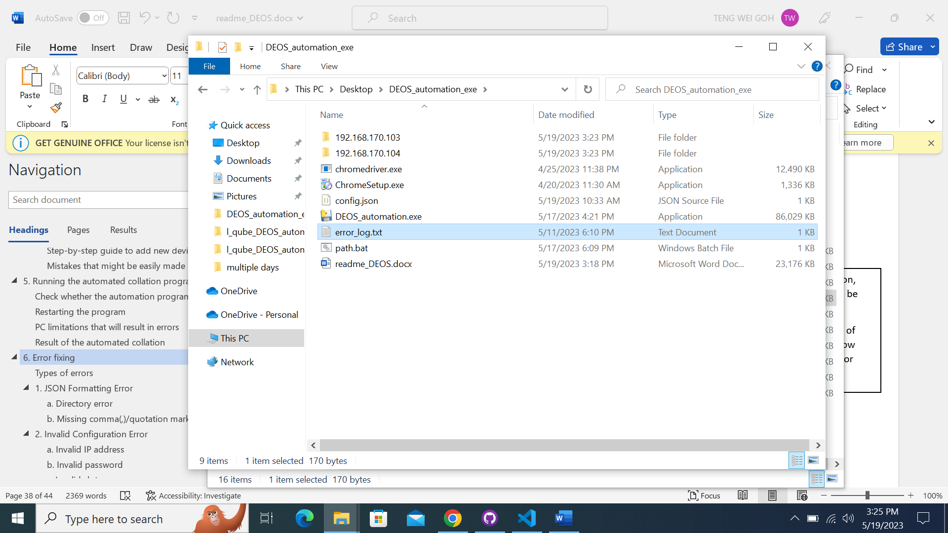

During the automation, this error_log.txt will be generated.

Please refer to Types of error below to see how long each type of error would take.



To view the errors if there are any, double-click the error_log.txt file.

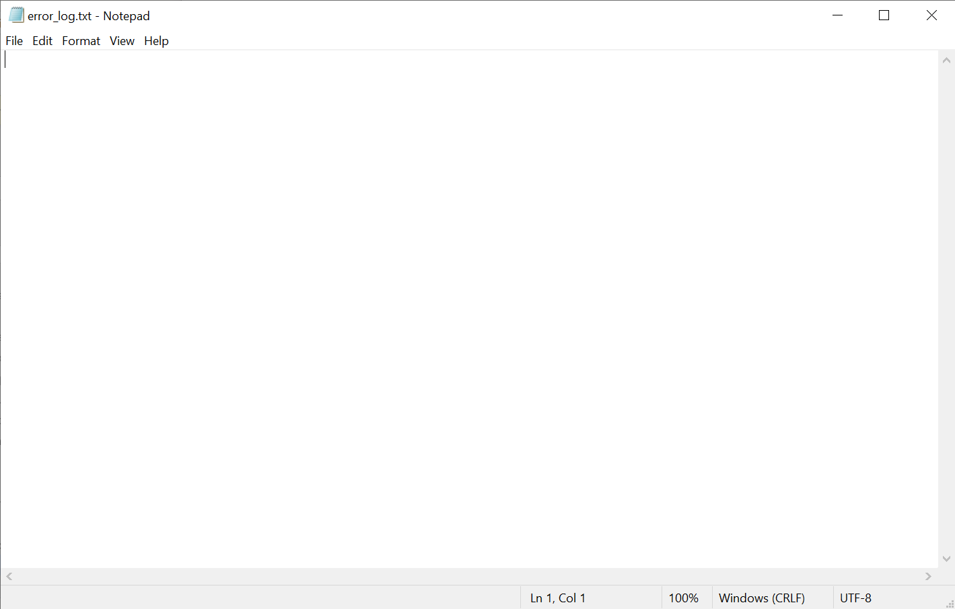

If the error_log.txt is empty, it means that everything is going smoothly and you do not need to do anything! 😊

## Types of errors

There are mainly 2 kinds of config.json error you might face:

## JSON Formatting Error

This means that there are formatting errors in the config.json file, which results in the program not being able to run.

Time to wait for error_log.txt: This would take **less than 10 seconds** as the program will cease to run immediately.

### Directory error

This means that there is a missing ‘\’ in the directory configuration.

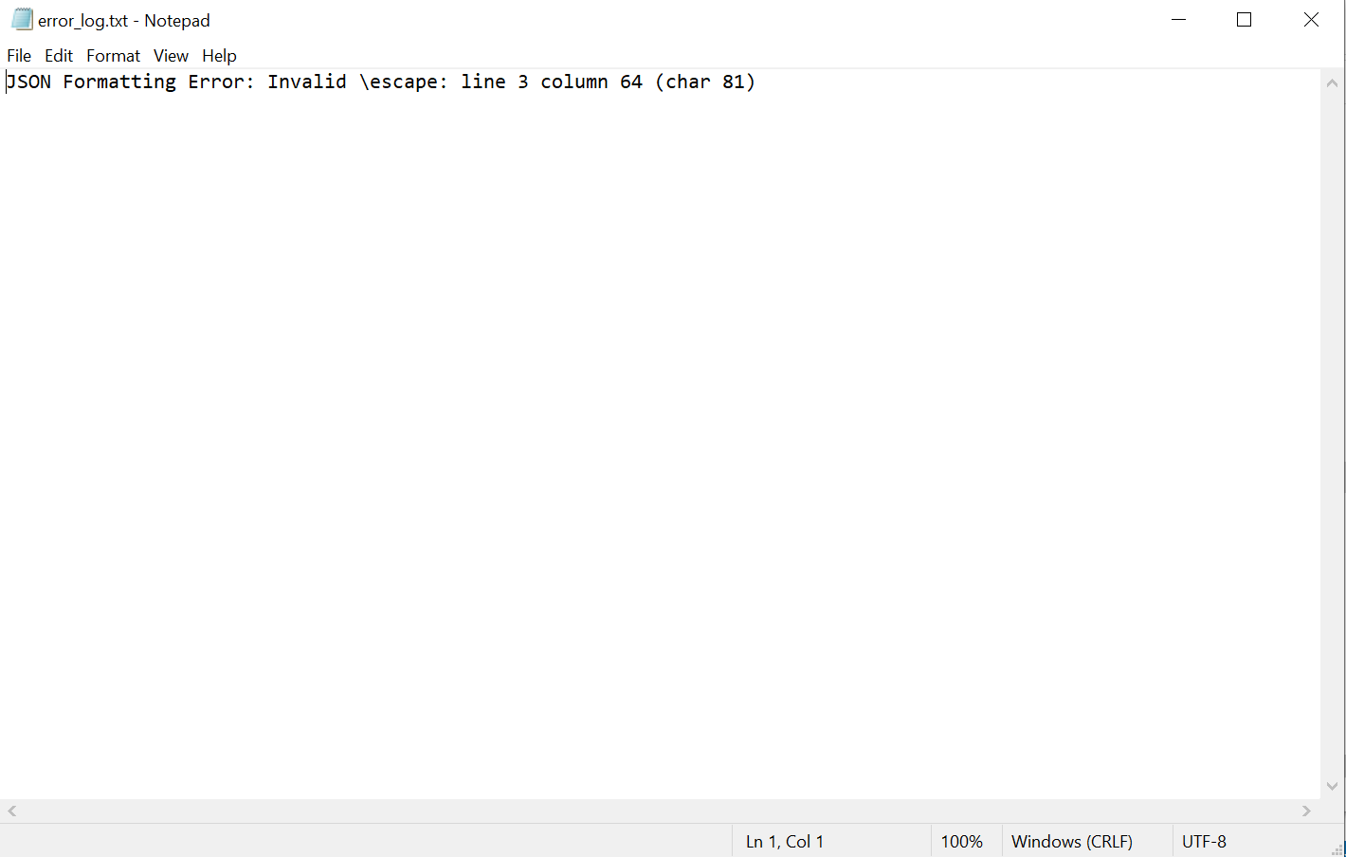

Check for **line 3 column 64** as indicated in the error_log file.

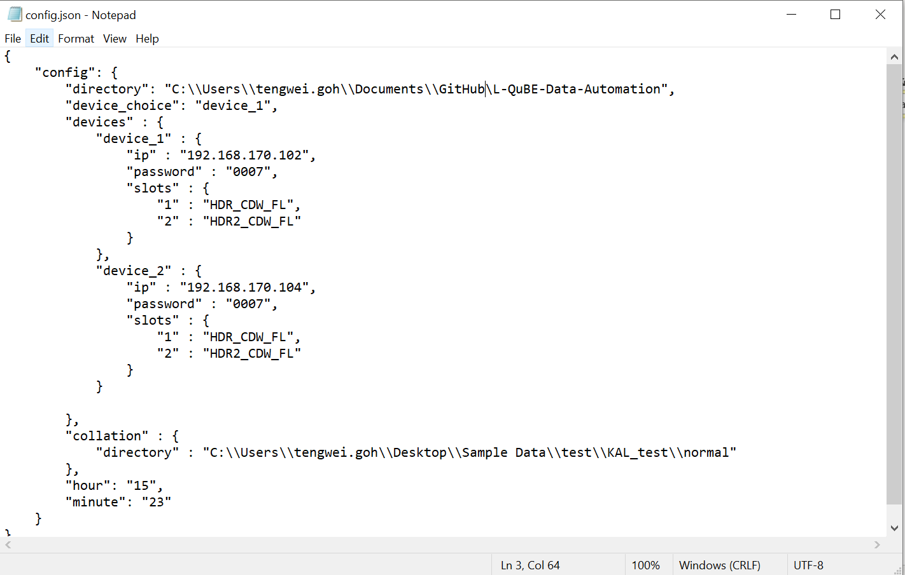

As you can see, Notepad displays which line and column your cursor is currently on. Hence, **move and click** your cursor on the **config.json** file to find the error location.

And voila, you can see that there is a missing ‘\’ in the directory configuration.

### Missing comma(,)/quotation mark(“)/colon(:)/curly bracket({})

This means that there is a missing , at the specified location.

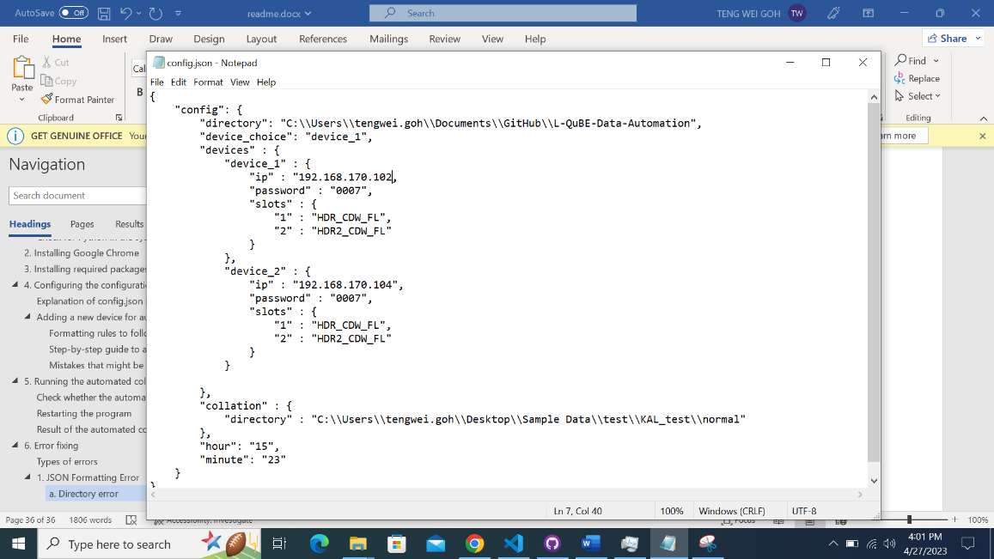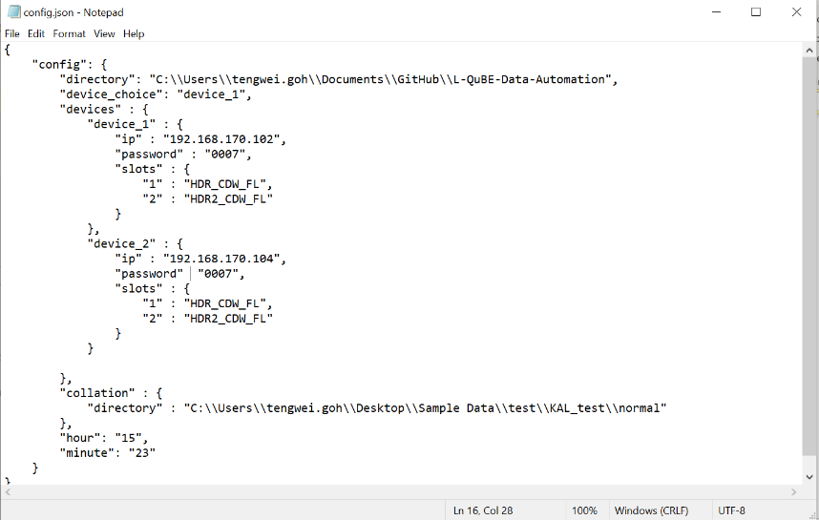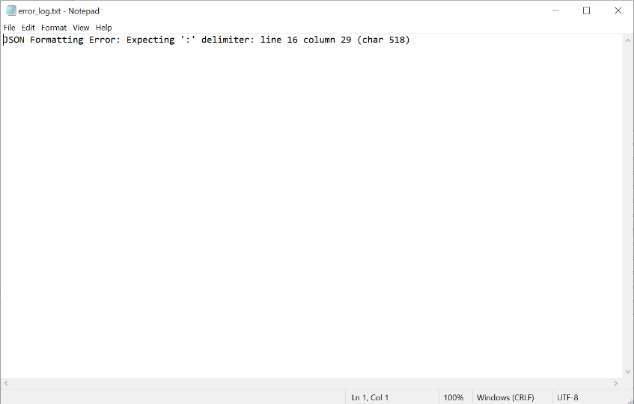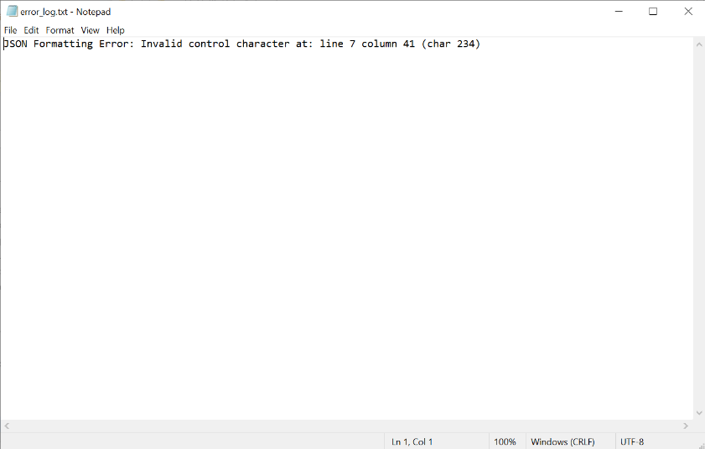

This means that there is a missing : at the specified location.

This means that there is a missing “ at the specified location.

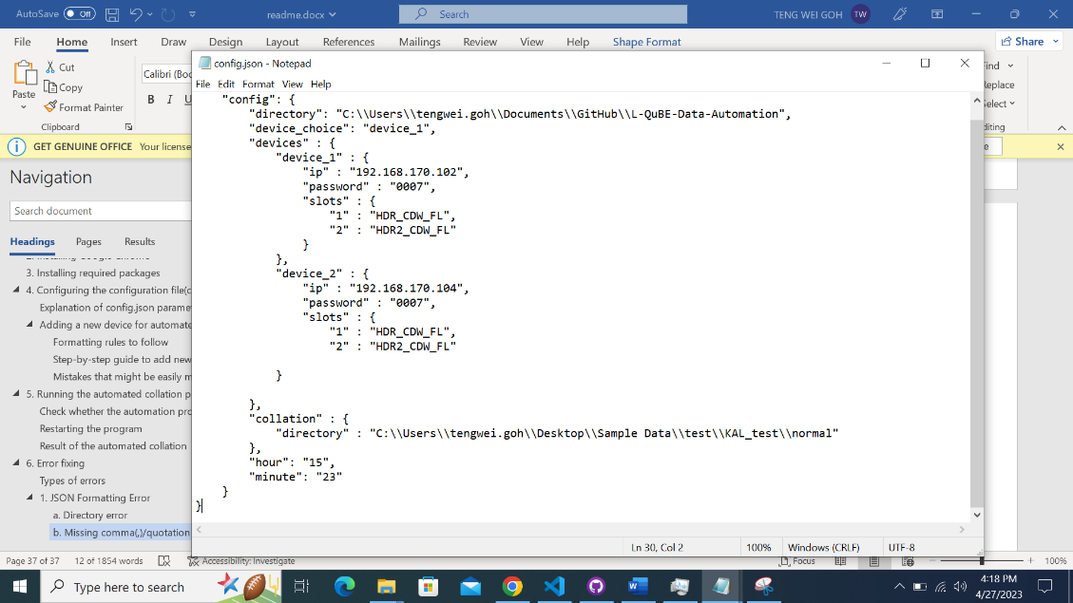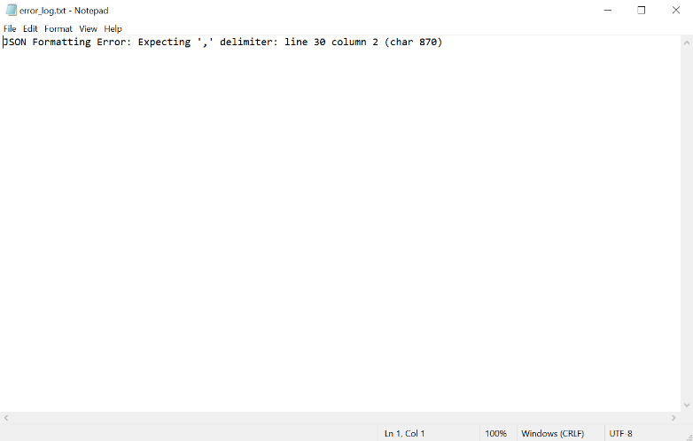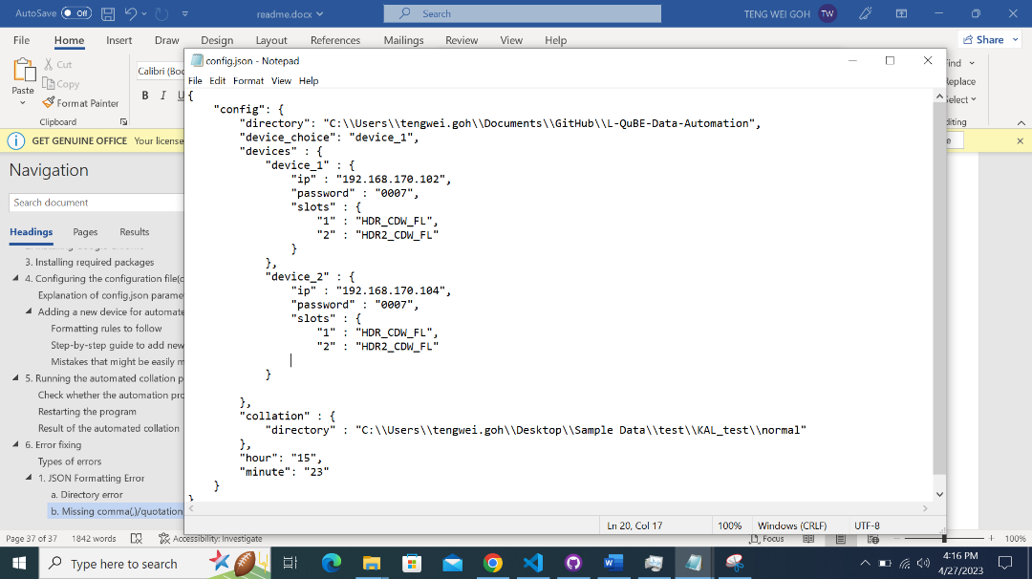

This is a tricky error. If the specified location is at the end of the file, this means that there is a **missing { or }** somewhere in the file, which I am not able to detect. Please analyse the configuration carefully to detect the missing { or }.

## Invalid Configuration Error

This means that there are configuration errors in the config.json file, which results in the program not being able to run.

Time to wait for error_log.txt: For 2 devices, this would take **around 3-4 minutes** as the program will take a while to register the error.

### Invalid IP address

This means that the IP address configured for device 1 is incorrect.

This means that the IP address configured for device 1 is incorrect.

### Invalid password

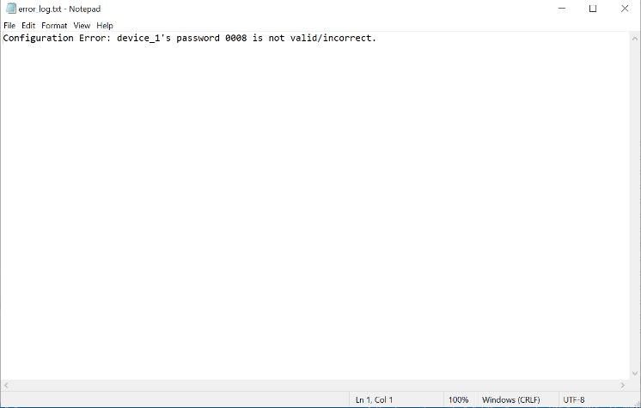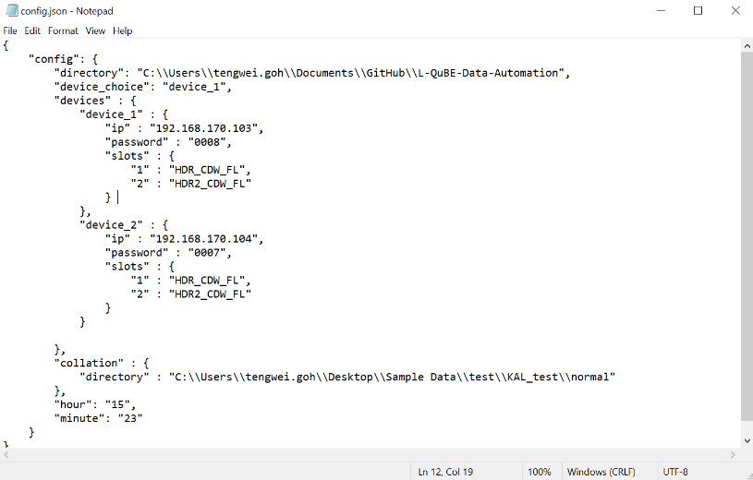

This means that the password configured for device 1 is incorrect.

### Invalid slot name

This means that the slot names for device 2 are spelled incorrectly.